­

Team Member

Capstone Project

2020CFSE007 – Suhail Haroon

EC3B - Elaboration

Residents Connect

2020CFSE018 - Rajeswari Subramanian

Contents

**1. Problem Statement** 5

**1.1** **Contribution** 5

**1.1.1 EC3B Documentaion** 5

**1.1.2 Work assignments** 5

**2. Artifacts/References:** 6

**2.1 Back End** 6

**2.2 Front End** 6

**2.3 Wireframe:** 6

**3. Domain Model** 7

**4. Logical Architecture** 16

**4.1 Logical Architecture Elements** 17

**4.2 Benefits of using MVC – Architecture** 18

**4.3 3-tier Architecture vs. MVC Architecture** 19

**5. Design Model** 19

**5.1 System Design** 19

**5.2 Authentication Service** 21

**5.2.1 Registration** 22

**5.2.2 Login** 23

**5.3 Notification Service** 23

**6. Deployment Plan:** 24

**6.1 CICD Pipeline:** 27

**6.1.1 CICD pipeline for microservices:** 27

**6.1.2 CICD pipeline for Frontend:** 28

**7.Data Model** 28

**7.1 CommunityInfo & Apartment Info Collection:** 28

**7.2 UserInfo Collection** 29

**7.3 ContactInfo Collection:** 30

**7.4 AnnouncementInfo Collection:** 31

**7.5 CarpoolingInfo Collection** 31

**7.6 ChatRoomInfo Collection** 31

**7.7 ClassifiedsInfo Collection** 32

**7.8. EventsmgmtInfo Collection** 32

**7.9 MaintenanceInfo Collection** 33

**7.10. PaymentsInfo Collection** 34

**7.11. PollingInfo Collection** 34

**7.12. FacilityInfo Collection** 35

**8. Prototyping** 35

**8.1 Figma – UX/UI Design:** 35

**8.2 Prototype II (Executable):** 46

**8.2.1 Authentication** 46

**8.2.2 Profile Setup** 47

**8.2.3 Buy and Sell** 57

**8.2.4 Chat Rooms** 58

**8.2.5 Classifieds** 63

**8.2.6 Payments** 66

**8.2.7 Car Pooling** 68

**8.2.8 Polling** 71

**8.2.9 Events Management** 73

# **1. Problem Statement**

EC-3B: Construction & Deployment

Complete system implementation at a reduced scale, working prototype of the system with the frontend/backend/database/cloud technologies integrated.

Expected Artifact –

Prototype III (Executable)

## **Contribution**

### **1.1.1 EC3B Documentaion**

* + 1. Revised Domain model: Suhail (2020CFSE007)
    2. Revised Logical Architecture: Ramesh (2020CFSE020)
    3. Revised Design model: Rajeswari (2020CFSE018)
    4. Revised Data model: Rajeswari (2020CFSE018)
    5. Deployment Plan: Rajeswari (2020CFSE018)
    6. Prototype III (Executable): Rajeswari (2020CFSE018) & Suhail (2020CFSE007)

### **1.1.2 Work assignments**

|  |  |  |  |  |  |  |  |  |  |  |  |
| --- | --- | --- | --- | --- | --- | --- | --- | --- | --- | --- | --- |
| Services | AssginedTo | Back End | | Frond End | | | Integration | | | Comments | |
| Status | % Completion | Status | % Completion | Status | | % Completion | (Pending work) | |
| Framework Setup | Rajeswari | In Progress | 90% | In Progress | 90% | In Progress | | 90% | Styling / formatting/ error messages | |
| authentication | Rajeswari | In Progress | 90% | In Progress | 90% | In Progress | | 90% | Reset Password | |
| profile Setup | Rajeswari | In Progress | 80% | In Progress | 80% | In Progress | | 80% | Styling / formatting/ error messages | |
| contacts Info | Suhail | In Progress | 20% | Not Started | 0% | In Progress | | 20% | Code merge is not happened | |
| Car pooling | Rajeswari | Not Started | 90% | Not Started | 0% | Not Started | | 90% | Styling / formatting/ error messages | |
| Buy and Sell | Rajeswari | In Progress | 90% | In Progress | 60% | In Progress | | 90% | Code break;  Styling / formatting/ error messages | |
| Polling | Rajeswari | In Progress | 90% | In Progress | 0% | In Progress | | 90% | Styling / formatting/ error messages | |
| Chat Room | Rajeswari | In Progress | 90% | In Progress | 90% | In Progress | | 90% | Styling / formatting/ error messages | |
| Events Management | Suhail | In Progress | 0% | Not Started | 0% | Not Started | | 0% | Code merge is not happened for frontend. Integration between backend and front end | |
| Visitor Management | Suhail | Not Started | 0% | Not Started | 0% | In Progress | | 0% |  | |
| Classifieds | Rajeswari | In Progress | 90% | Not Started | 90% | Not Started | | 0% | Styling / formatting/ error messages | |
| Facility Booking | Rajeswari | In Progress | 20% | In Progress | 20% | Not Started | | 0% | In Progress | |
| Dashboard | Rajeswari | In Progress | 40% | In Progress | 0% | In Progress | | 0% | In Progress | |
| Maintenance Request | Suhail | Not Started | 0% | Not Started | 0% | Not Started | | 0% |  | |
| Payment | Rajeswari | In Progress | 70% | In Progress | 70% | In Progress | | 0% | In Progress | |

# **2. Artifacts/References:**

## **2.1 Back End**

Github: <https://github.com/Capstone-BitsPilani/ResidentConnect-API>

Technology used: Express JS, Firebase Authentication, AWS serverless (Lambda, AWS Endpoint, Dynamo DB, SES, SQS)

DB used: Mango DB, Dynamo DB, Firestore, Firebase live database.

## **2.2 Front End**

<https://github.com/Capstone-BitsPilani/ResidentConnect-FrontEnd>

Technology used: React JS, Material-UI

## **2.3 Wireframe:**

Figma: <https://www.figma.com/file/Z41Ggif8PV4WihLU1R0ALS/sample_project?node-id=1112%3A2219>

# **3. Domain Model**

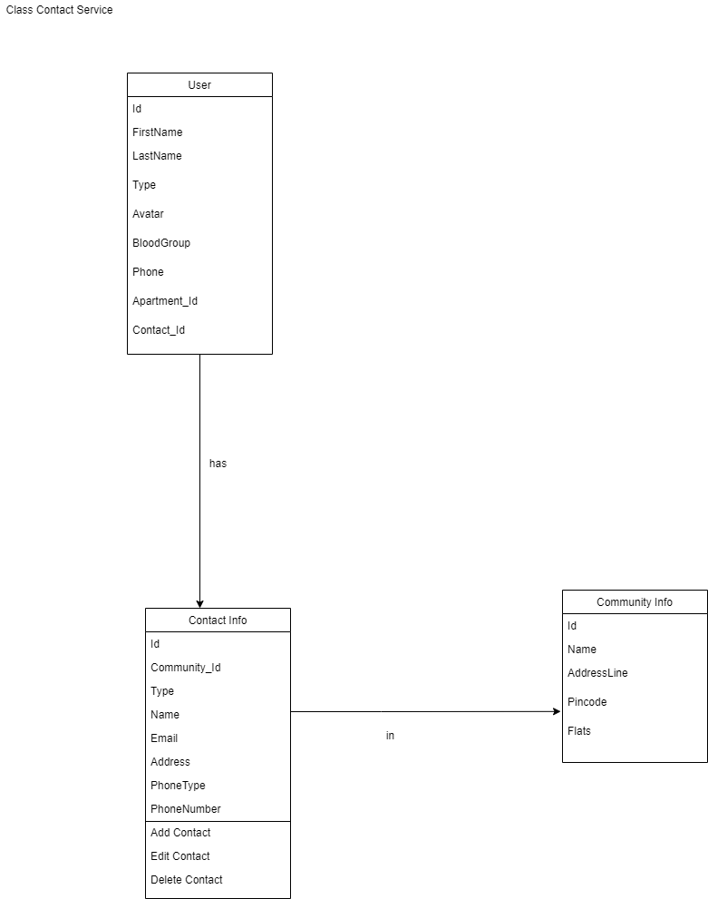

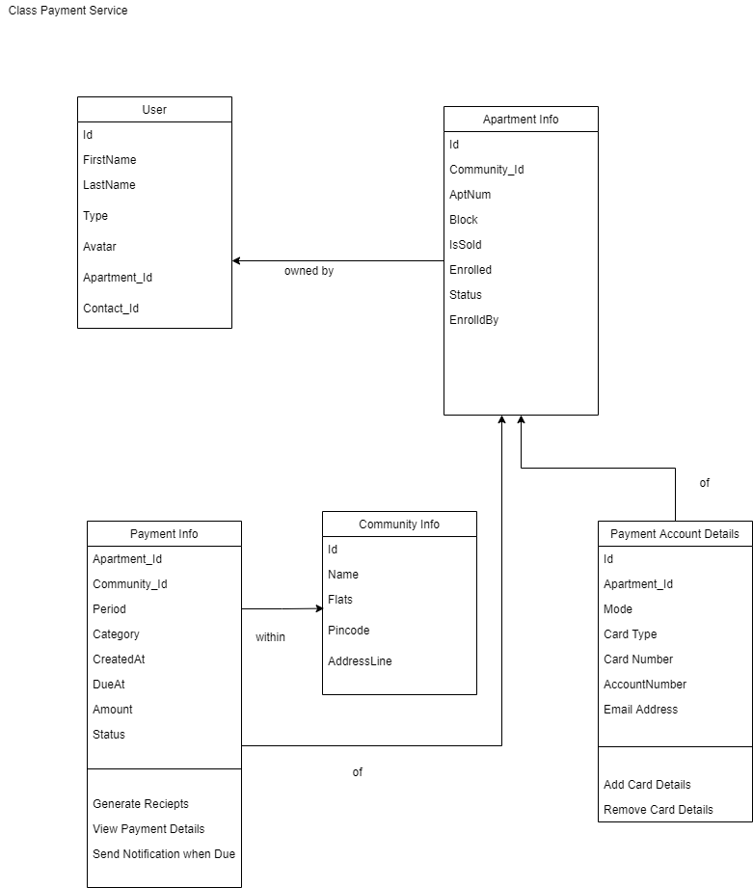

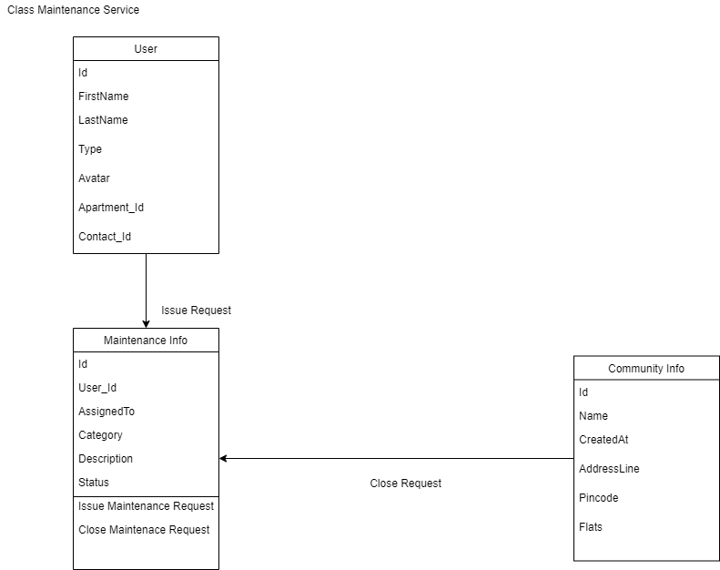

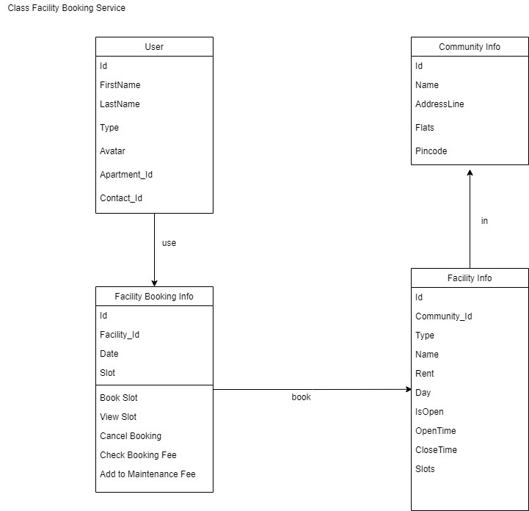

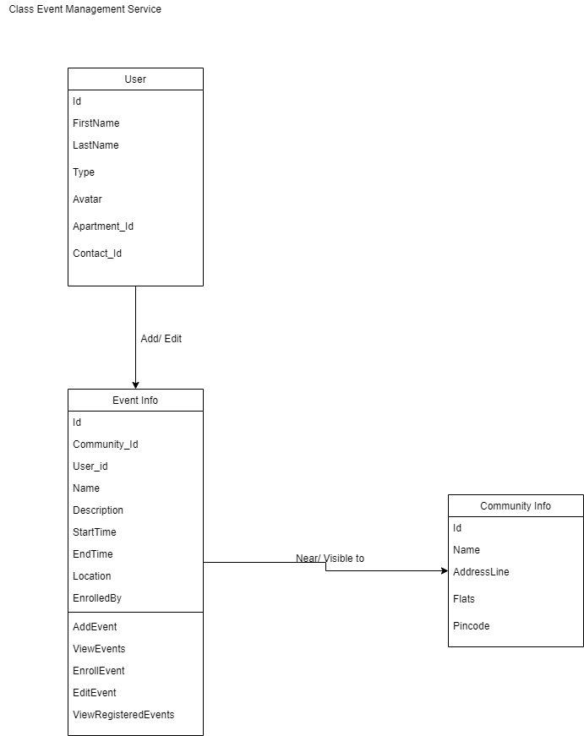

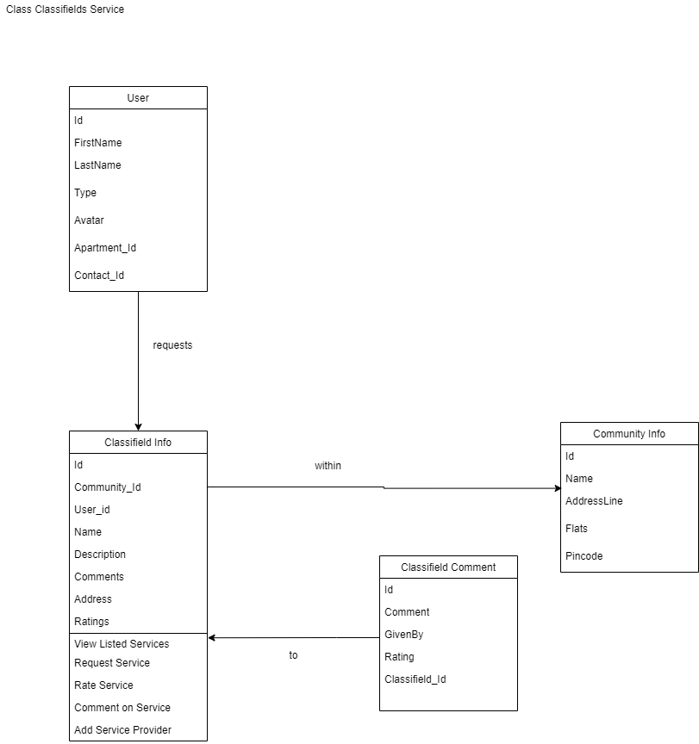

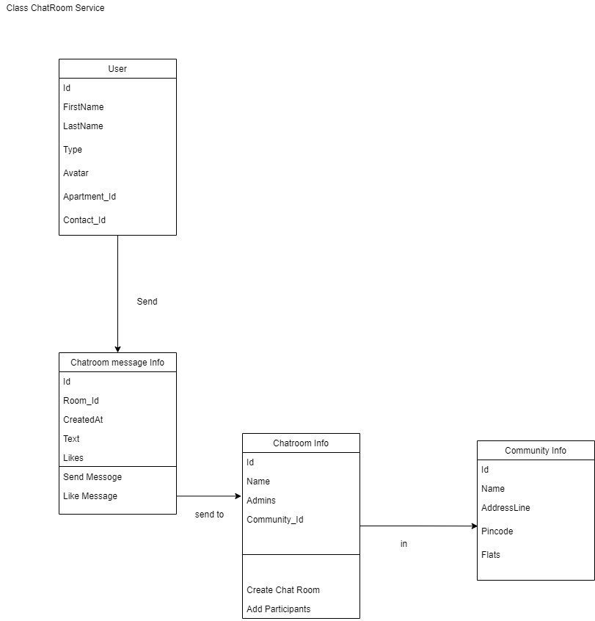

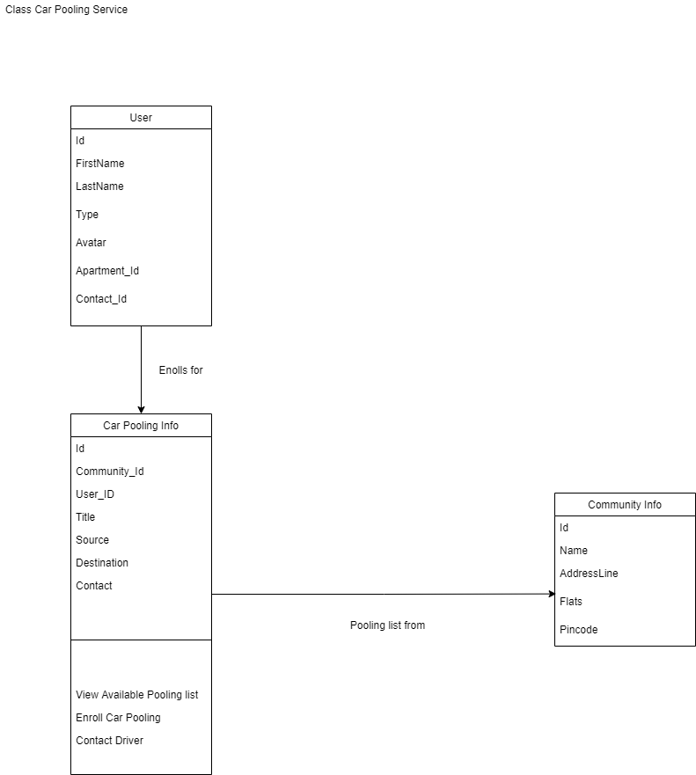

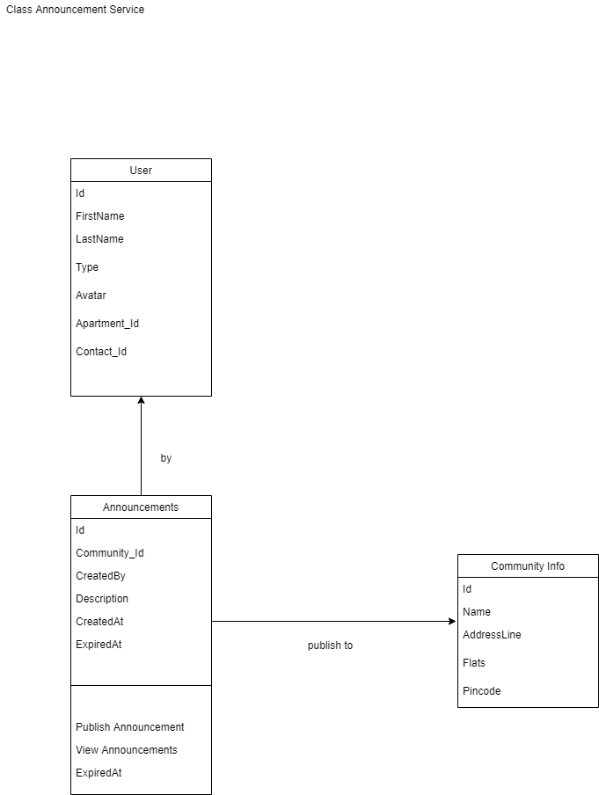

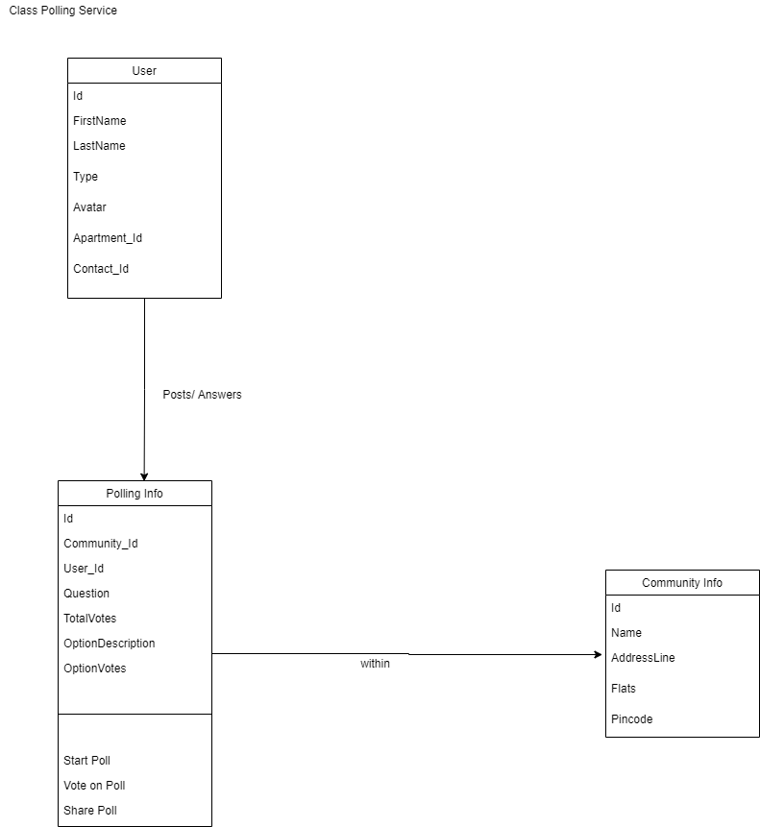

# **4. Logical Architecture**

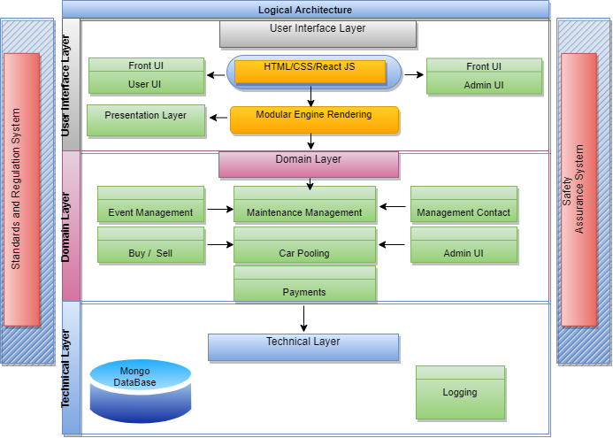

Large scale organization of software classes into packages, subsystems and layers

• Logical grouping and no Deployment Considered

• Layered architecture

o Coarse grouping of classes, packages, subsystems that has a cohesive responsibility

o Higher layers consumes services of lower layers

• Usual layers

o User Interface

o Application Logic and Domain

o Technical Services

## **4.1 Logical Architecture Elements**

• UI  
 o view   
 o Common mobile or web interfaces

• Application

o Workflow, app controller   
o Handles requests from presentation layers   
o REST endpoint handler

• Domain

o Business logic   
o Takes care of implementing business rules as response to app layer requests

• Business Infrastructure   
 o Very general low level business services like converters

• Technical Services   
 o High level technical services and frameworks like logger, DB adapter

• Foundations   
 o Low level technical services, frameworks, databases

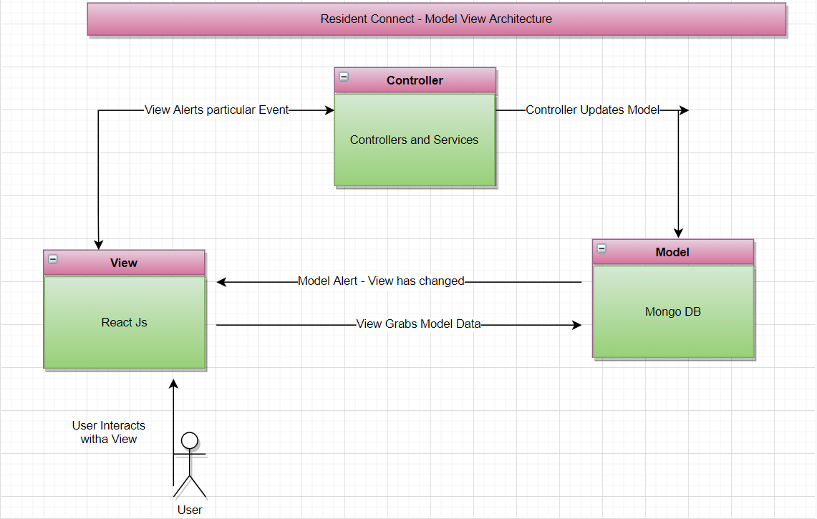

## **4.2 Benefits of using MVC – Architecture**



* Easy code maintenance which is easy to extend and grow
* MVC Model component can be tested separately from the user
* Easier support for new types of clients
* Development of the various components can be performed parallelly.
* It helps you to avoid complexity by dividing an application into the three units. Model, view, and controller
* It only uses a Front Controller pattern which process web application requests through a single controller.
* Offers the best support for [test-driven development](https://www.guru99.com/test-driven-development.html)
* It works well for Web apps which are supported by large teams of web designers and developers.
* Provides clean separation of concerns (SoC).
* Search Engine Optimization (SEO) Friendly.
* All classes and objects are independent of each other so that you can test them separately.
* MVC design pattern allows logical grouping of related actions on a controller together.
* The MVC is an architectural pattern that separates an application into
  + 1) Model, 2) View and 3) Controller
* Model: It includes all the data and its related logic



* View: Present data to the user or handles user interaction
* Controller: An interface between Model and View components

## **4.3 3-tier Architecture vs. MVC Architecture**

|  |  |  |
| --- | --- | --- |
| Parameter | 3-Tier Architecture | MVC Architecture |
| Communication | This type of architecture pattern never communicates directly with the data layer. | All layers communicate directly using triangle topology. |
| Usage | 3-tier: widely used in web applications where the client, data tiers, and middleware a run on physically separate platforms. | Generally used on applications that run on a single graphical workstation. |

# **5. Design Model**

## **5.1 System Design**

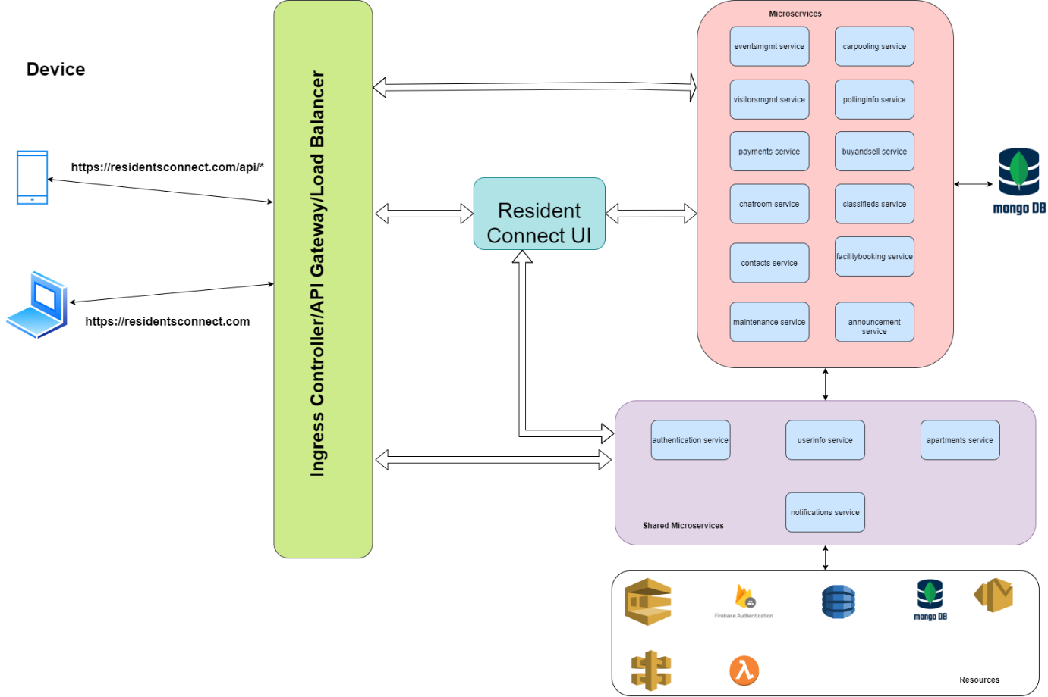

**Microservice Architecture:**

* Microservice -based architecture is considered for this project. Each and every functionality would be implemented as separate microservices. They may or may nor share the same databases though many of them using mango db.
* Event based architecture is not considered, as microservices in this application are mostly independent of one another.
* Notification & Chat room services are planned to be implemented using serverless with the help of AWS and firebase accordingly.

**Application load balancer vs API gateway:**

* Application load balancer uses to manage the network traffic based path routing. Based api path, it routes to corresponding target where micro service is running.
* API gateway : Notification service creates endpoint to send the notification which will be used by other services.

## **5.2 Authentication Service**

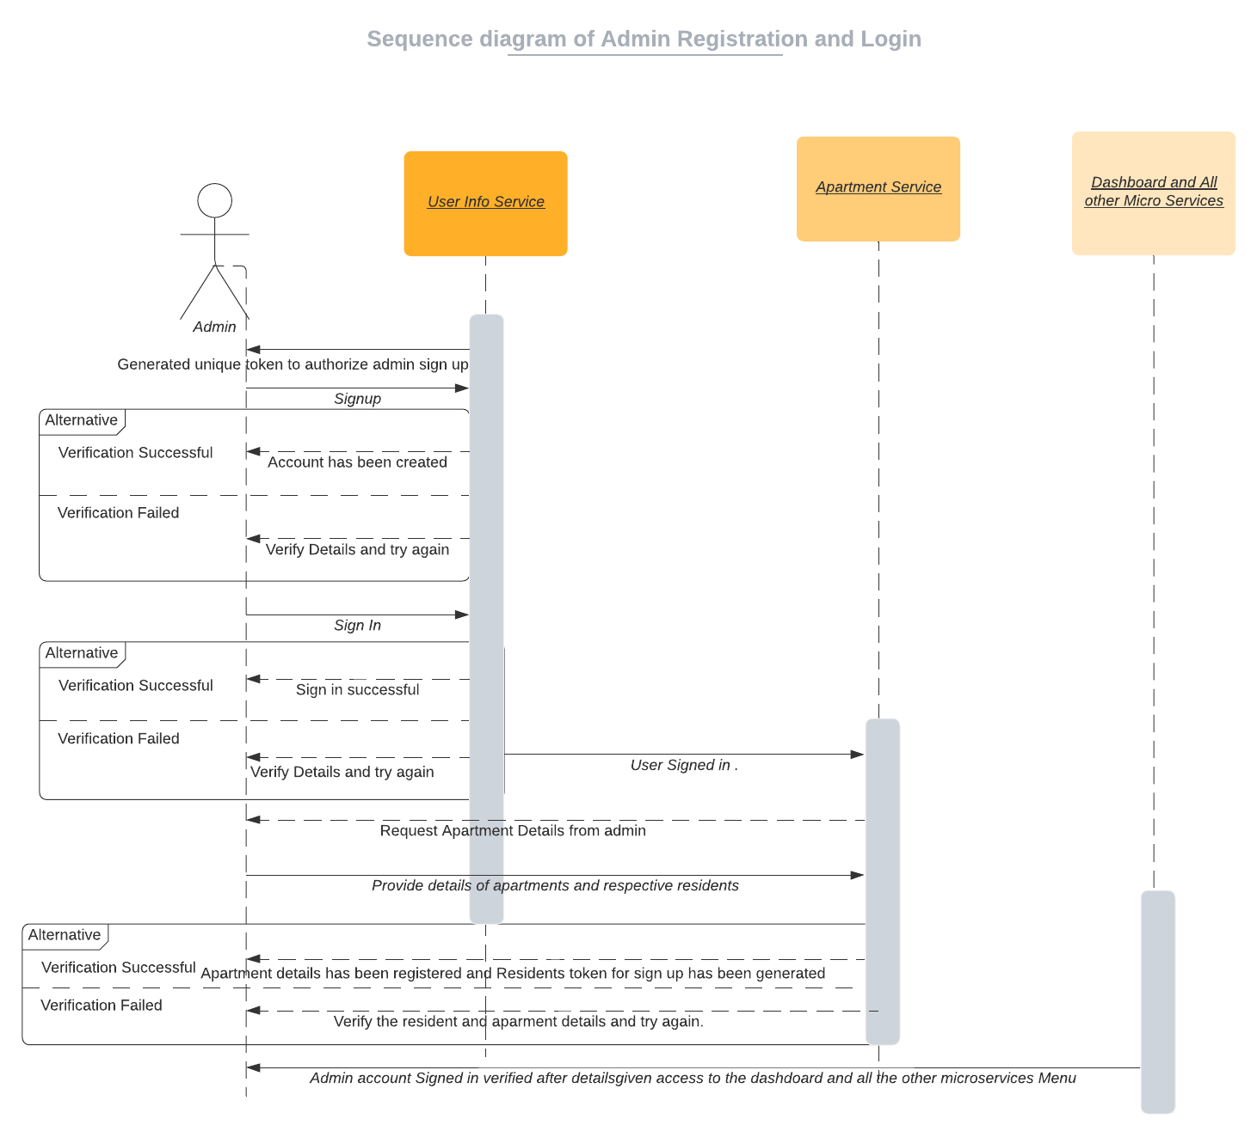

## **5.2.1 Registration**

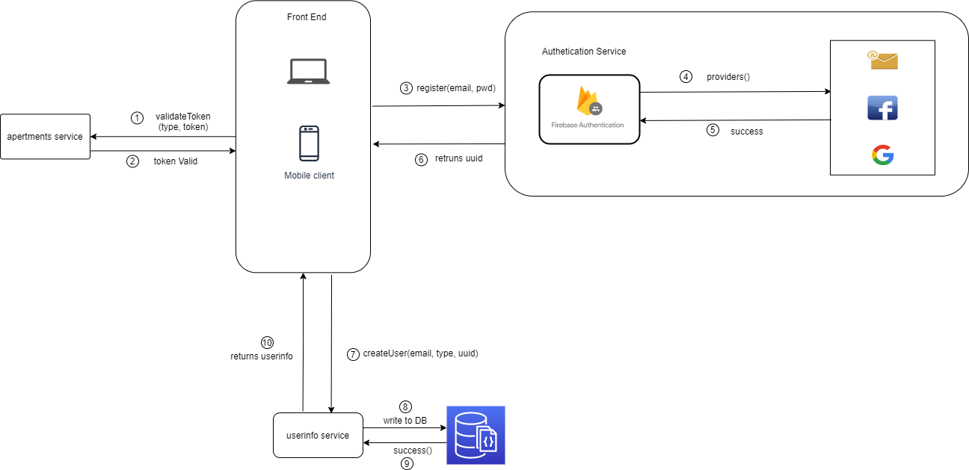

* 1. Validate given token by connecting with apartment service
  2. Application invokes register method with type of registration (gmail, facebook, email/password), he prefers. Based on the request received from client, firebase authentication service registers users and return user details (along with unique UUID).
  3. Once uuid received from firebase, createuser calls would be made to userinfo service to store user details like email address, uuid, etc..

Other details like name, phone number, blood group while resident/admin setup profile.

## **5.2.2 Login**

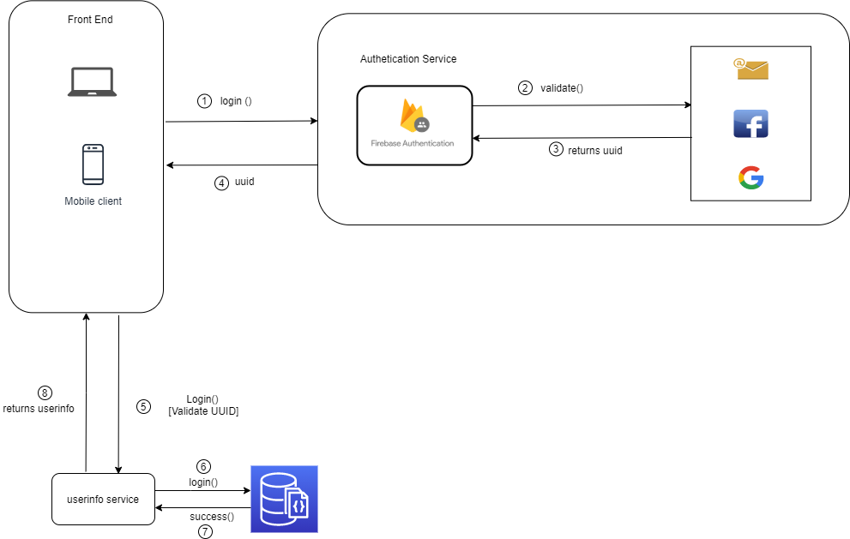

During login service call, firebase returns uuid, if user is registered already. This uuid would be compared with uuid present in userinfo collection with the help of userinfo service for vertification.

## **5.3 Notification Service**

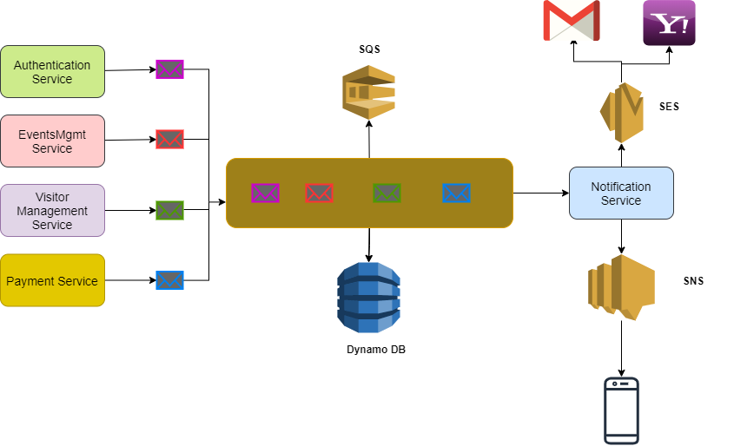

Email notification service is created using AWS-serverless method. SQS (Simple Queue Service), SES (Simple Email Service), Dynamo DB is used.

**SQS (Simple Queue Service):** Generated email message is sent to SQS queue and details are recorded in Dynamo DB. sendMail – POST API is called for this purpose. This endpoint is created by AWS gateway.

**SES (Simple Email Service) :** Notification service listens SQS using ‘receiveMail’ handler and generate email message. This generated email message sent to corresponding receipts. Any reminder mail which needs to be send, this service will take care of it.

**SNS (Simple Notification Service):** SNS service is used for sending message to resident’s mobile numbers. Using Amazon SNS topics, publisher systems can fanout messages to a large number of subscriber systems including Amazon SQS queues, AWS Lambda functions and HTTPS endpoints

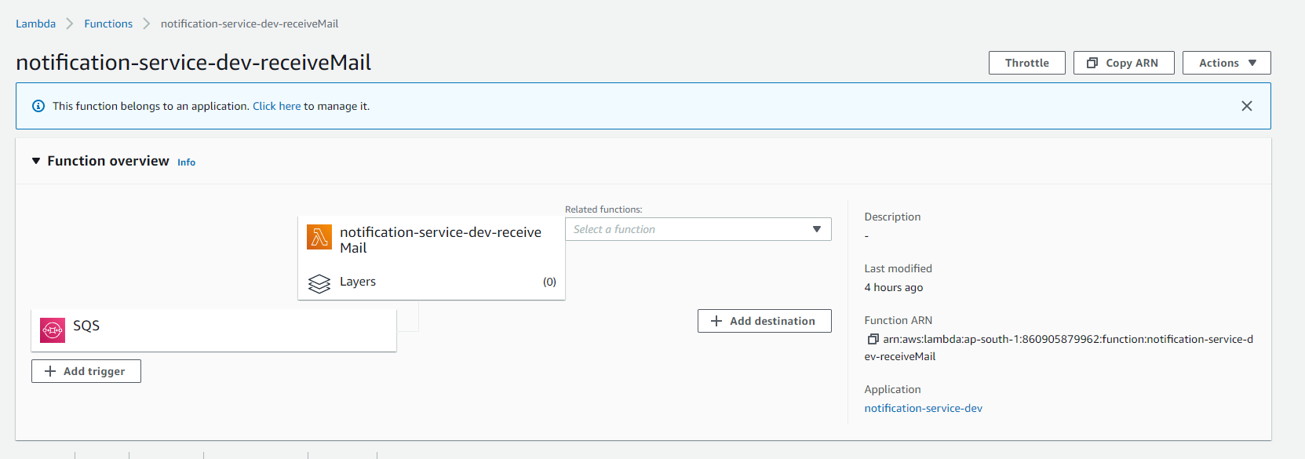

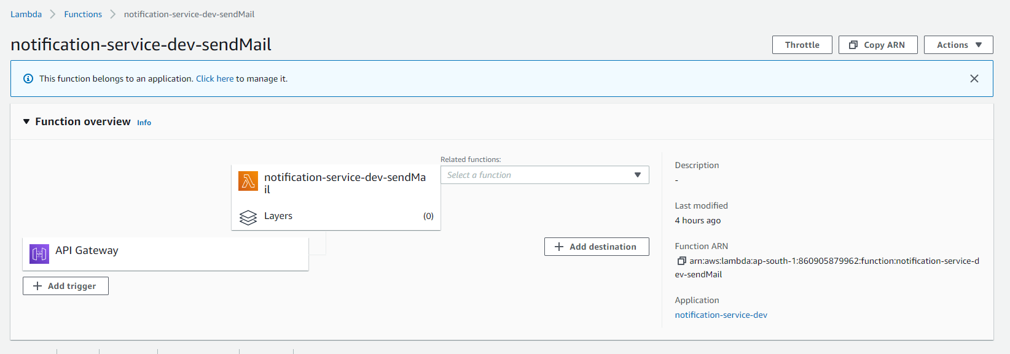

# **6. Deployment Plan:**

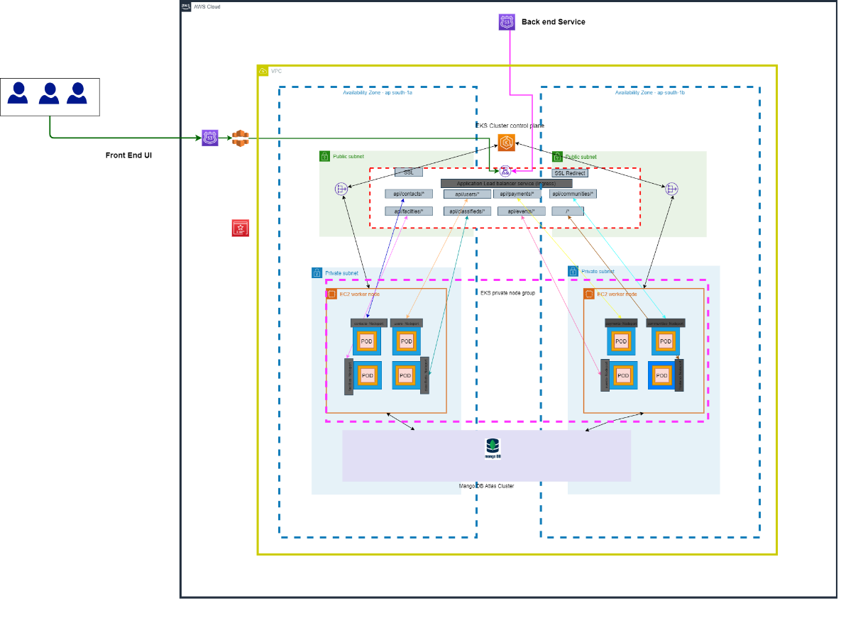

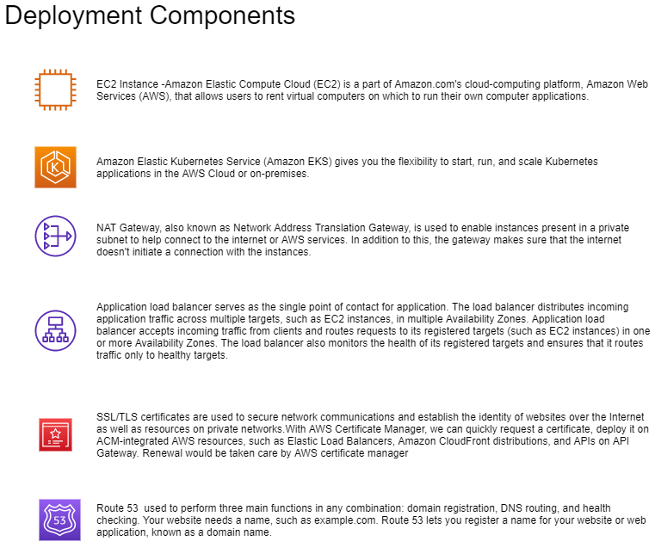

Below AWS infrastructure used for deployment,

* AWS Resources
* VPC
* Internet Gateway (IGW)
* Security Groups, Route Tables and Route Table Associations
* IAM roles, Instance profiles and Policies
* An EKS Cluster
* Autoscaling group and Launch Configuration
* EKS Worker Nodes
* ALB Ingress
* The ConfigMap required to register Nodes with EKS
* KUBECONFIG file to authenticate kubectl using the heptio authenticator aws
* binary
* Elastic Beanstalk
* MongoDB in Atlas
* Jenkins in EC2 instance
* IAM user for accessing the resources
* CloudFront

Refer attached document for step by step procedures to deploy front end & backend in AWS.



## **6.1 CICD Pipeline:**

### **6.1.1 CICD pipeline for microservices:**

Microservices are deployed to EKS using AWS codepipeline

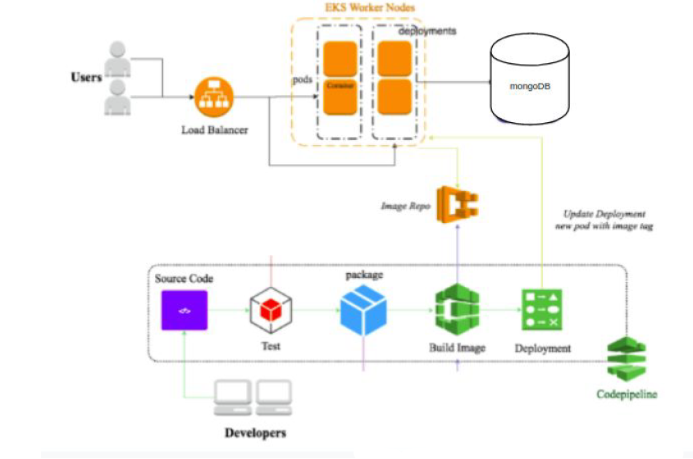

Steps involved,



* 1. User/developer pushed the code in git.
  2. “AWS Code Build “ tests microservice, It runs automation testcases
  3. When testcases passes, Docker image is created and pushed to ECR.
  4. EKS updates the deployment Pods (groups of one or more Docker containers with shared storage/network) using a rolling update strategy by picking the images from Elastic Container Registry automatically.

### **6.1.2 CICD pipeline for Frontend:**

Below jenkin pipeline used for deployment of ‘React JS front end’ code in AWS EC2 instance.

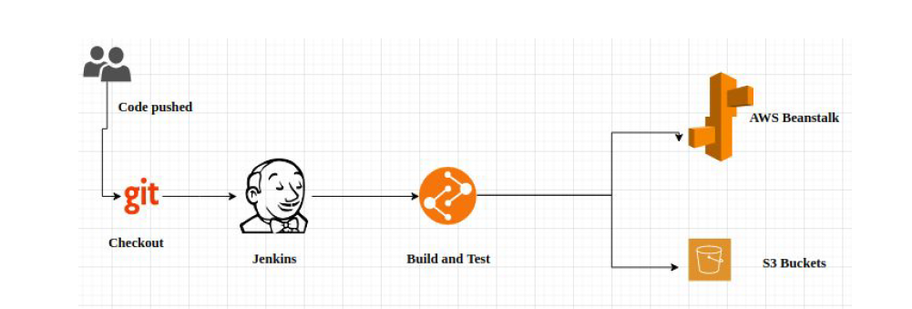

Steps involved,



* 1. User/developer pushed the code in git.
  2. Jenkin performs build& test,
     + 2.1 It runs automation testcases
     + 2.2 When testcases passes, application would be built
  3. Build would be pushed to S3 and build is taken by beanstack from S3
  4. Elastic Beanstalk will deploy the application and manage the application so that there is a very less down time. Load balancer attached with Beanstalk provides autoscaling and make sure the application is running properly and if there is high traffic load then it will spin up a new instance to balance the traffic

# **7.Data Model**

Non-SQL databases are used for this project , as this application involves images, videos on various phases.

Below Non-SQL databases are used in this project

* 1. DynamoDB – Used by notification service, to store notification messages
  2. Firebase live database – This database will be used for chatroom service.
  3. Atlas MangoDB: All other services use mango DB for storing their data.

Please do refer below schema diagrams,

## **7.1 CommunityInfo & Apartment Info Collection:**

CommunityInfo and ApartmentInfo collection has complete details of apartments like , address, flats, floors, block, etc..

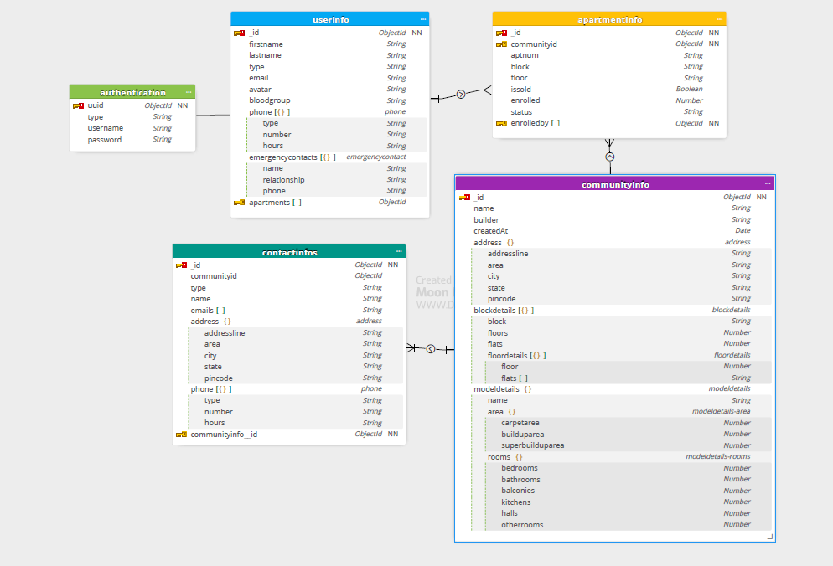

## **7.2 UserInfo Collection**

UserInfo collection holds resident and admin details (role, name, email, phone number, blood group, etc) except credentials details



## **7.3 ContactInfo Collection:**

This service uses contactinfo collection. One document per community id. Community id itself uses id for this collection



## **7.4 AnnouncementInfo Collection:**

Announcement service uses ‘announcementinfo’ collection. It has one to many relationships with userinfo and communityinfo. Multiple announcements can be made by one person and same goes for community.

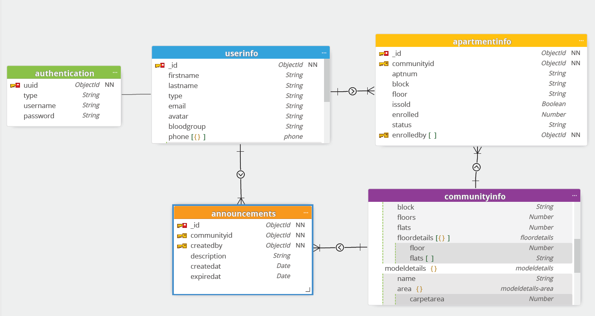

## **7.5 CarpoolingInfo Collection**

Carpollinginfo collection used by carpooling service. It has one to many relationships with userinfo and communityinfo

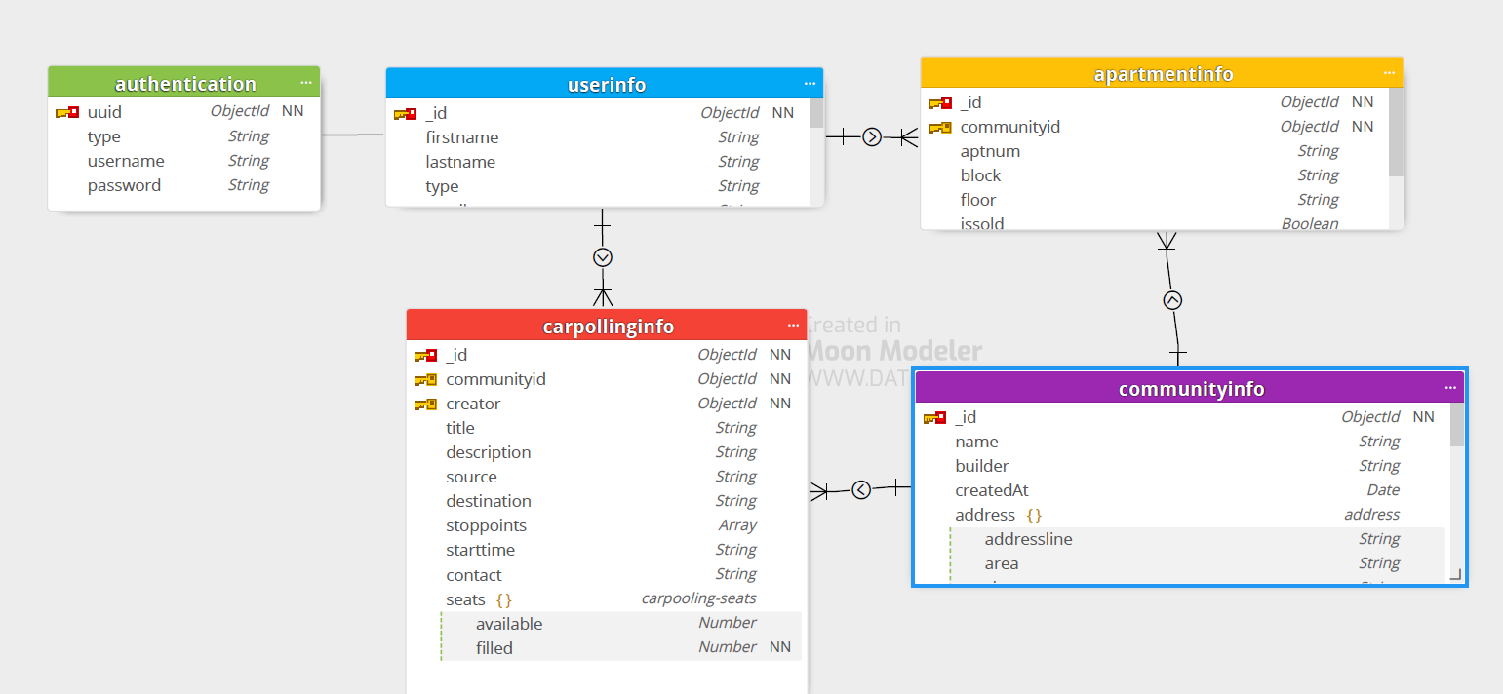

## **7.6 ChatRoomInfo Collection**

**Collections:**

chatroominfo collection – stores chatroom details

chatroom_messageinfo – stores each messages of the chat rooms

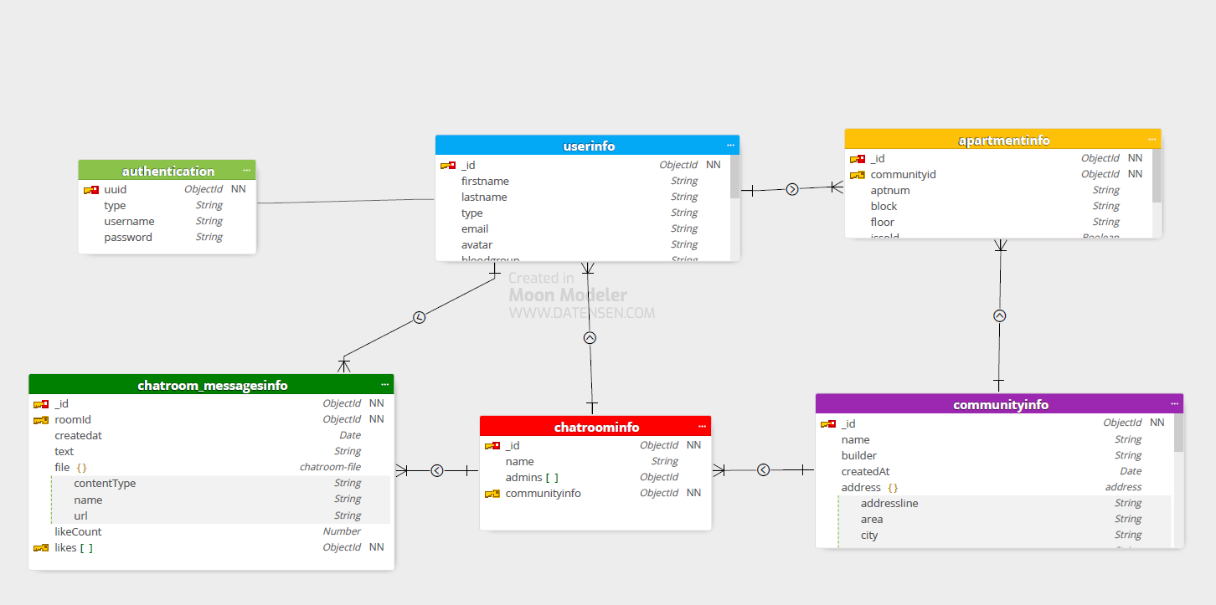

## **7.7 ClassifiedsInfo Collection**

Classifiedsinfo and classifiedscomments collections are used by classifieds service. Classifiedscomments has details of each review comments provided for the classified.

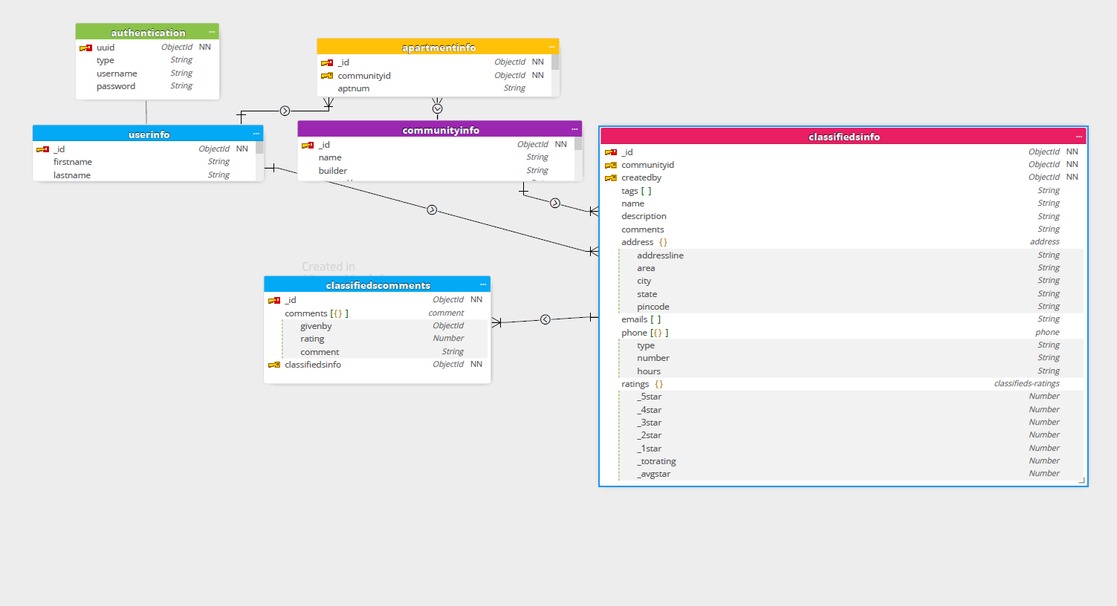

## **7.8. EventsmgmtInfo Collection**

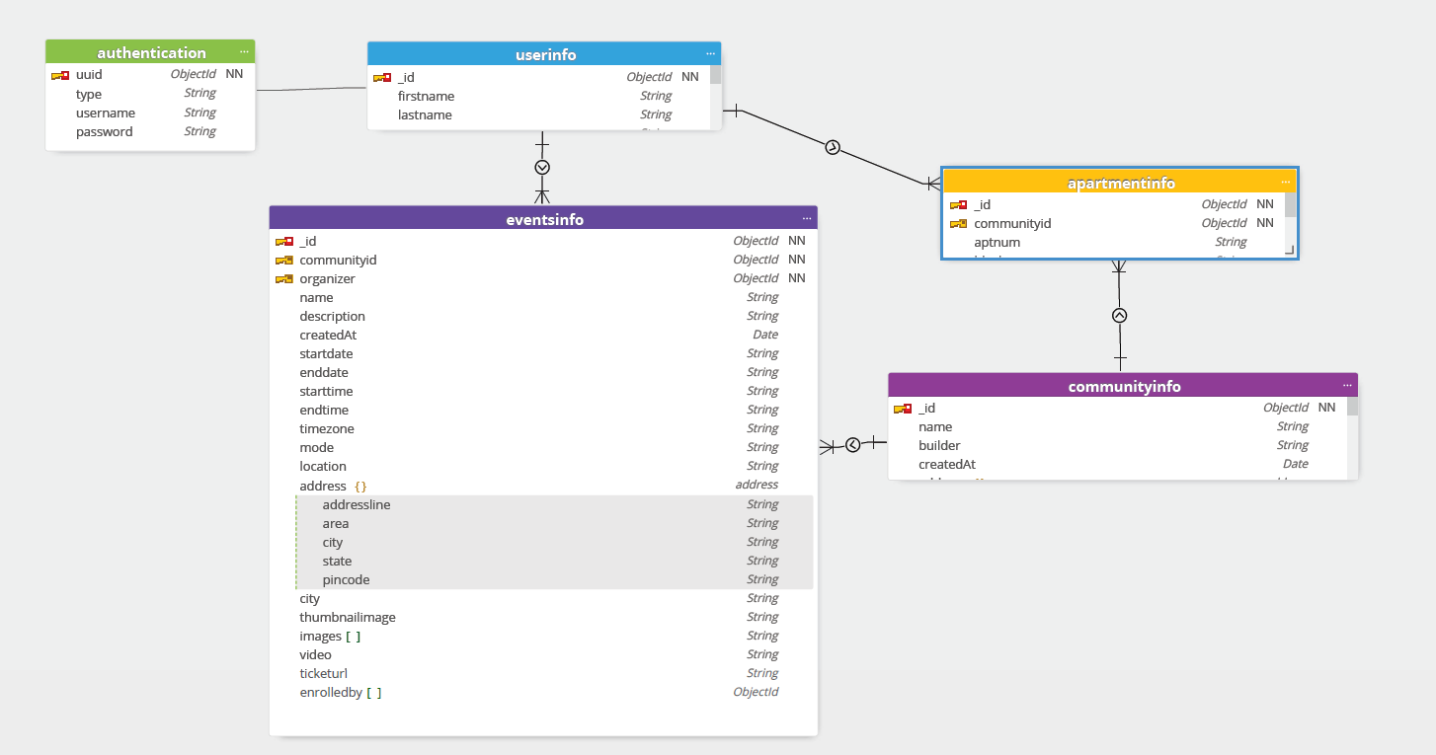

## **7.9 MaintenanceInfo Collection**

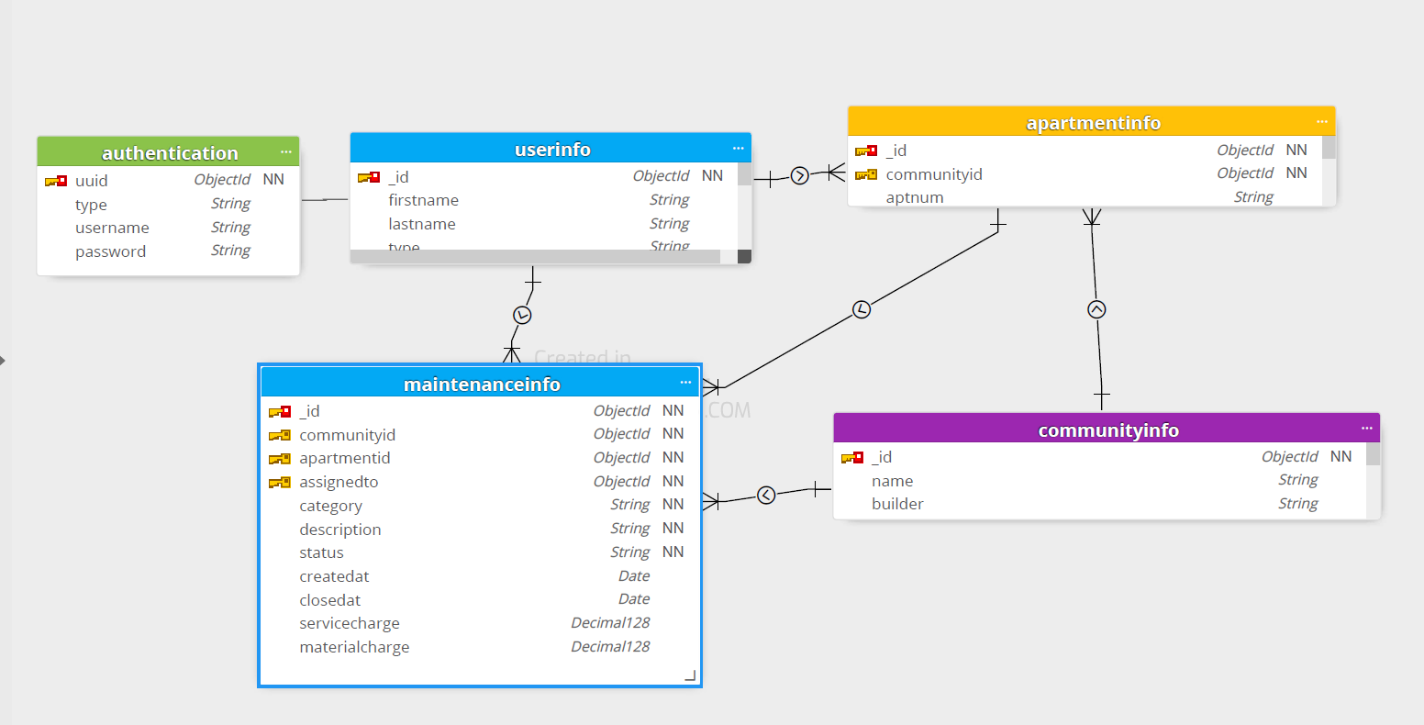

## **7.10. PaymentsInfo Collection**

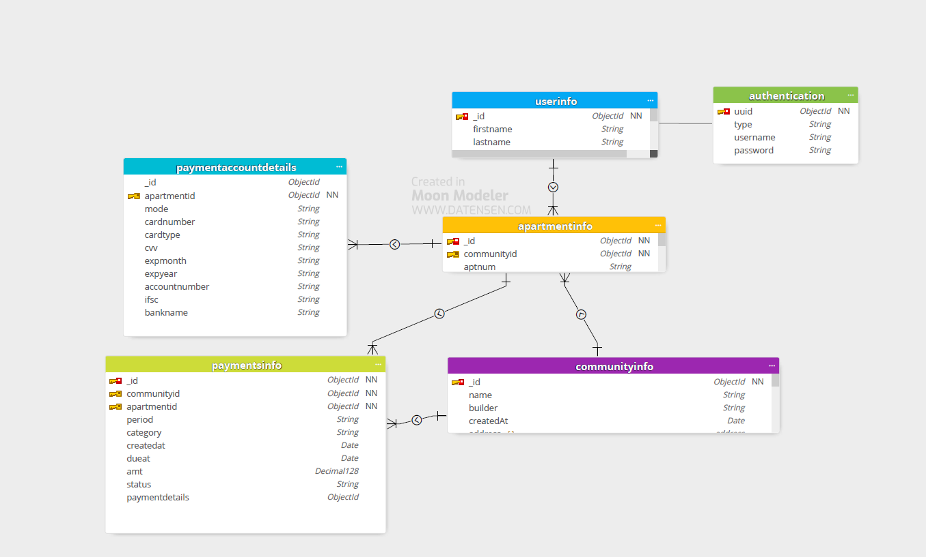

## **7.11. PollingInfo Collection**

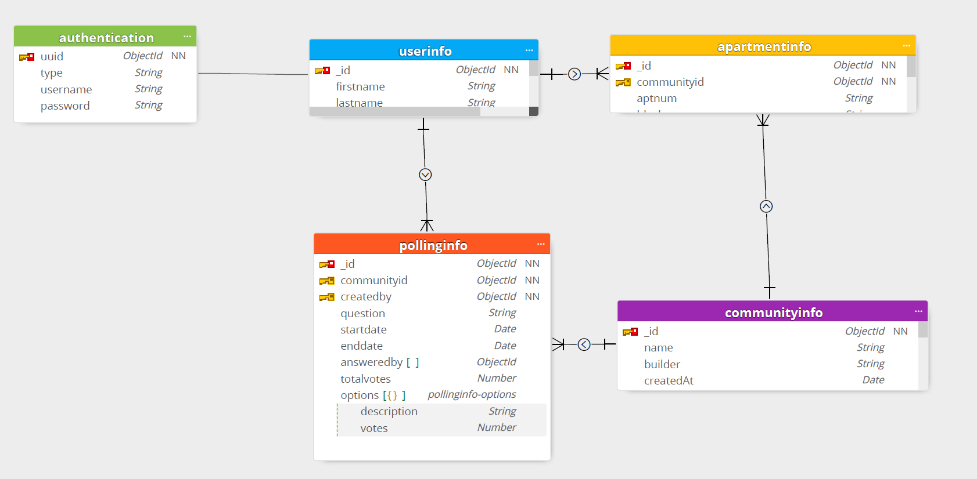

## **7.12. FacilityInfo Collection**

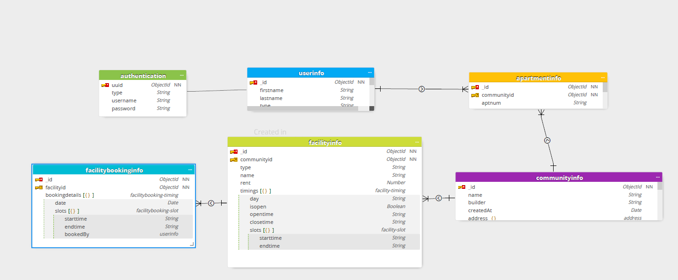

# **8. Prototyping**

## **8.1 Figma – UX/UI Design:**

Using Figma, we have created UI/UX design for our project. We are planning to implement the front end based on UI design shared in Figma

Refer UI designs of complete list of pages in below url (refer ‘ResidentConnect_Desktop’) .

<https://www.figma.com/file/Z41Ggif8PV4WihLU1R0ALS/sample_project?node-id=1112%3A2219>

below is some samples UI design prepared,

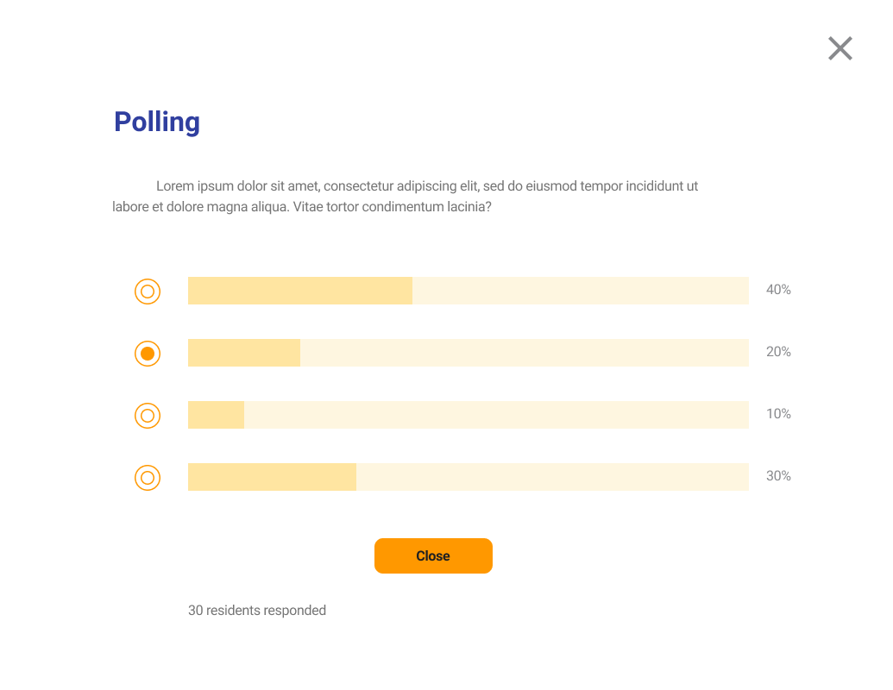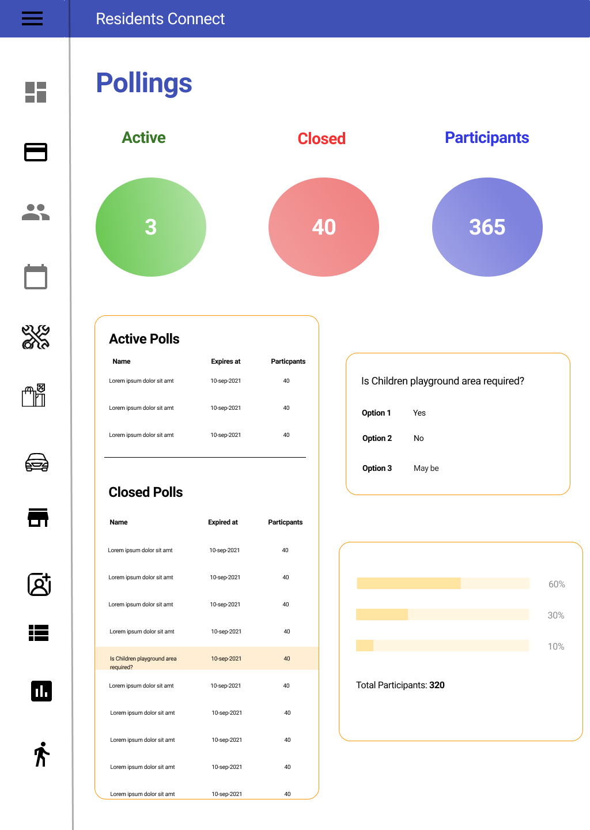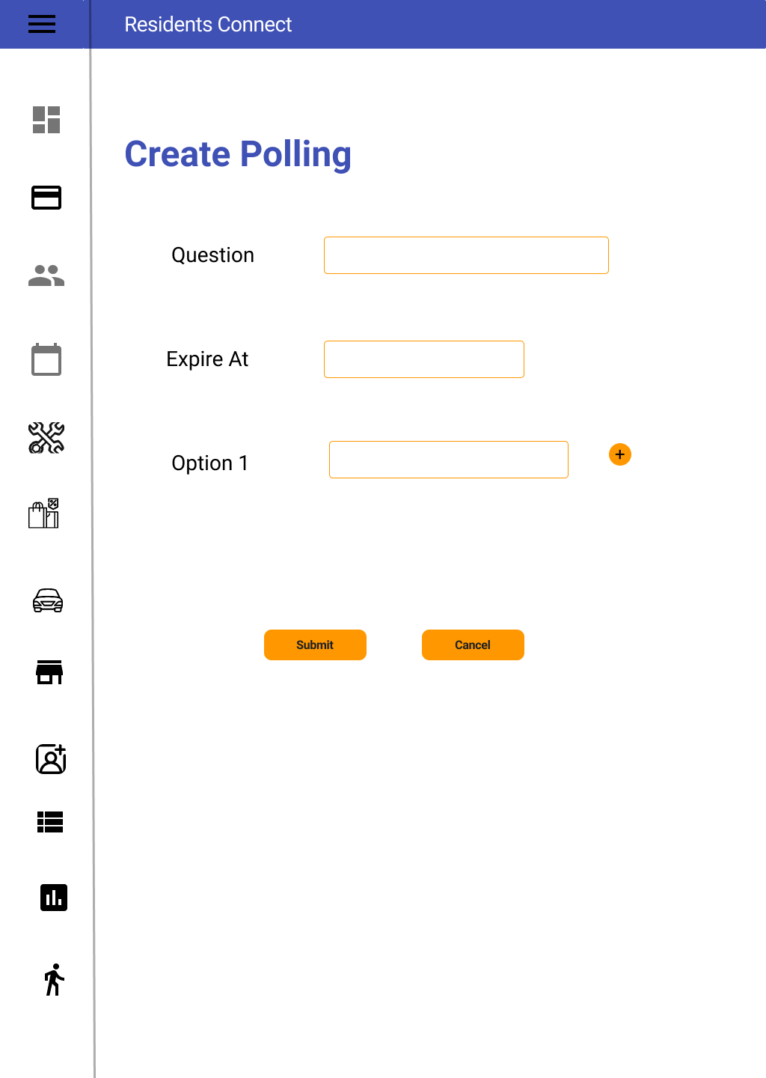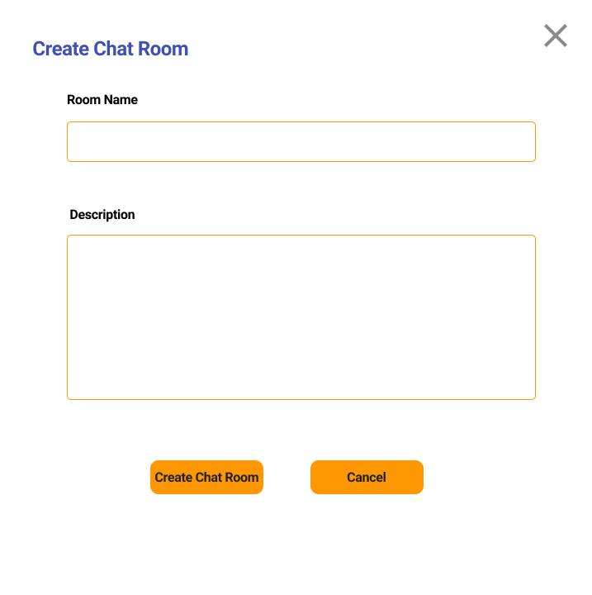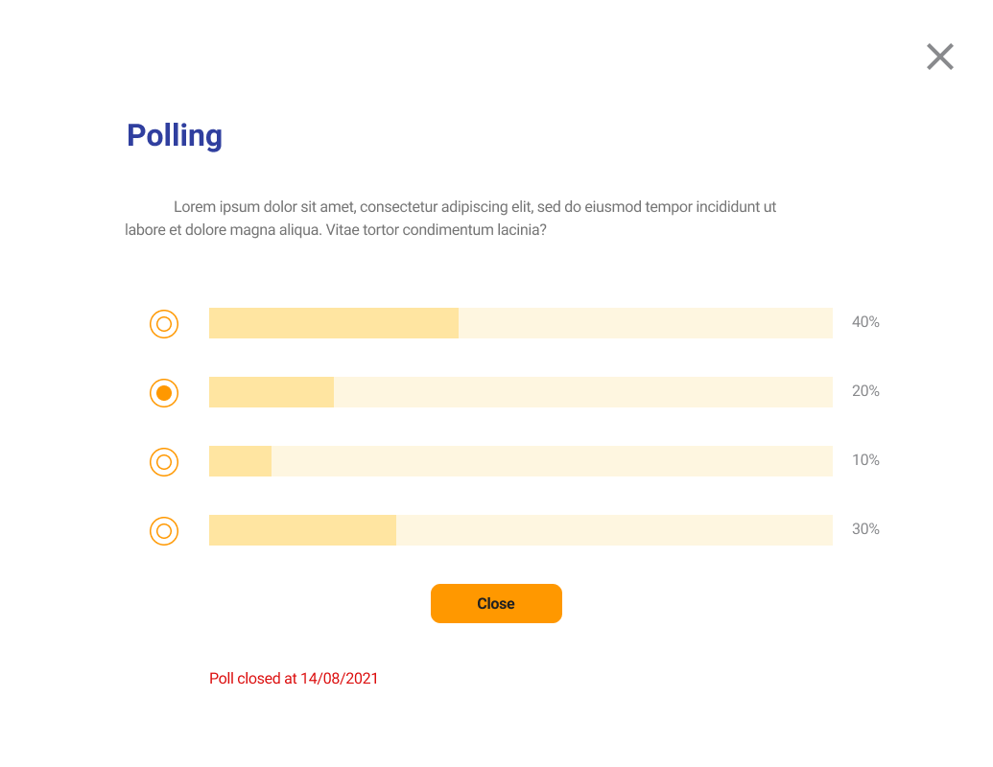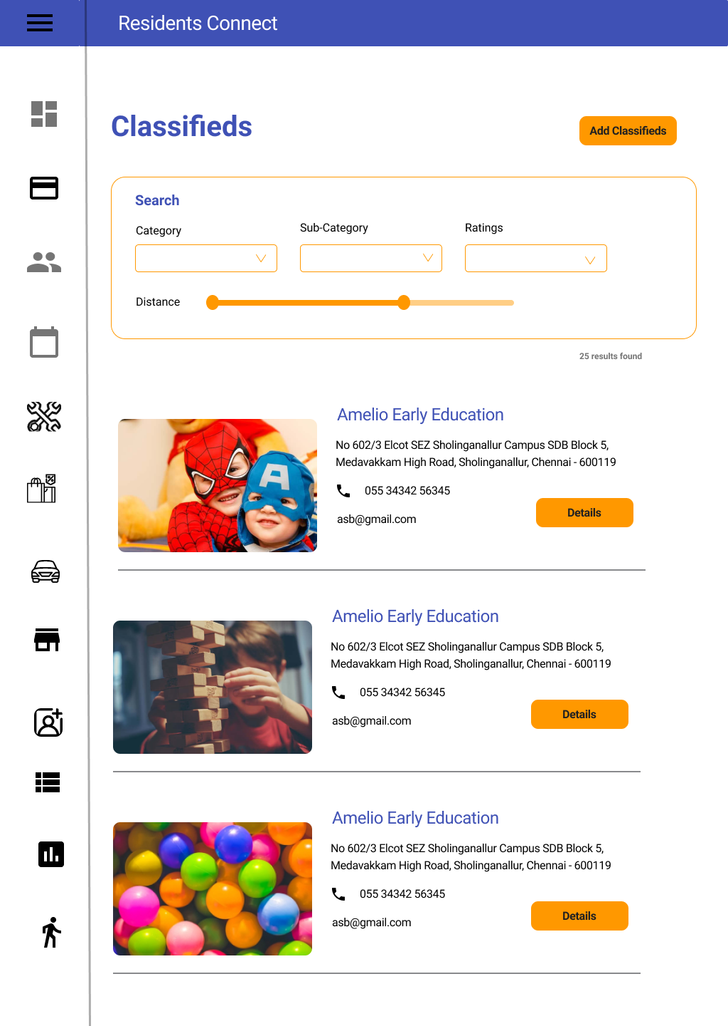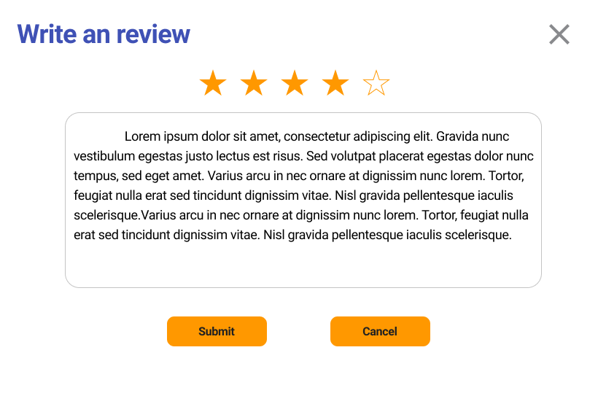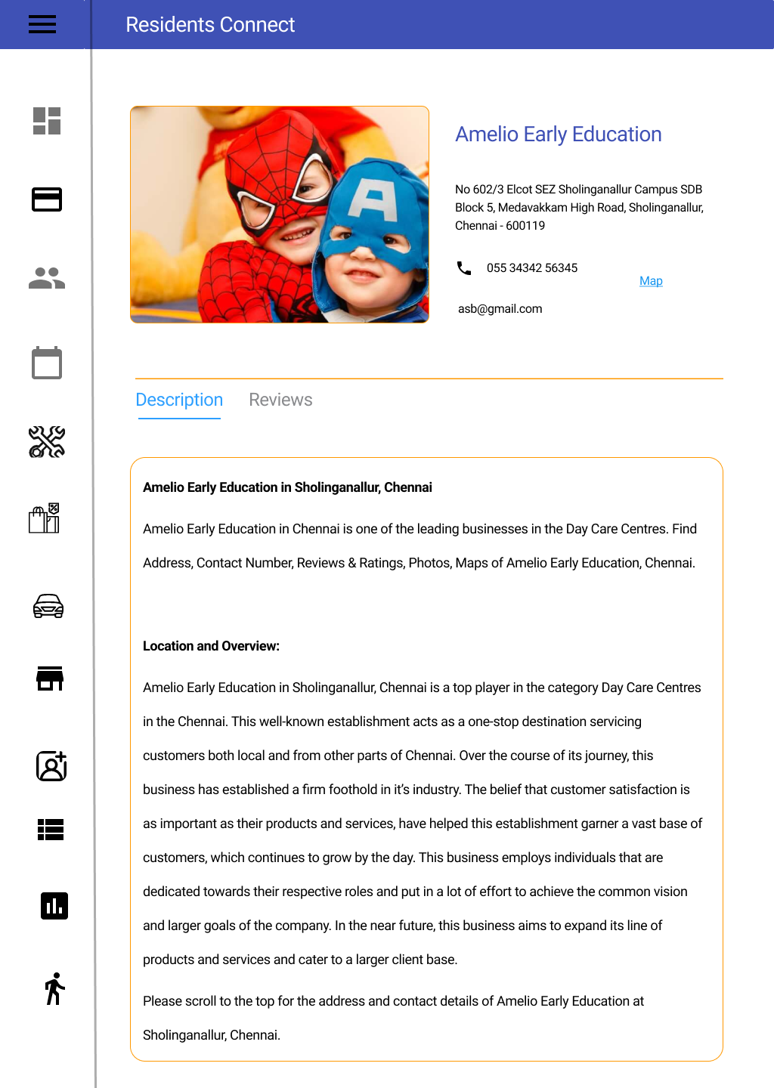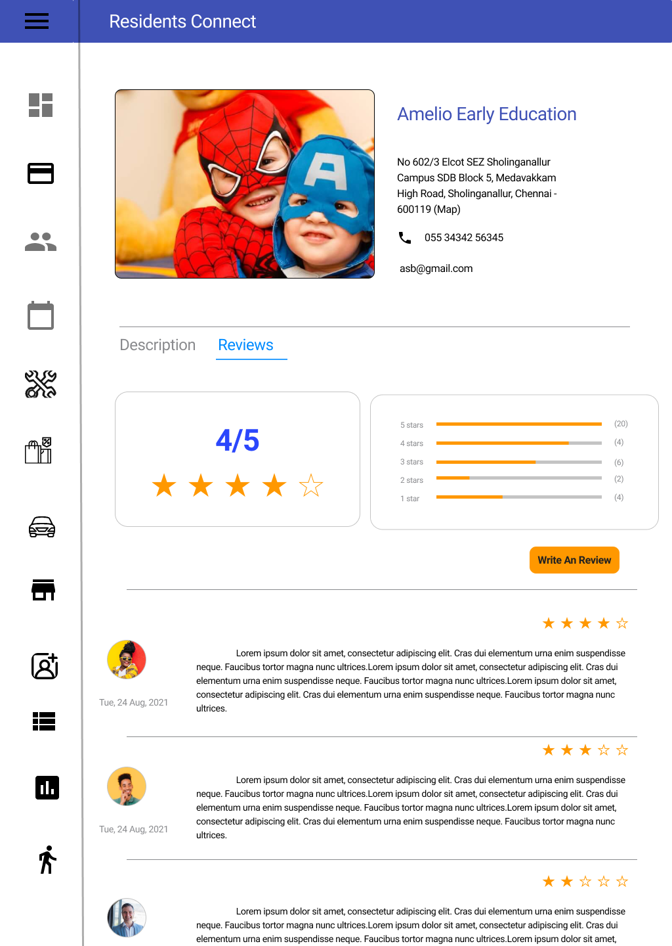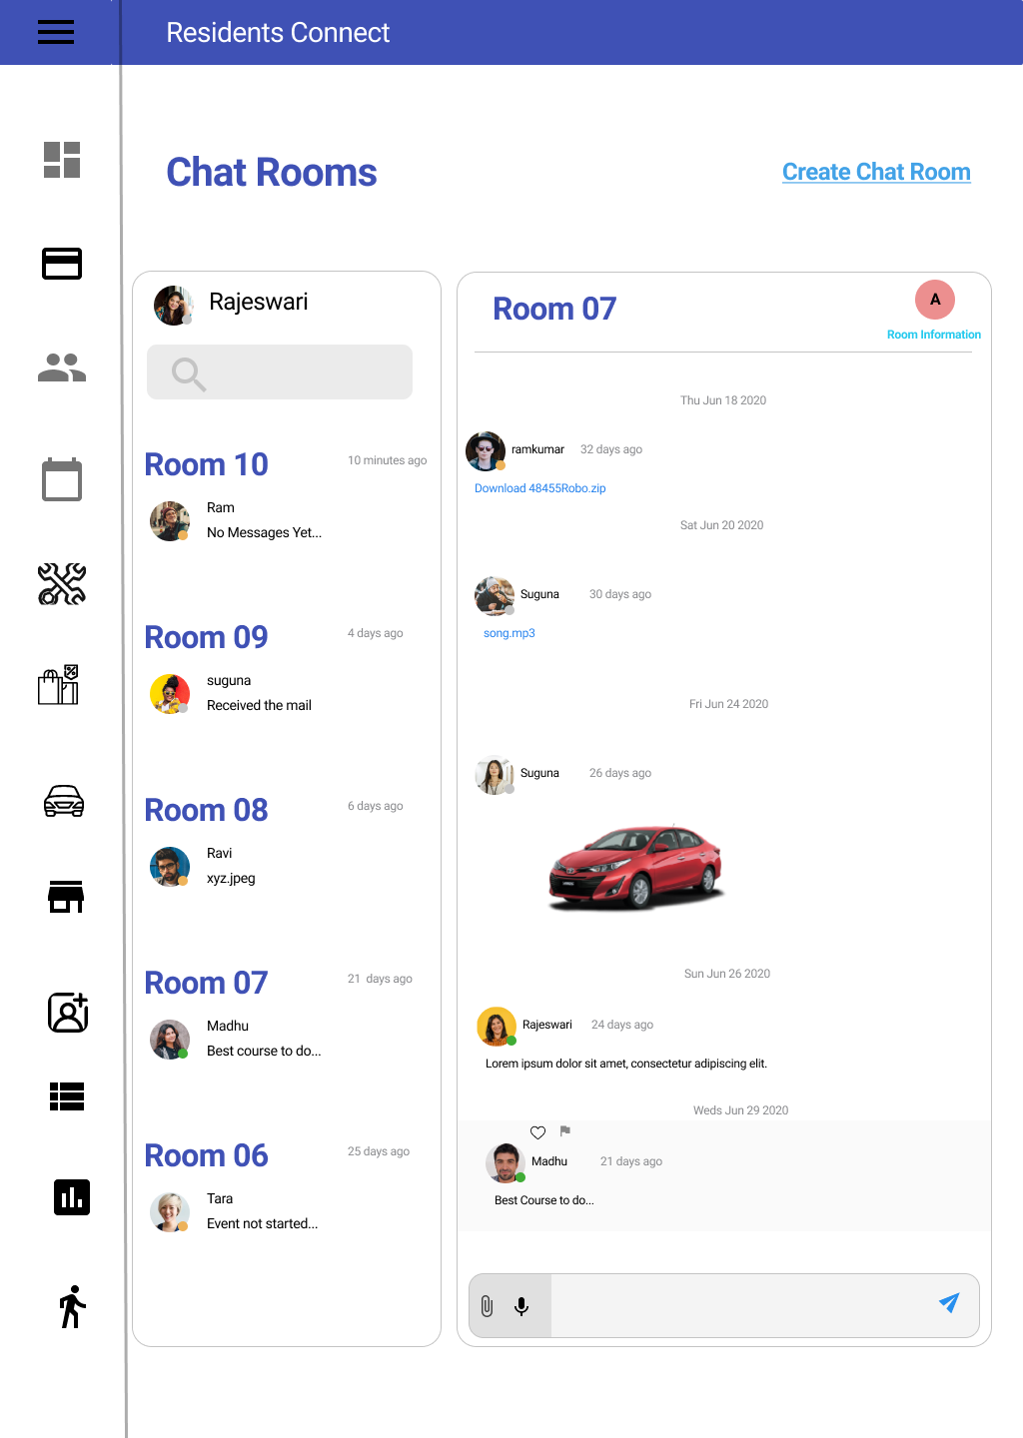

## **8.2 Prototype II (Executable):**

Below components are implemented partially

* 1. Authentication
  2. Profile Setup
  3. Buy and Sell
  4. Chat room

### **8.2.1 Authentication**

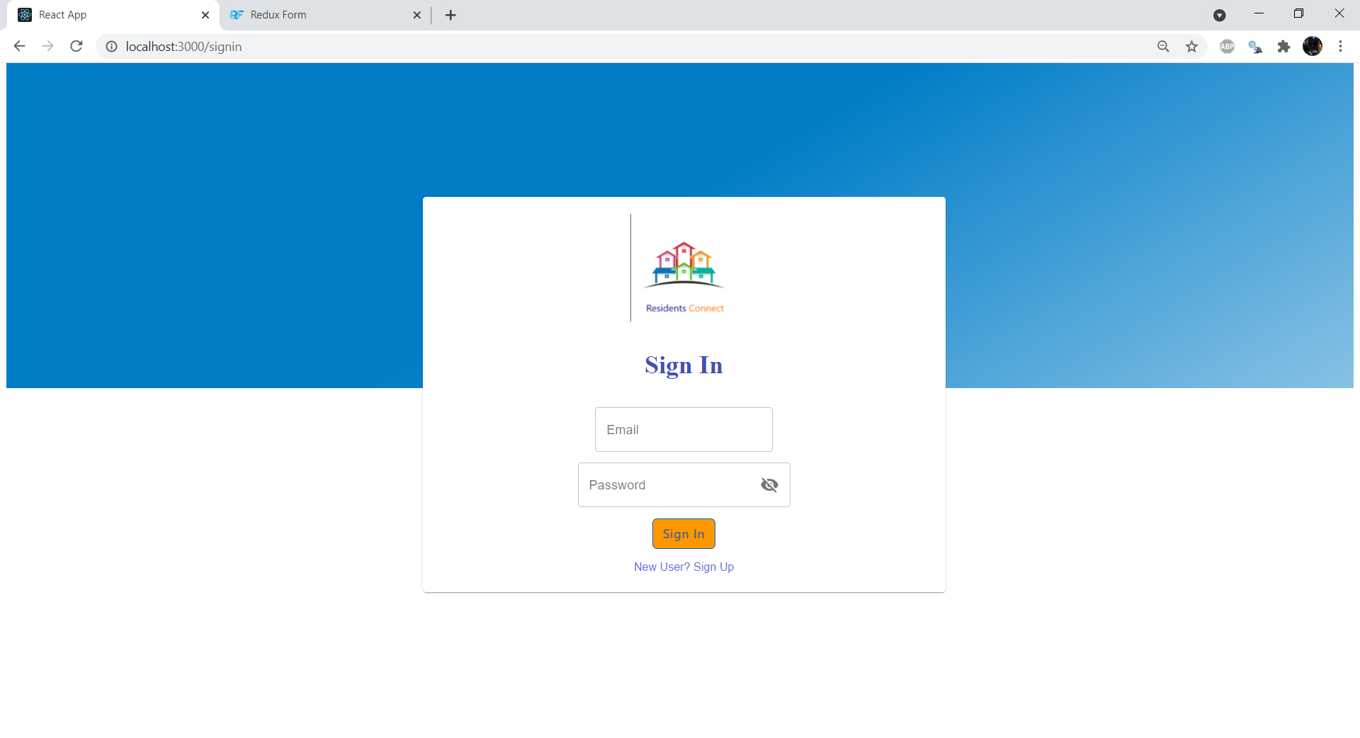

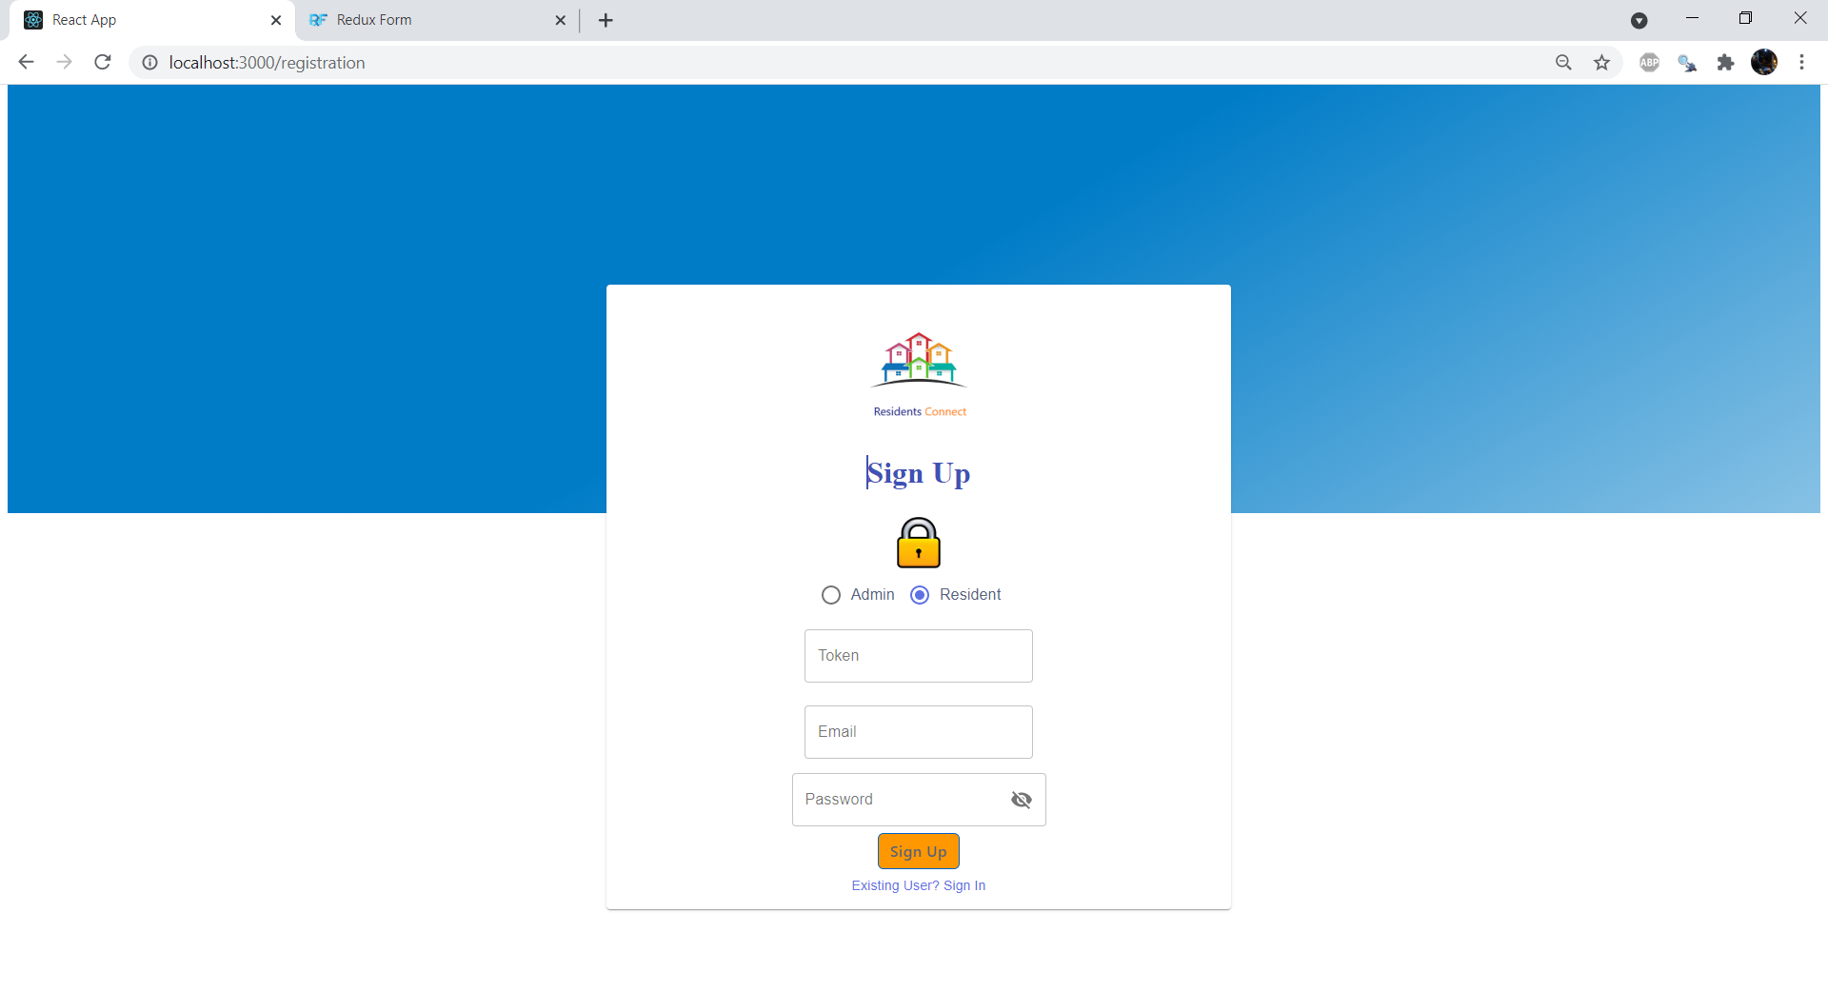

### **8.2.2 Profile Setup**

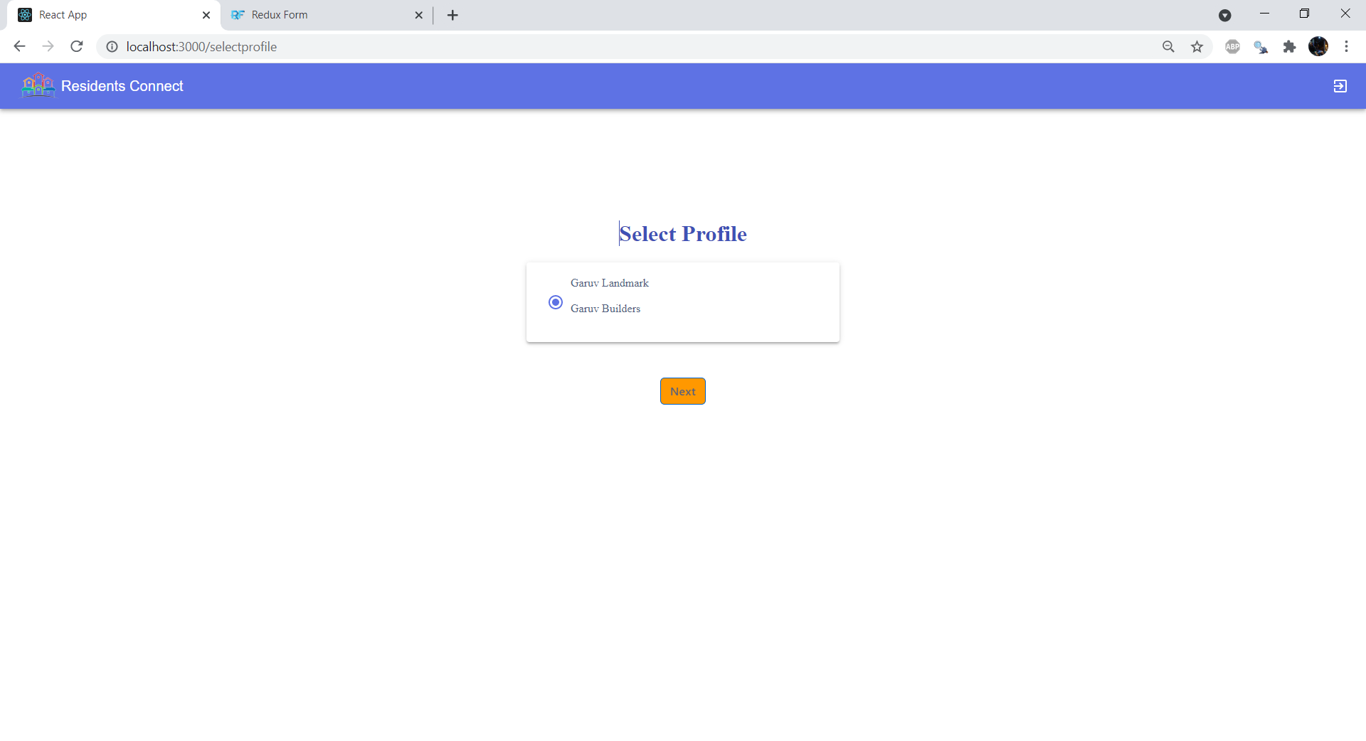

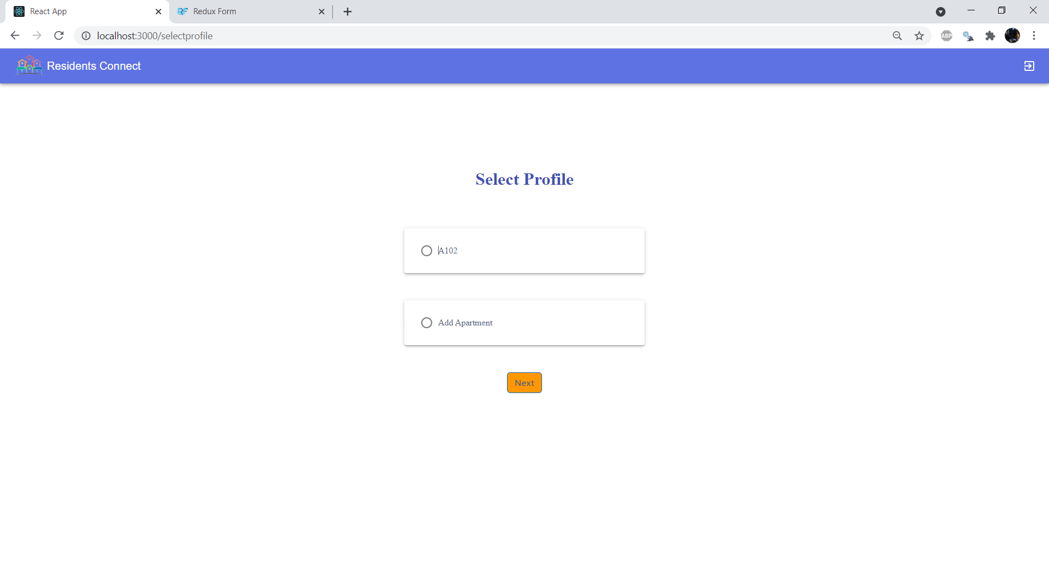

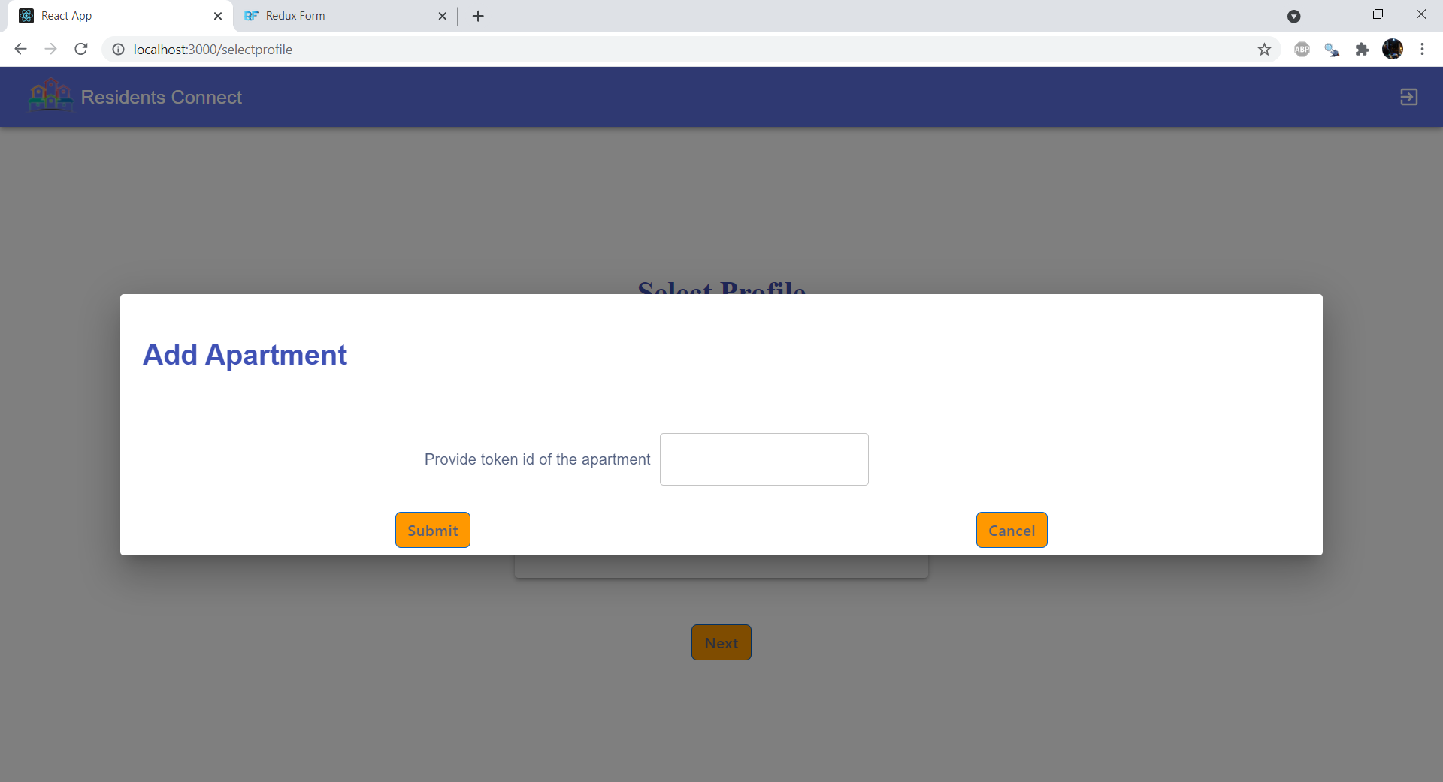

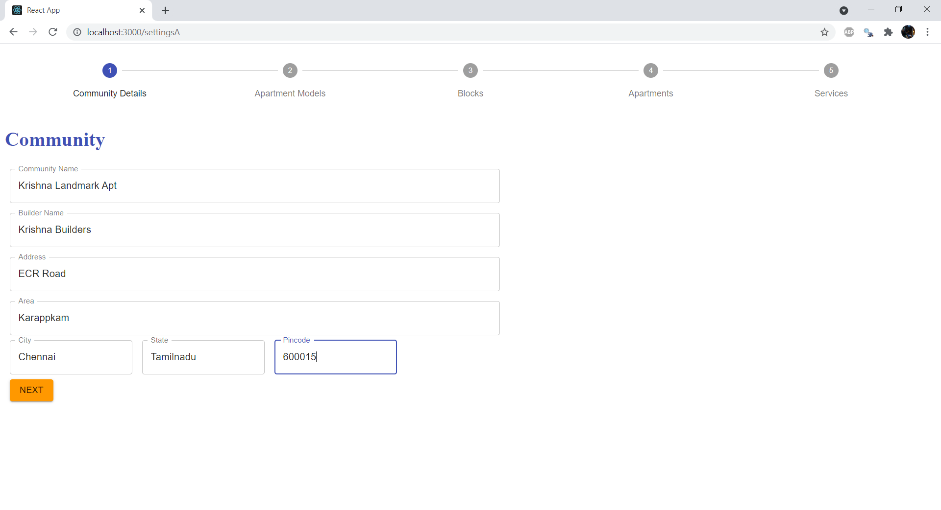

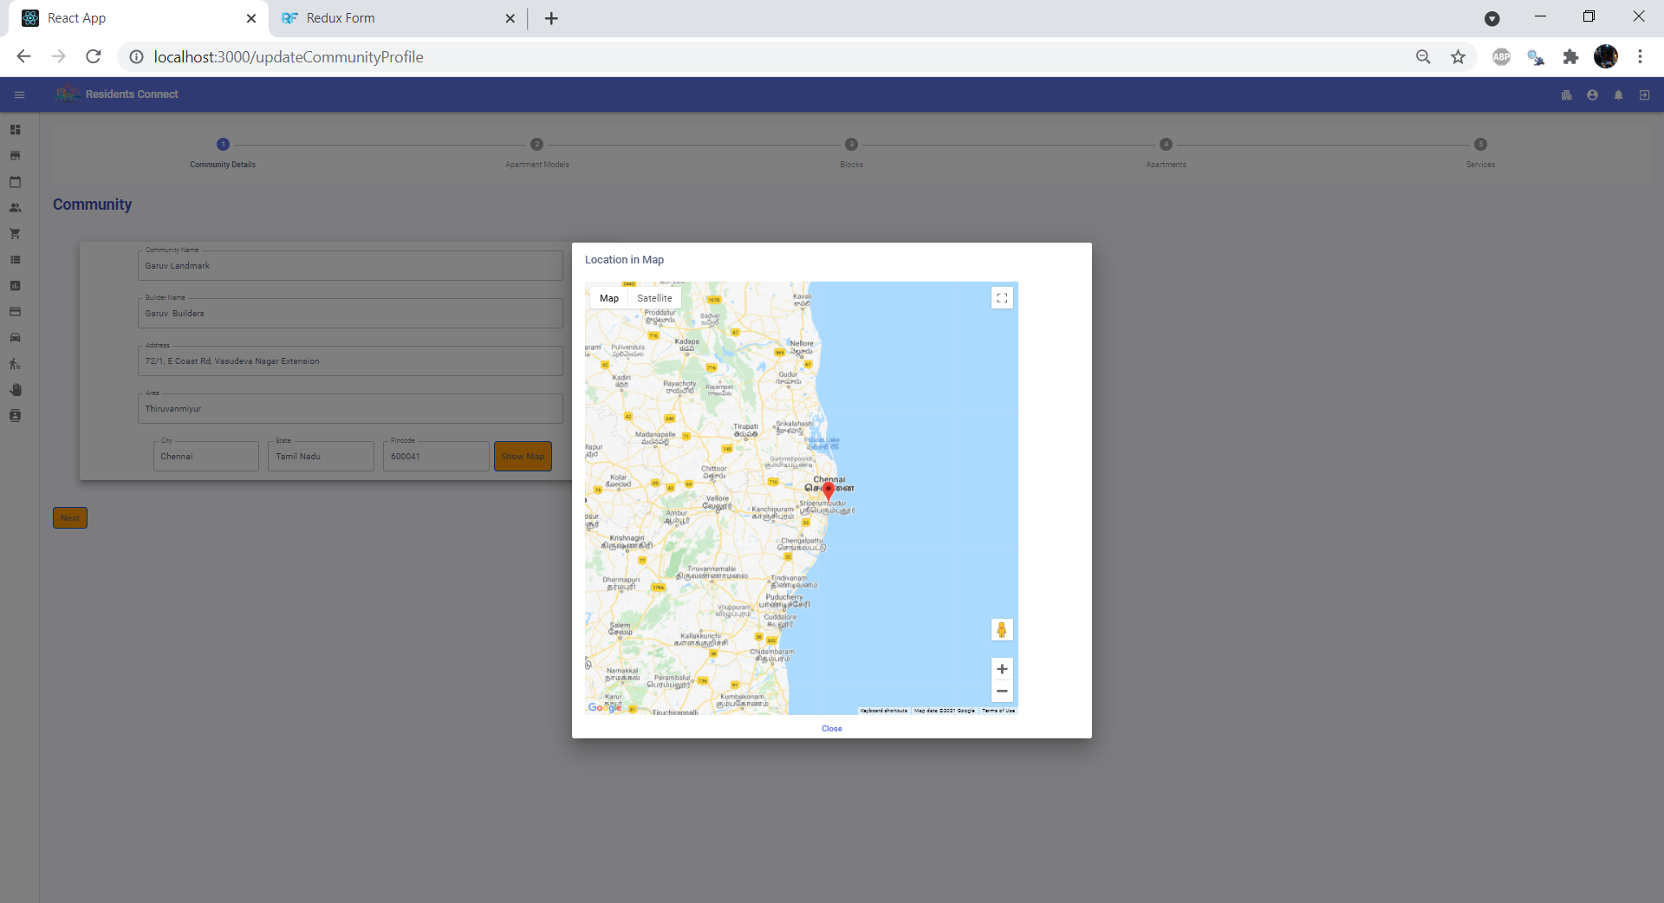

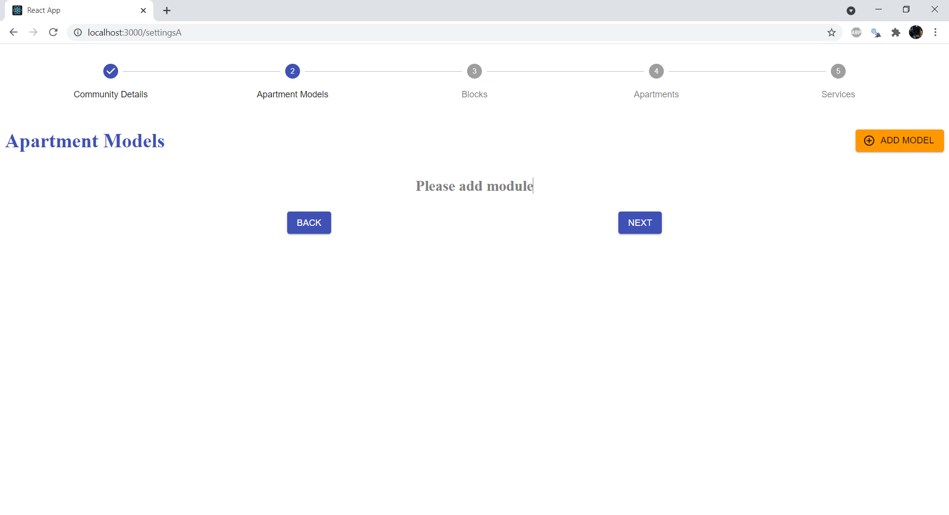

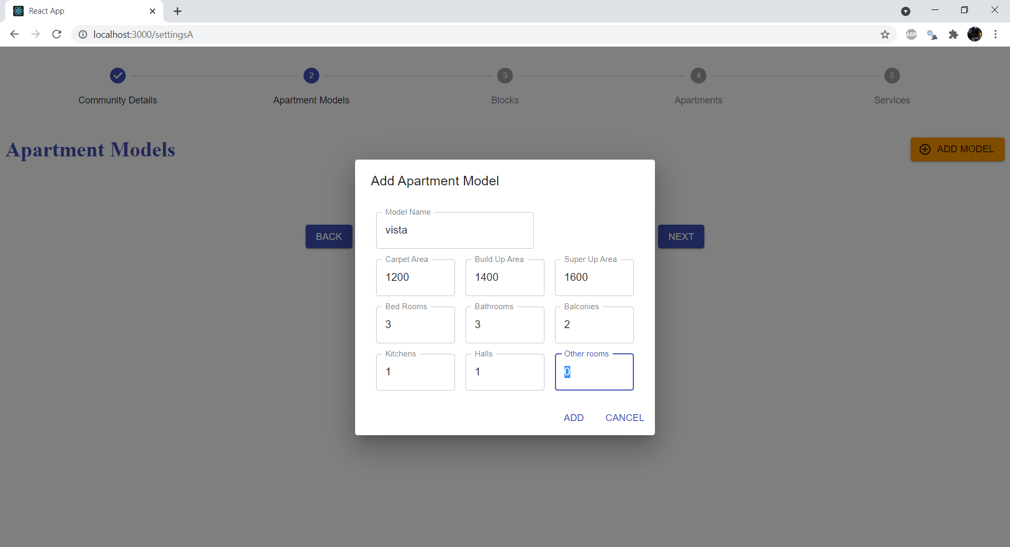

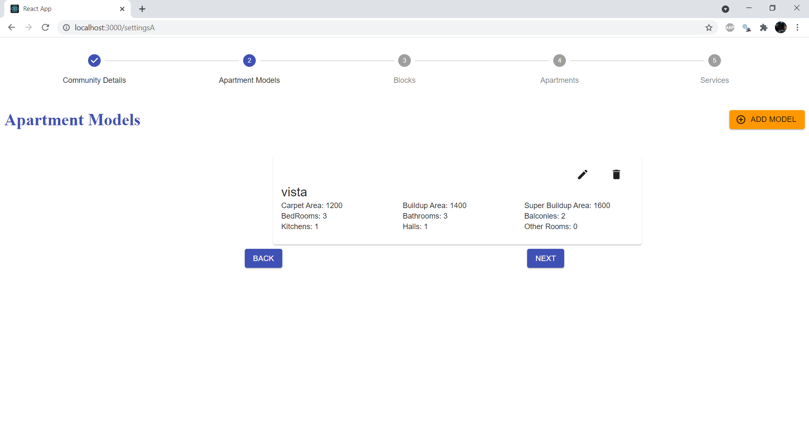

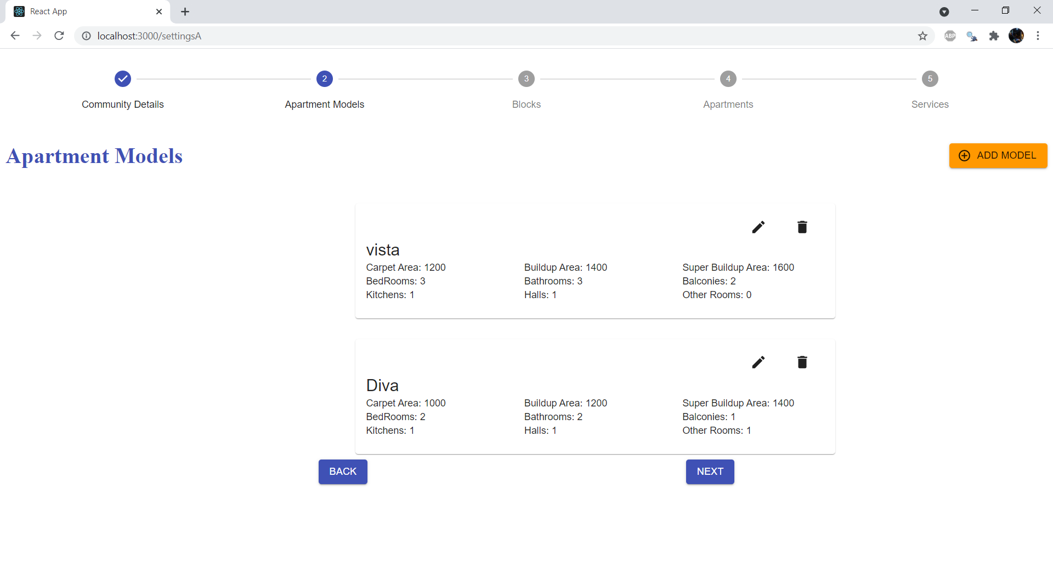

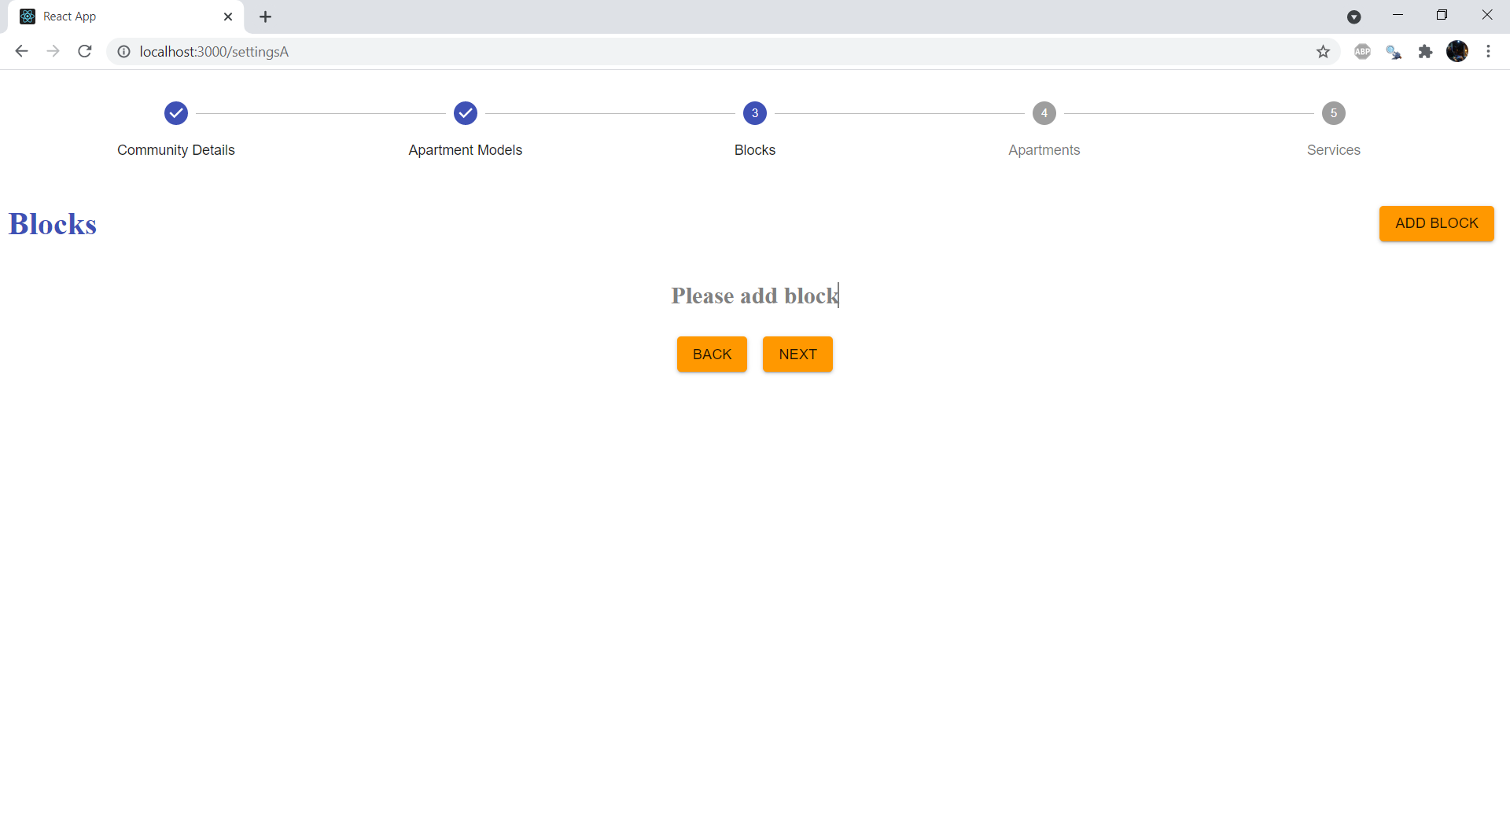

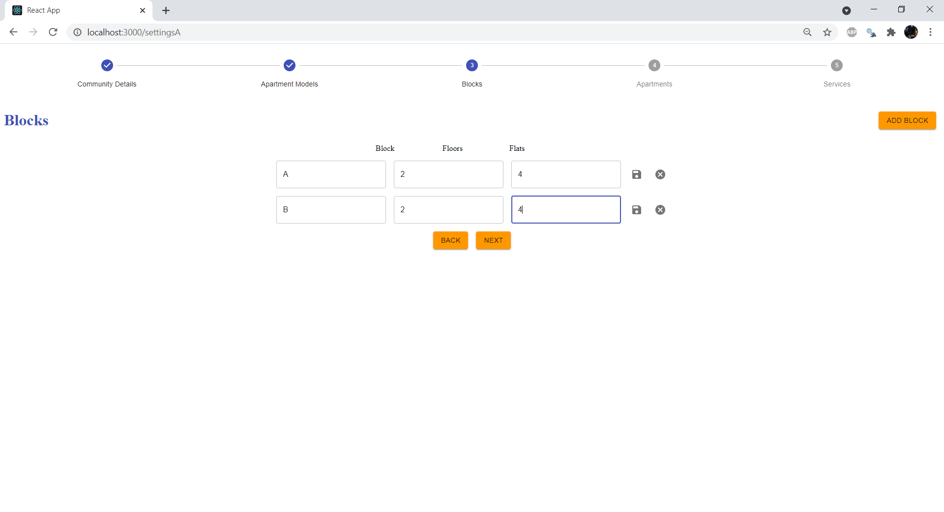

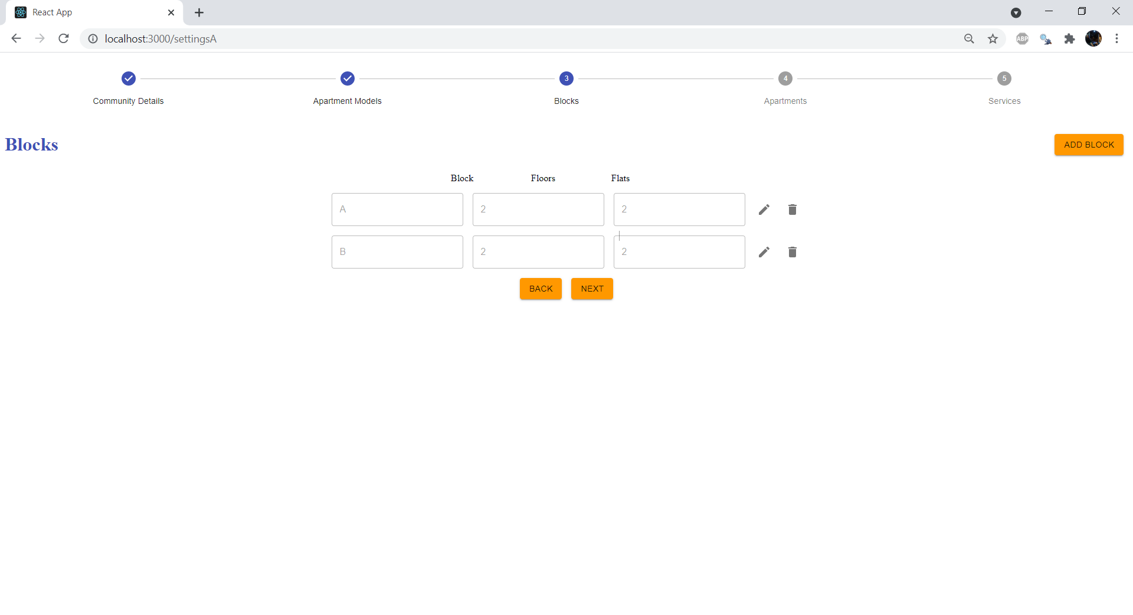

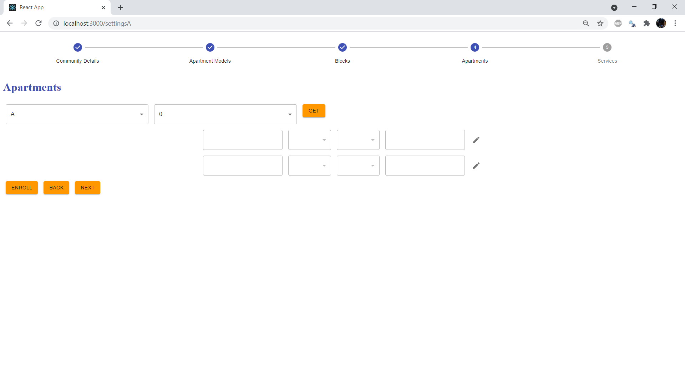

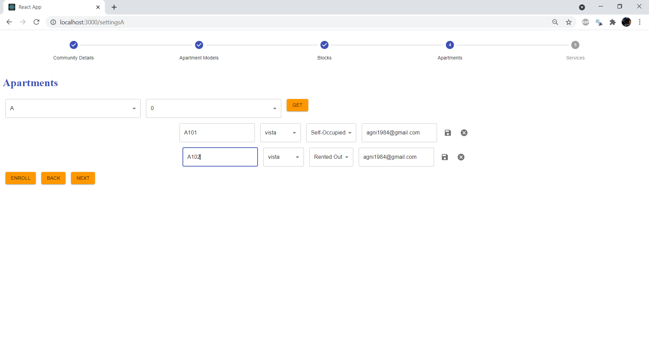

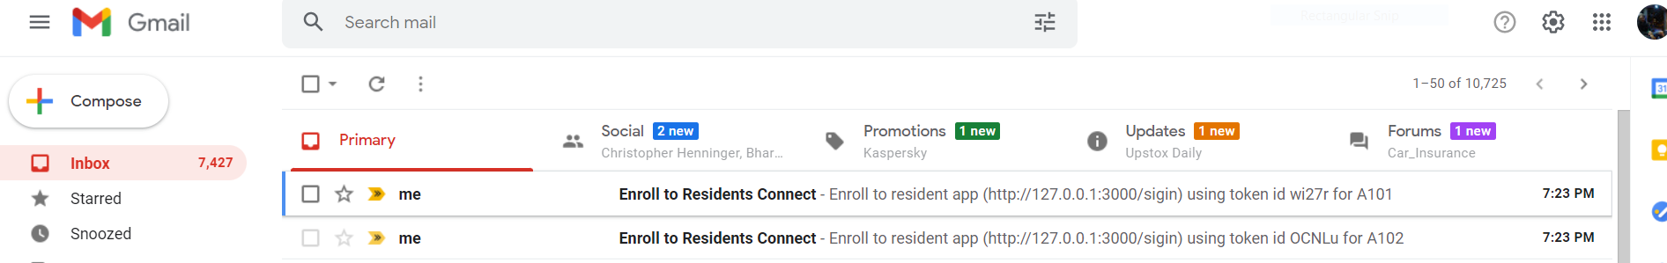

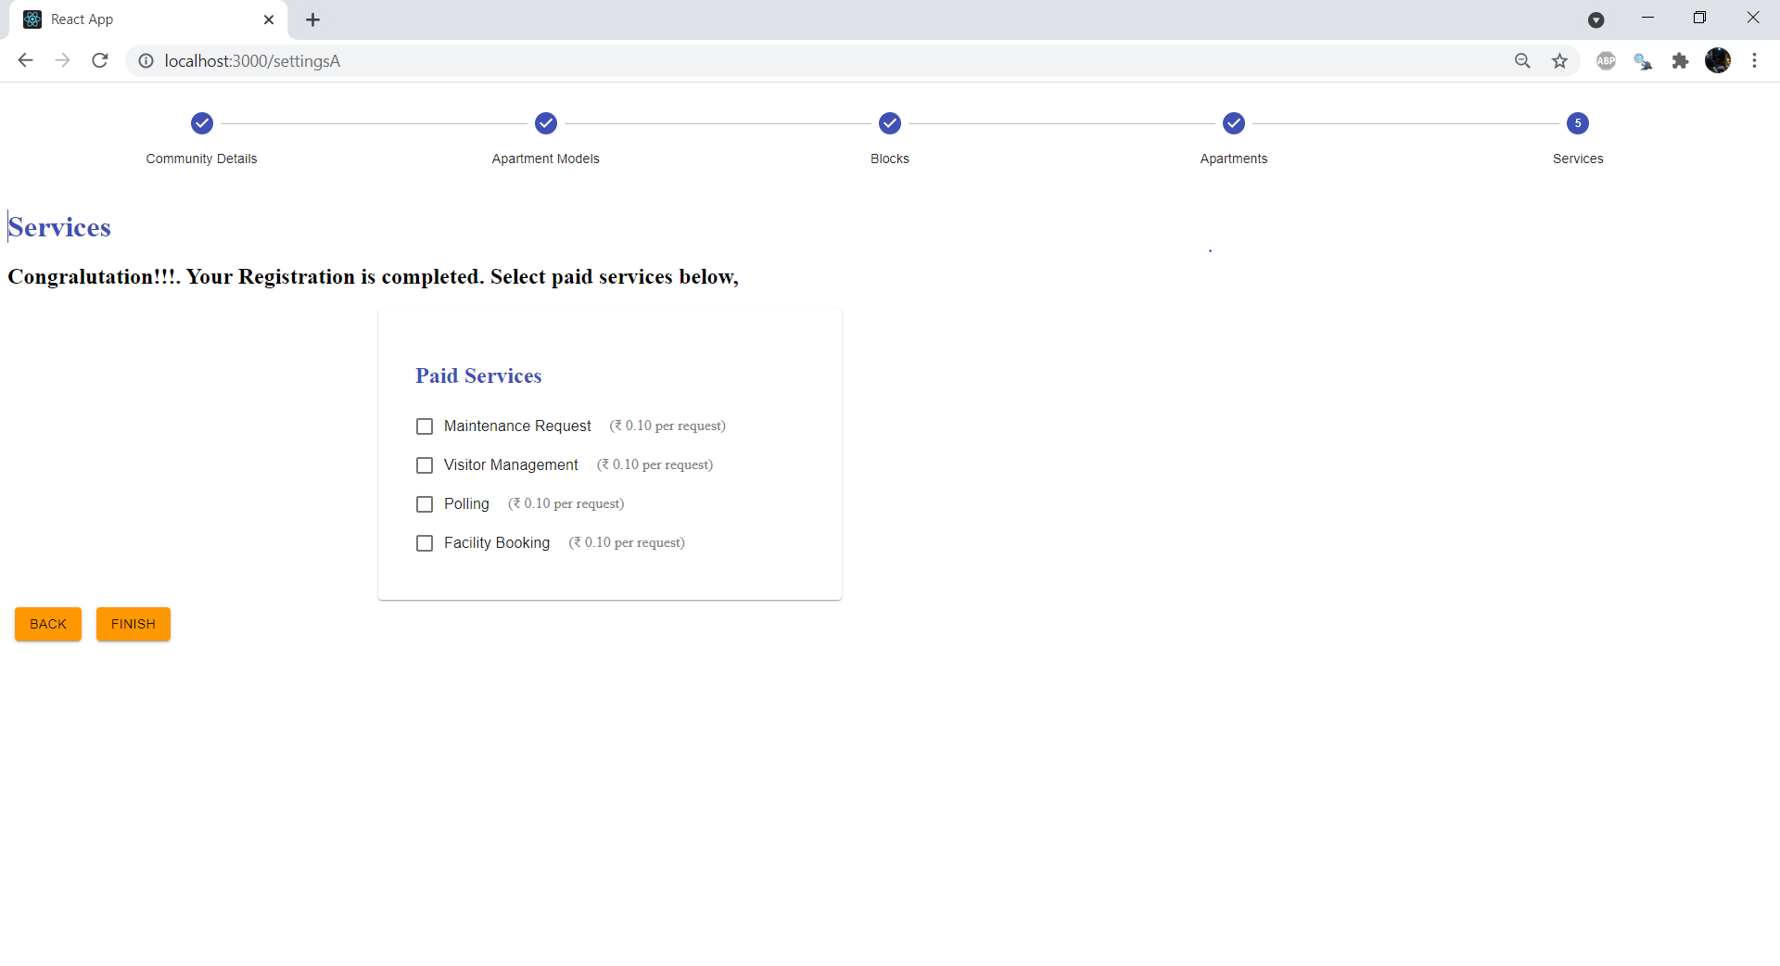

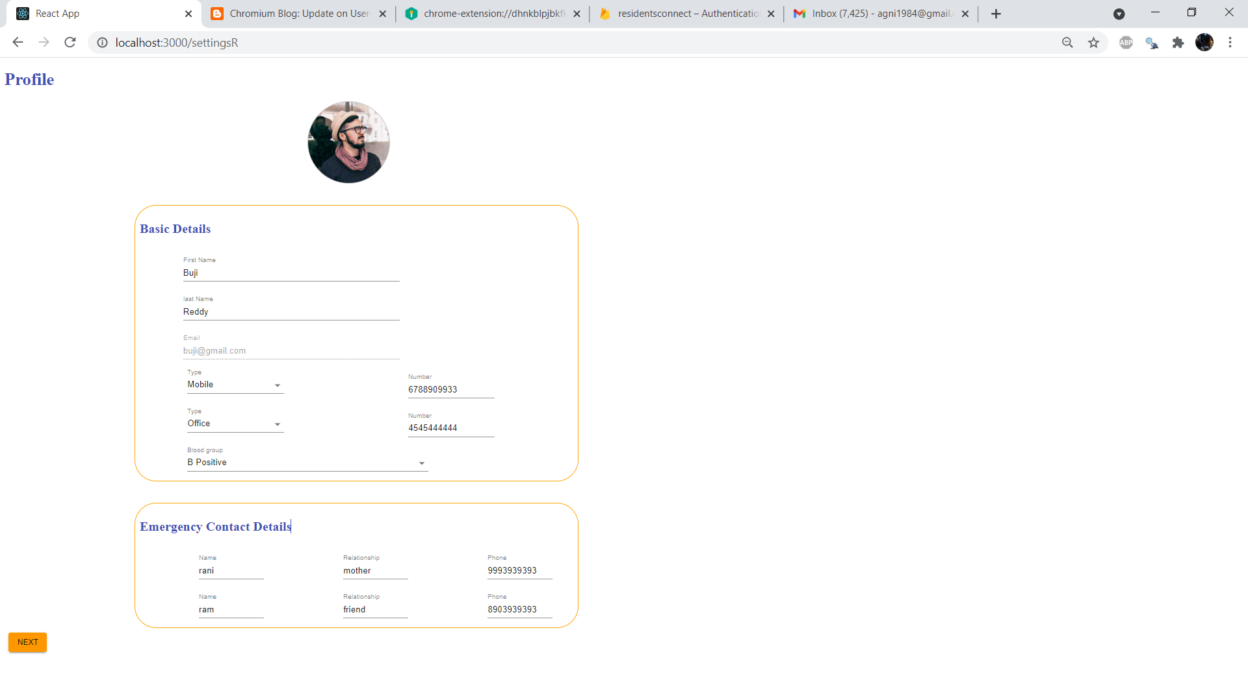

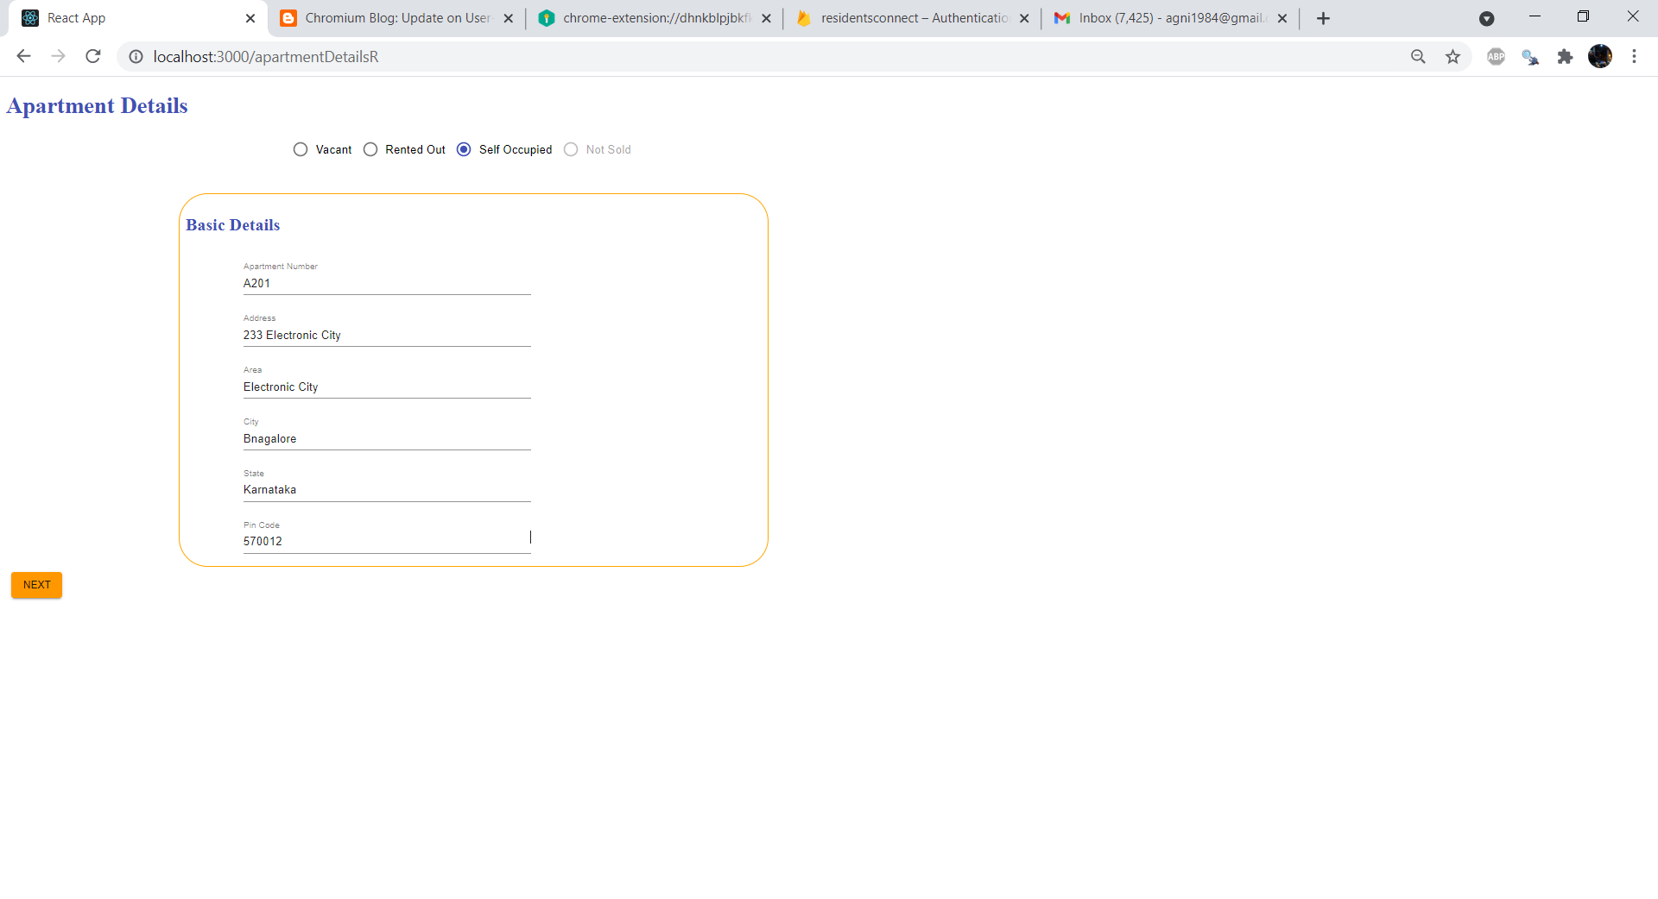

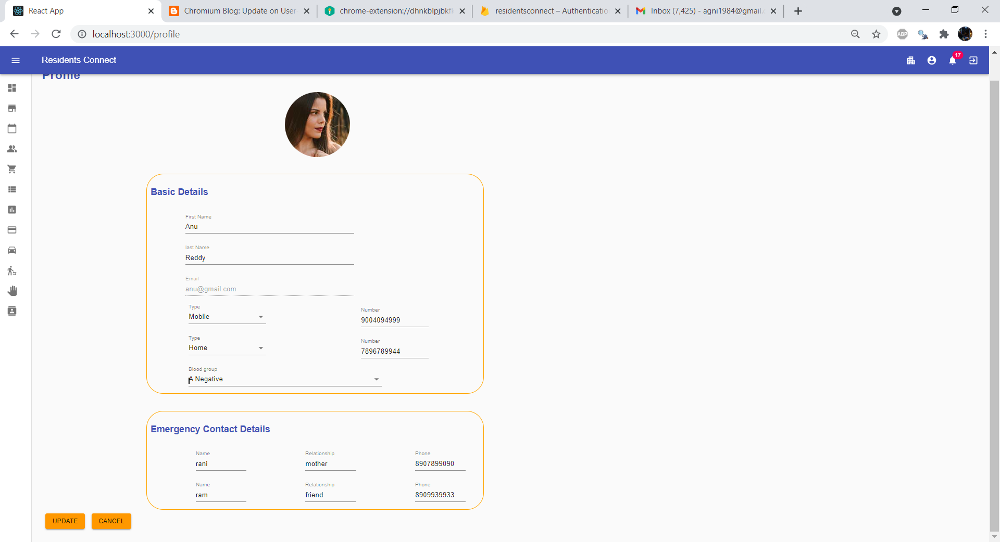

### **8.2.3 Buy and Sell**

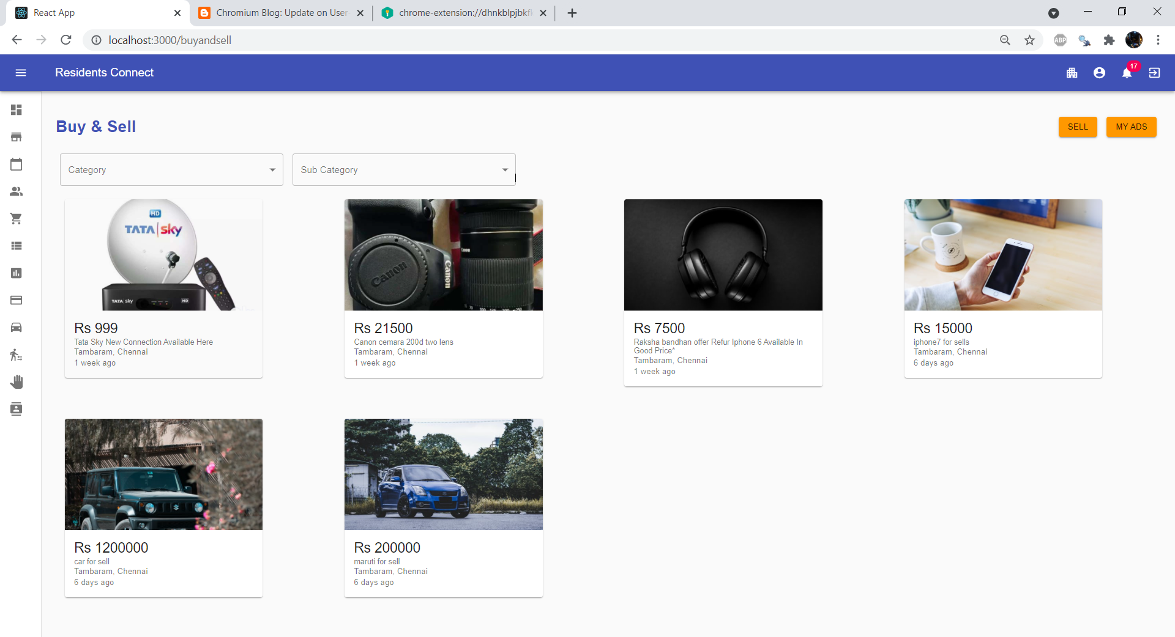

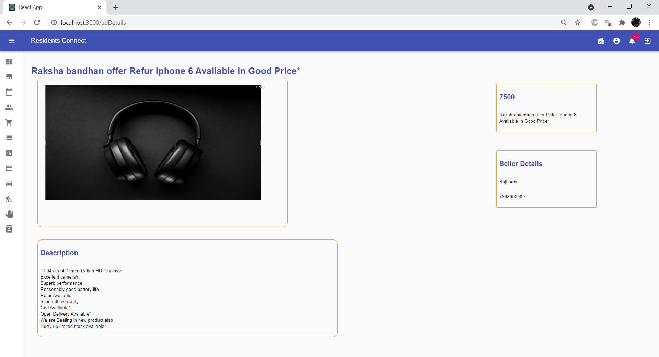

### **8.2.4 Chat Rooms**

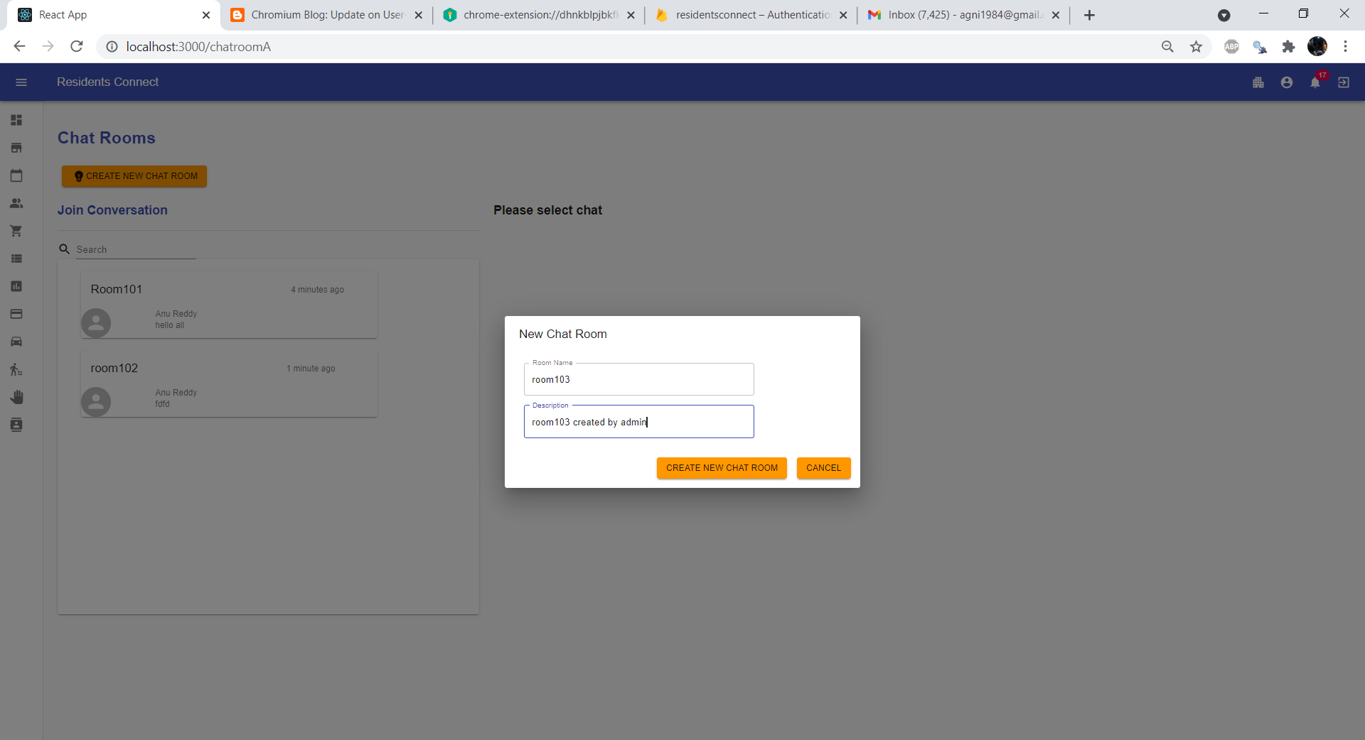

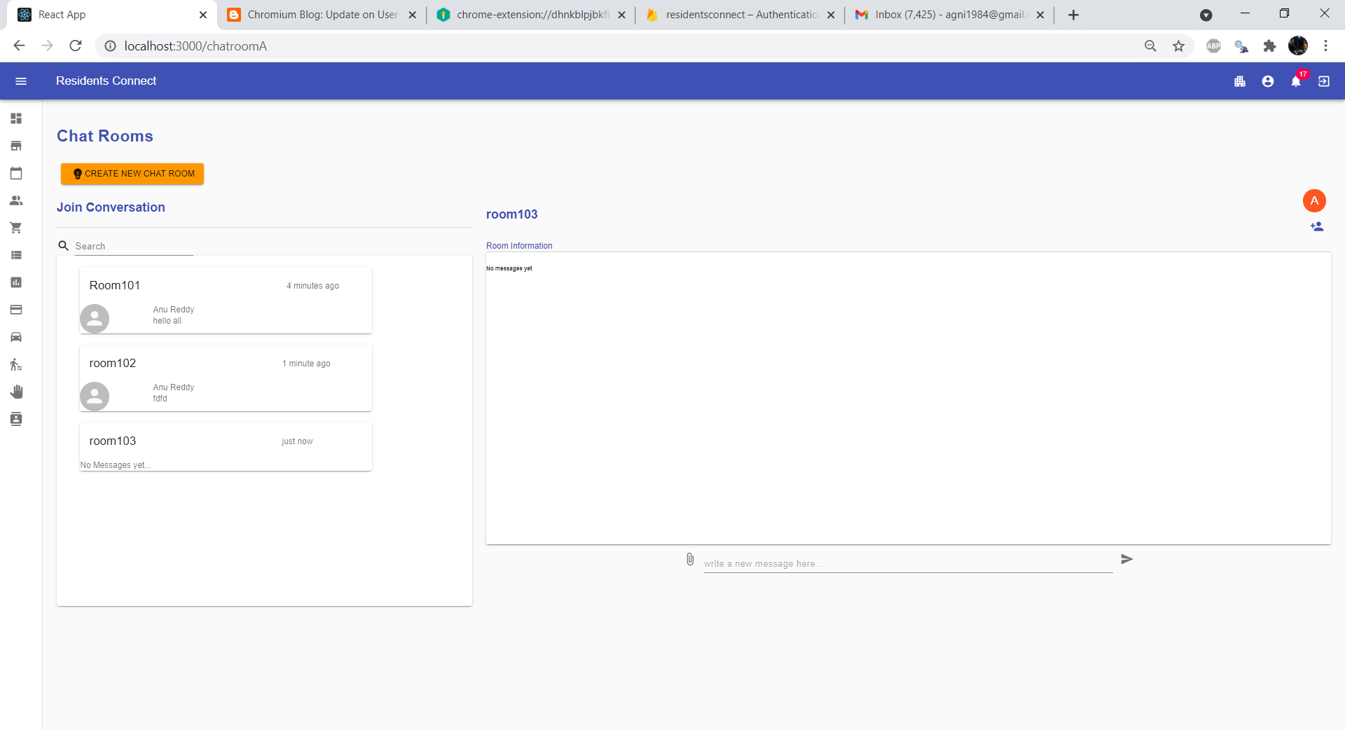

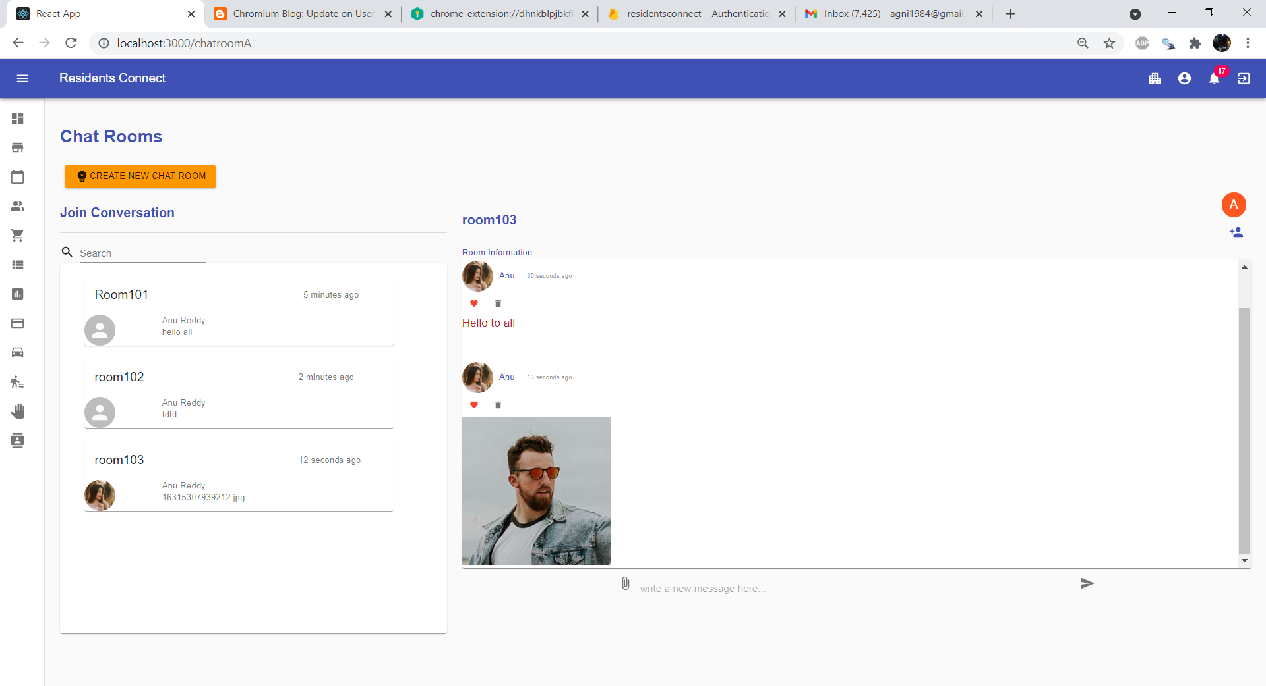

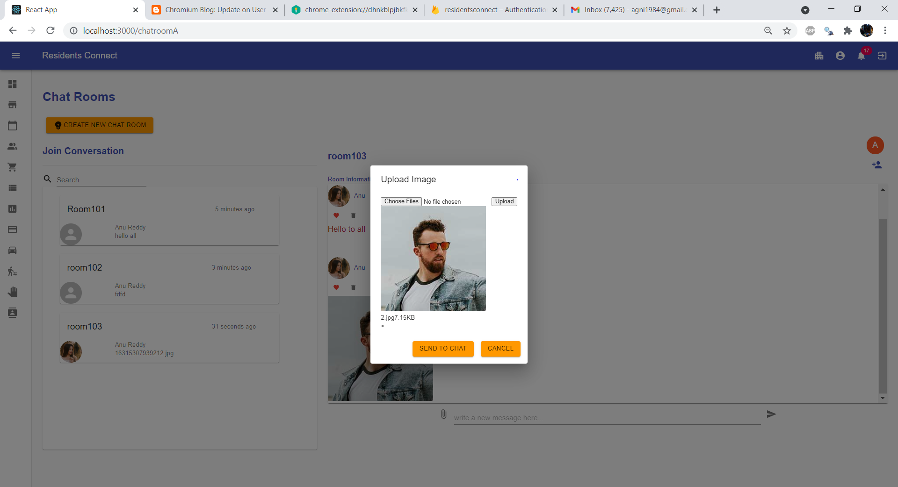

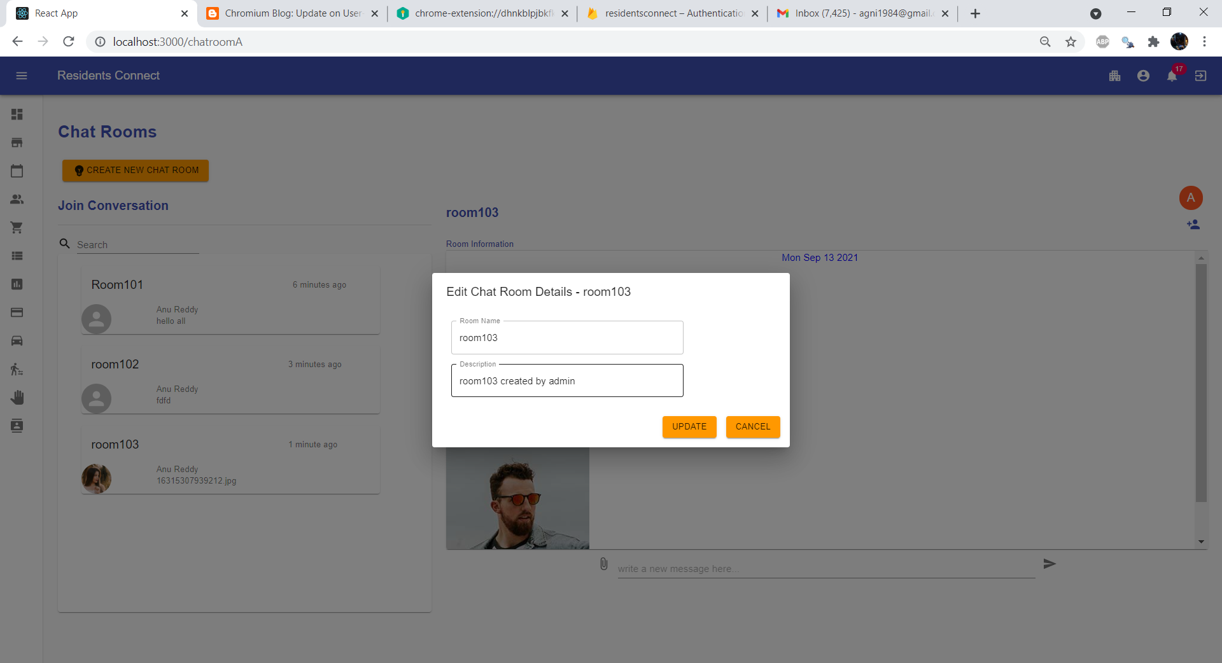

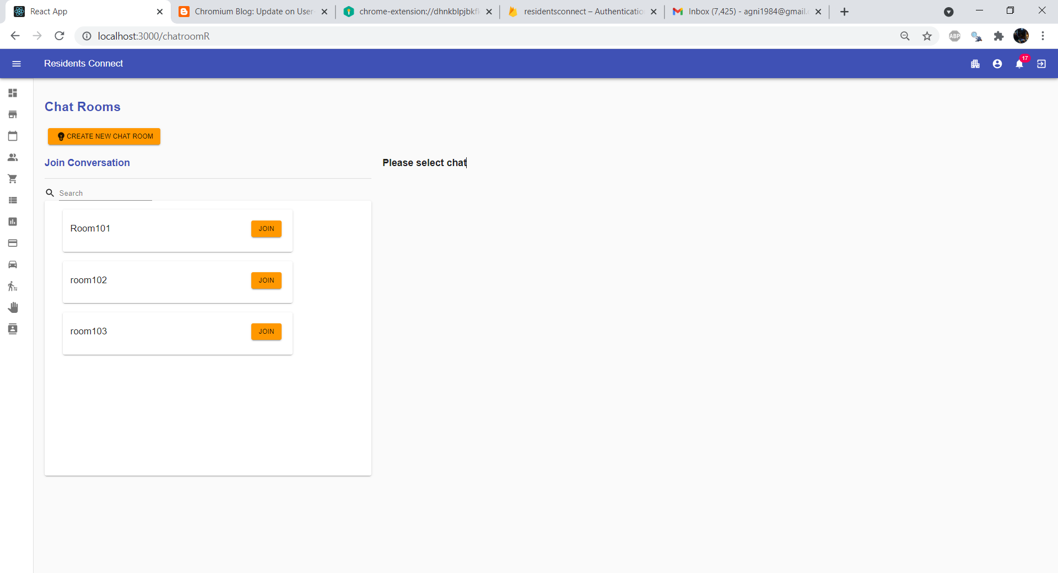

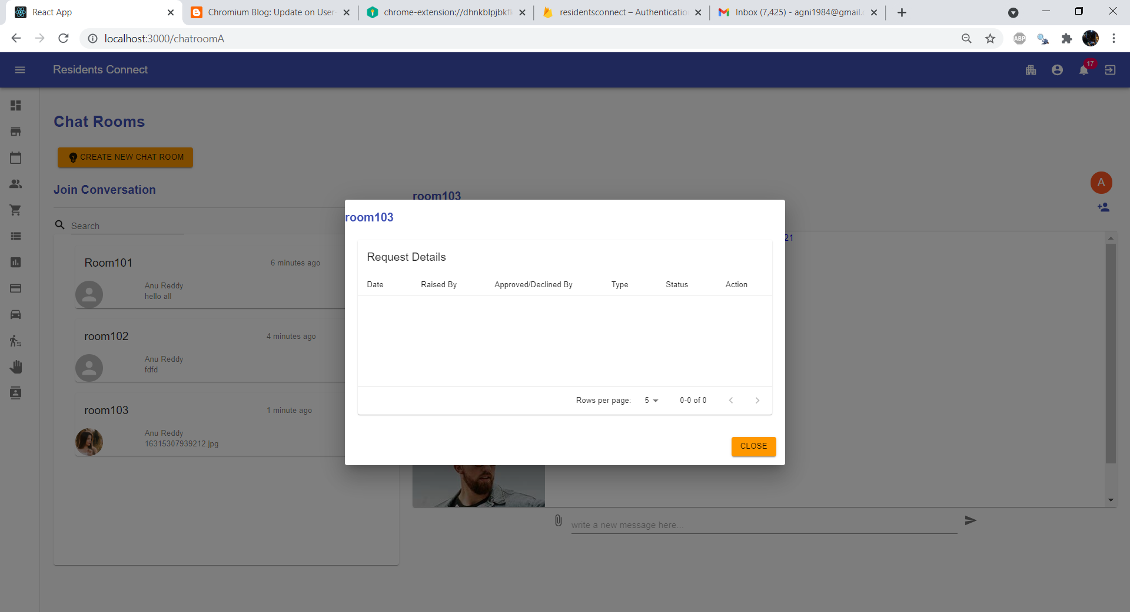

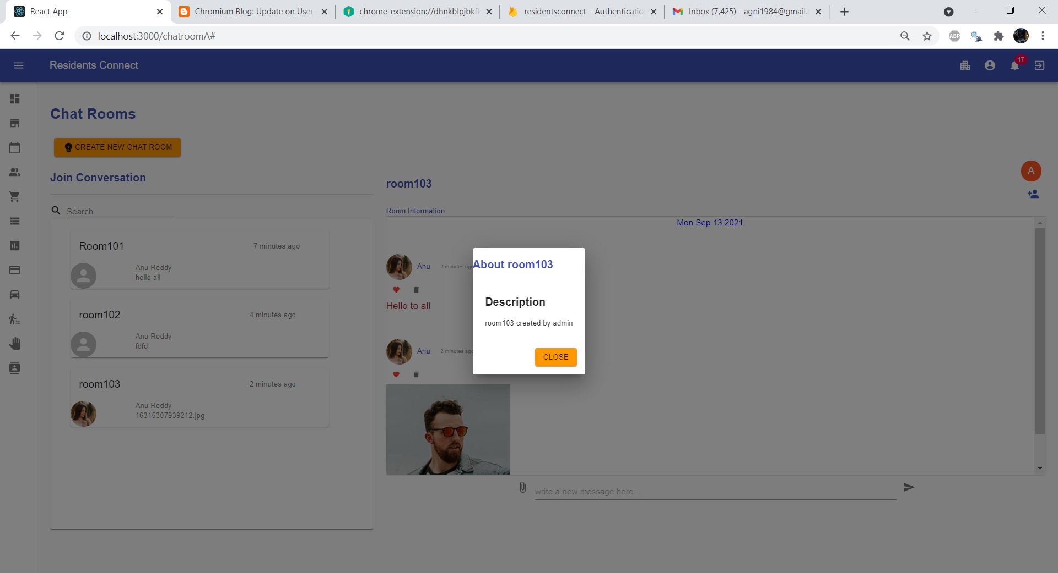

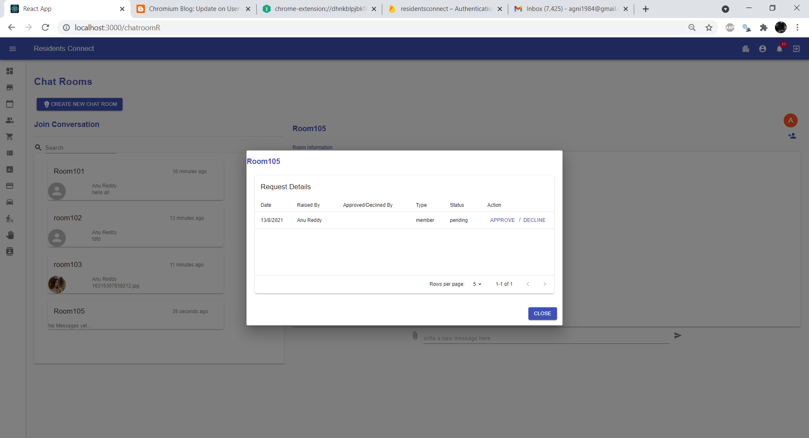

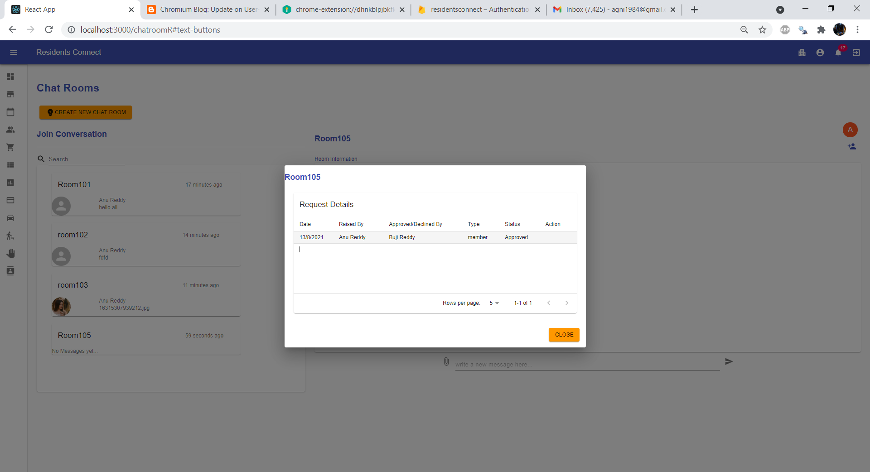

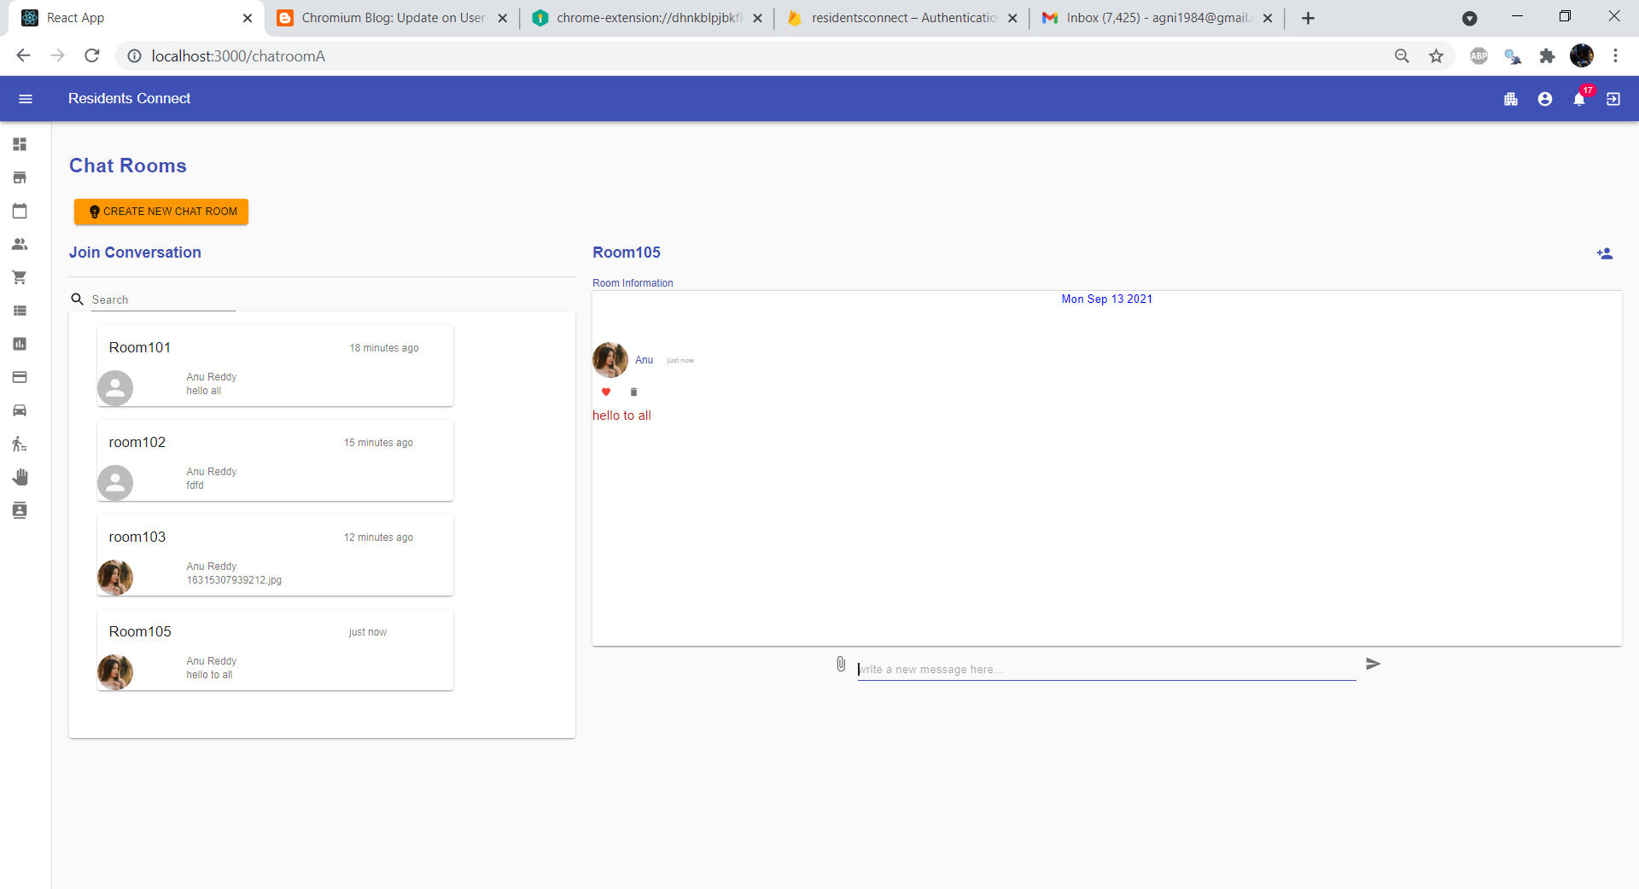

### **8.2.5 Classifieds**

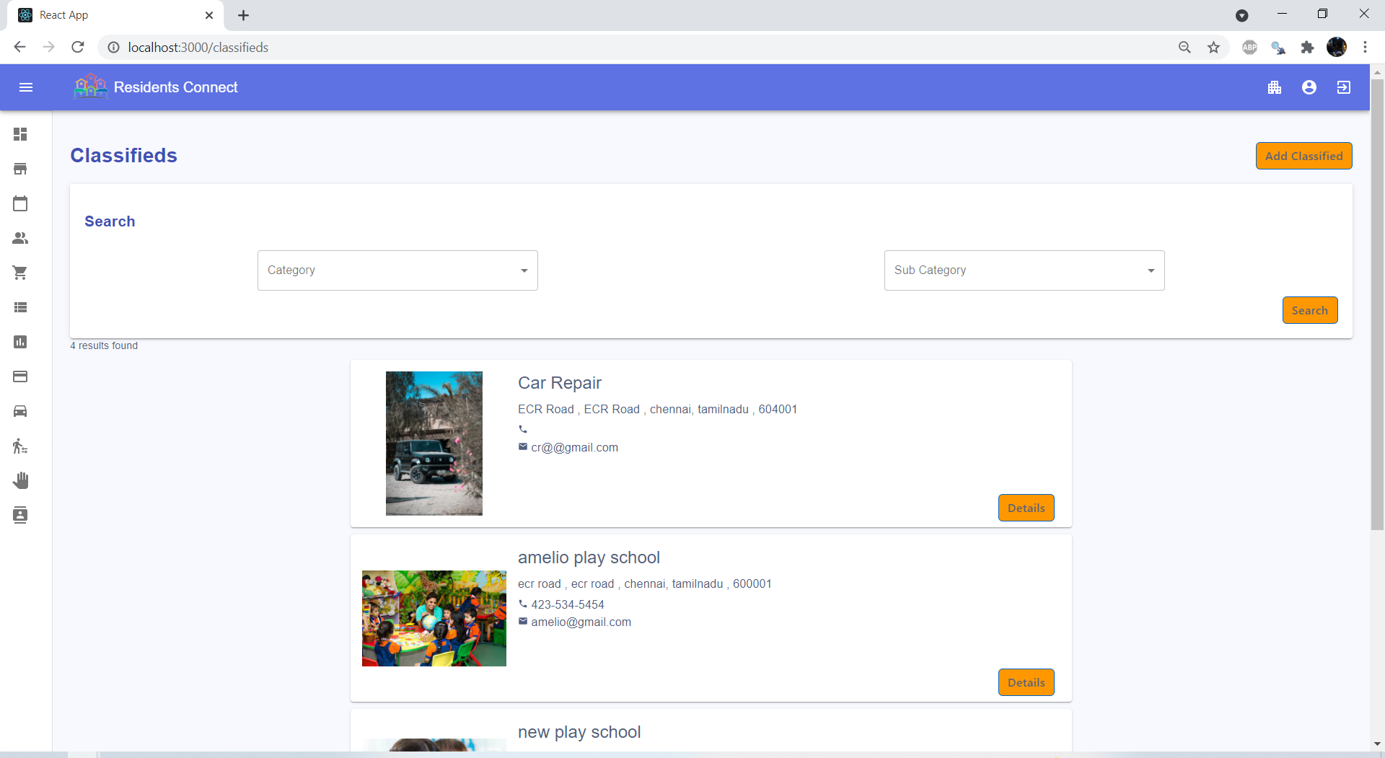

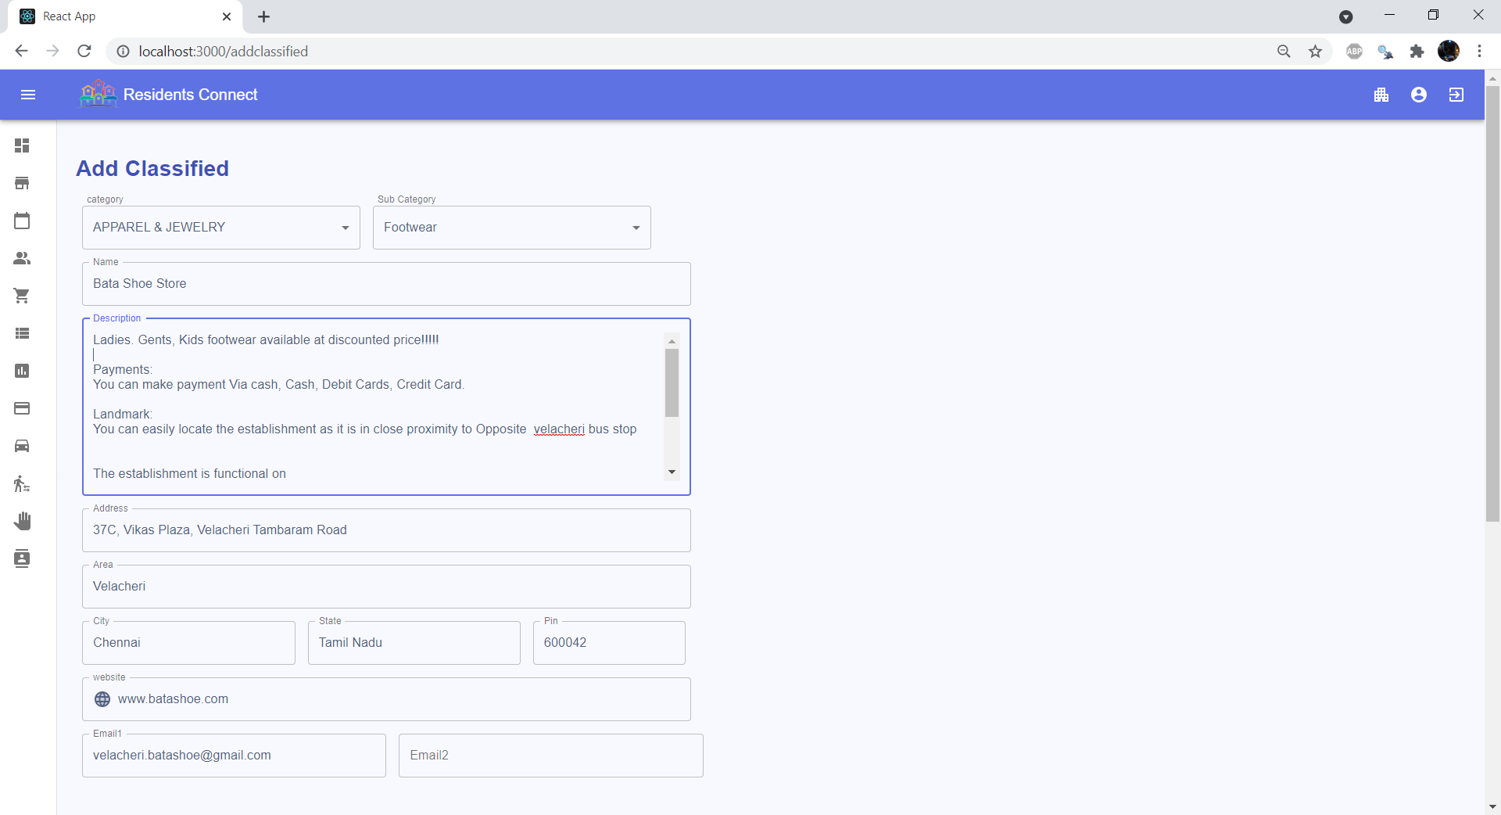

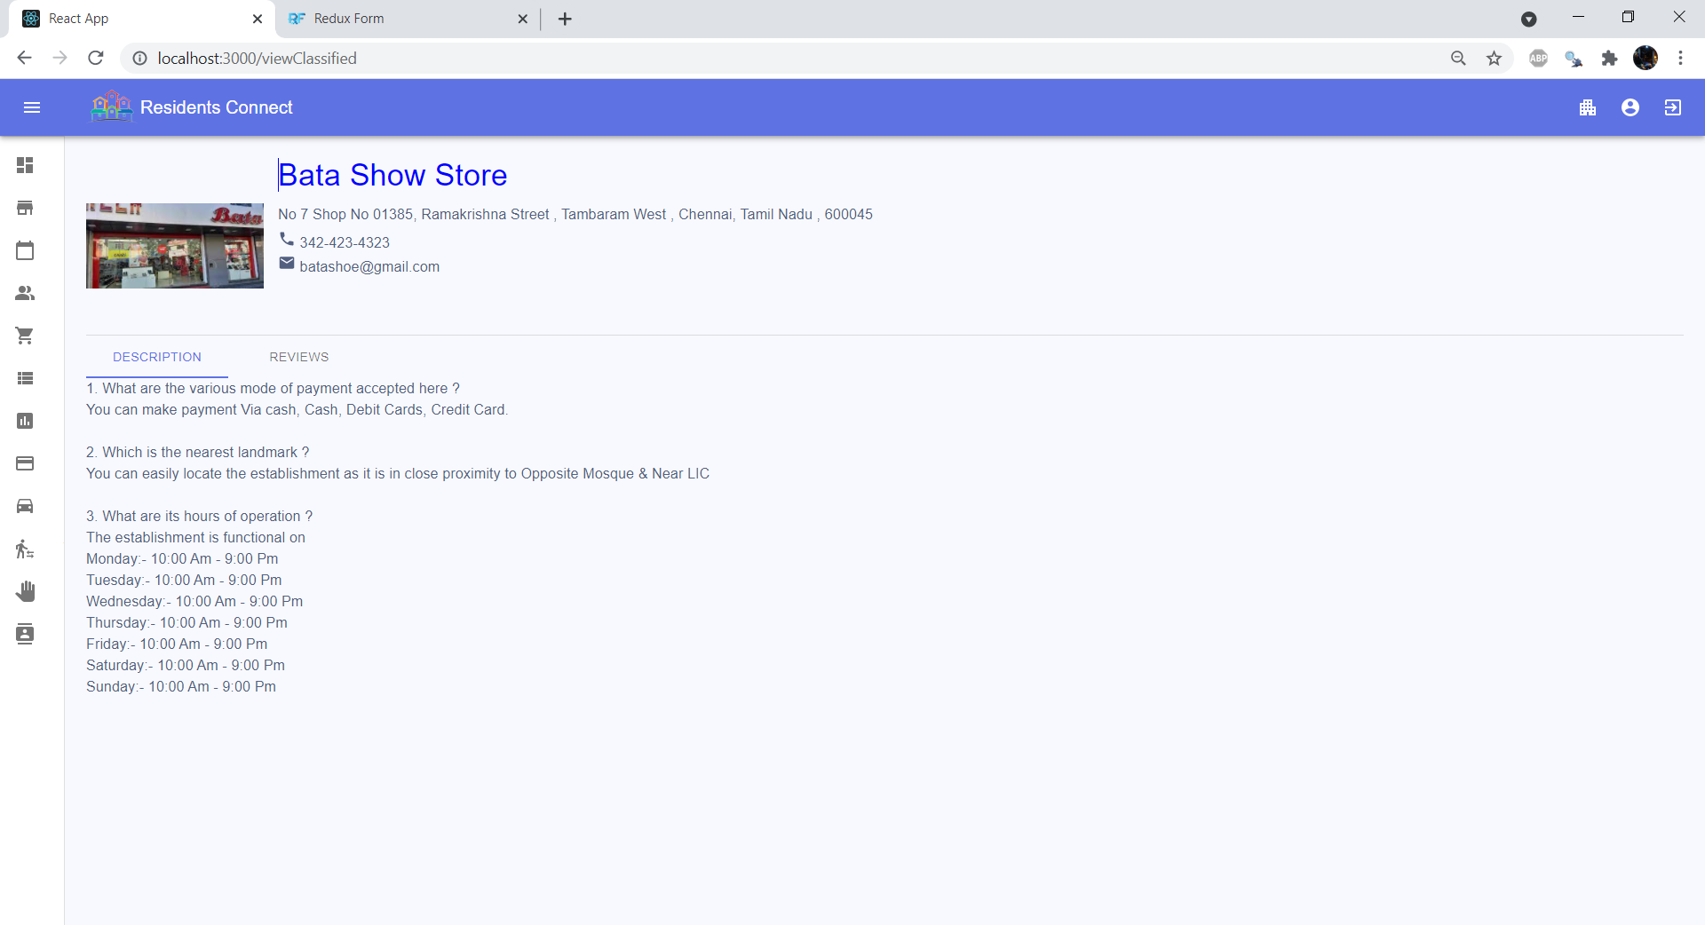

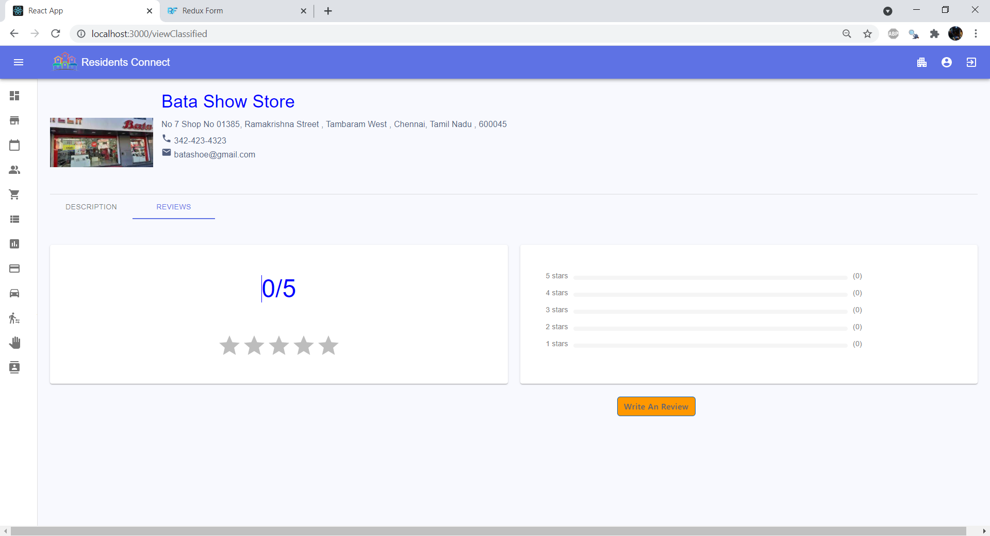

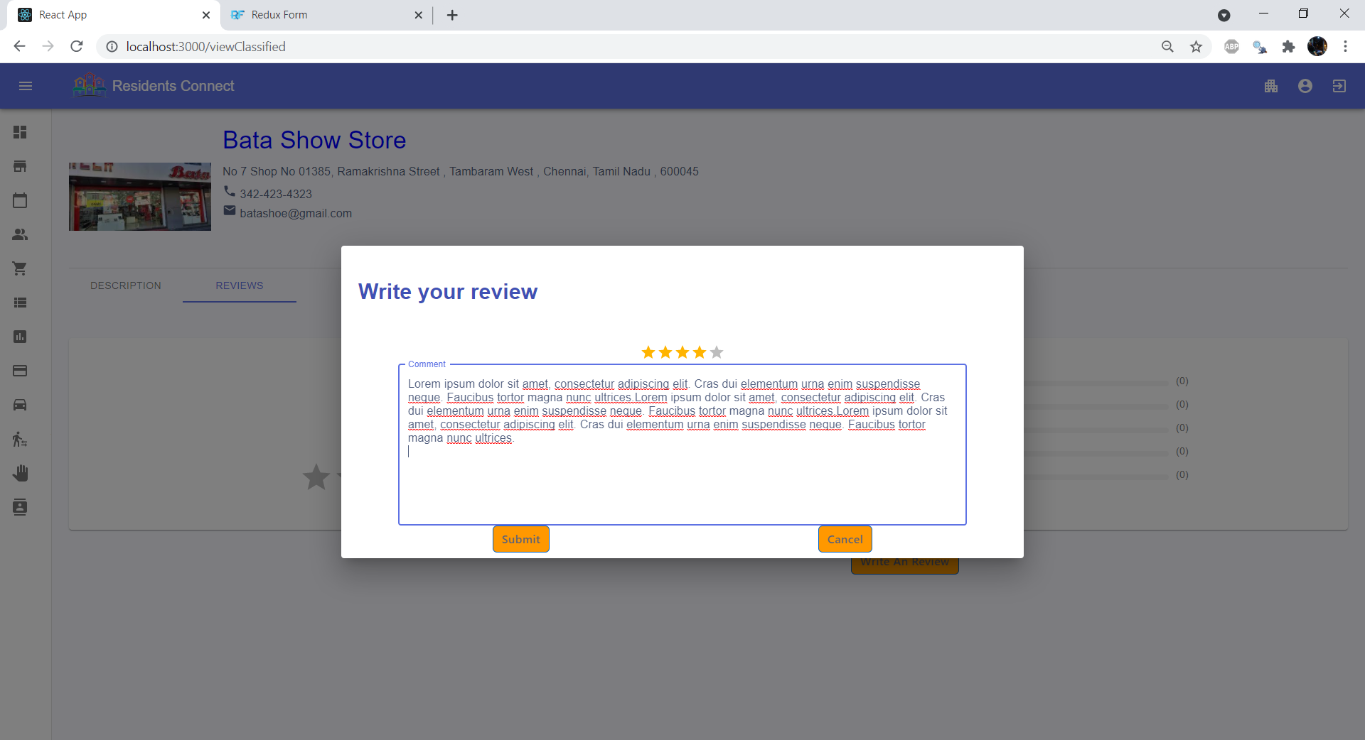

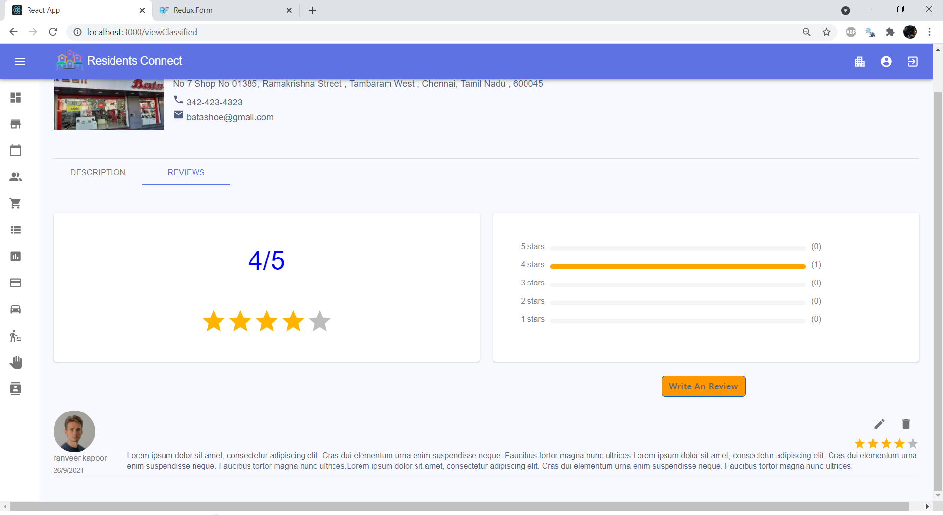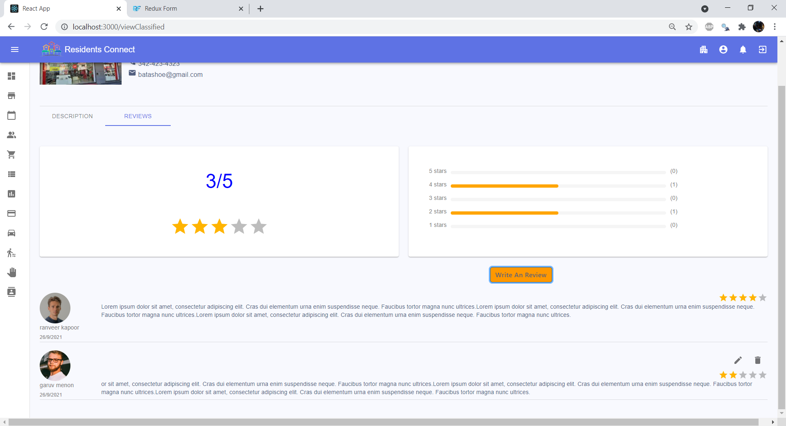

### **8.2.6 Payments**

**Admin Payment Page:**

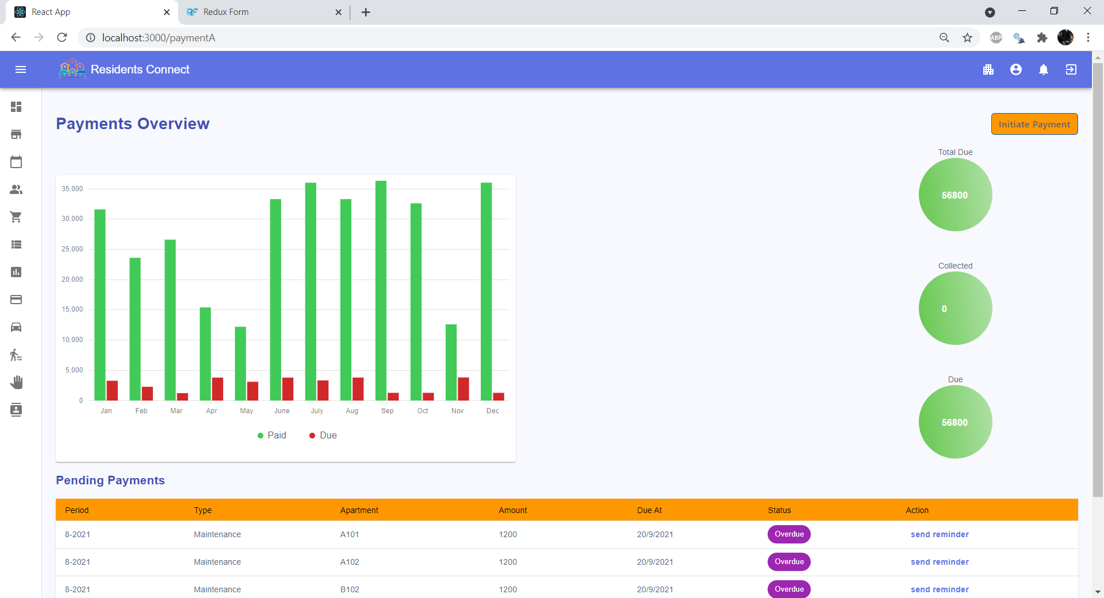

Resident Payments Page

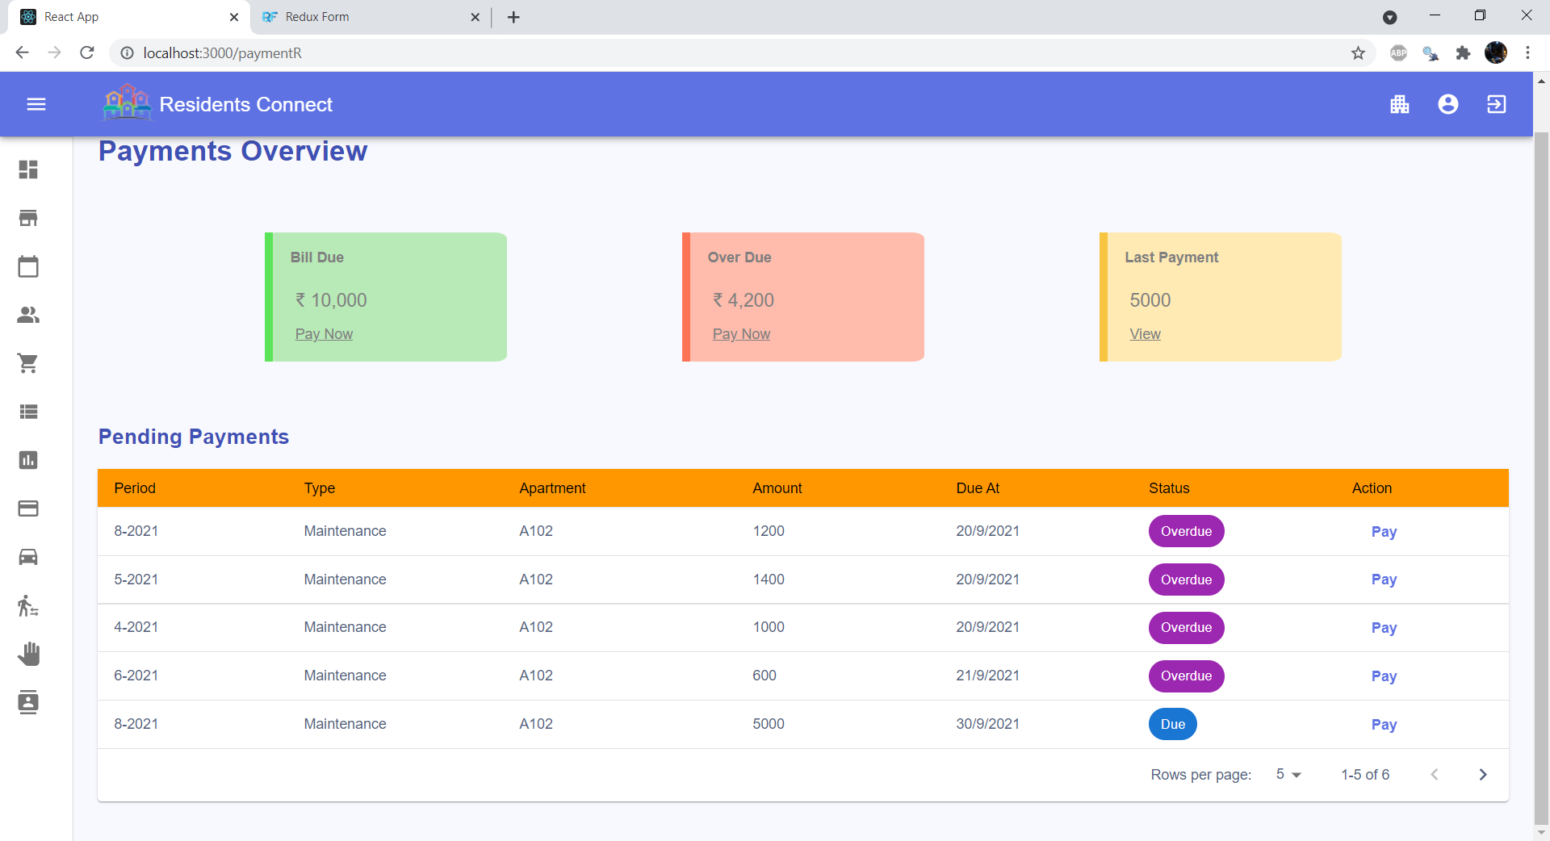

### **8.2.7 Car Pooling**

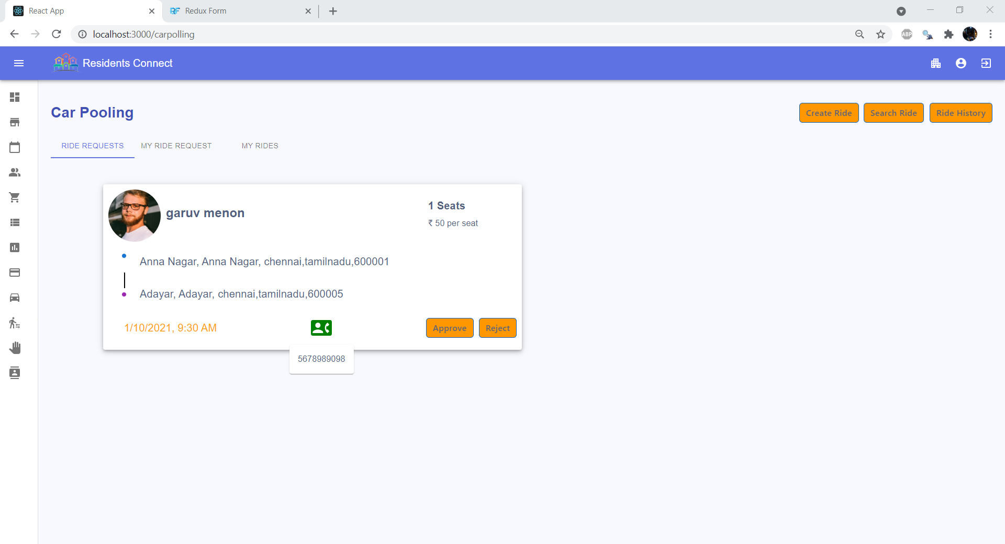

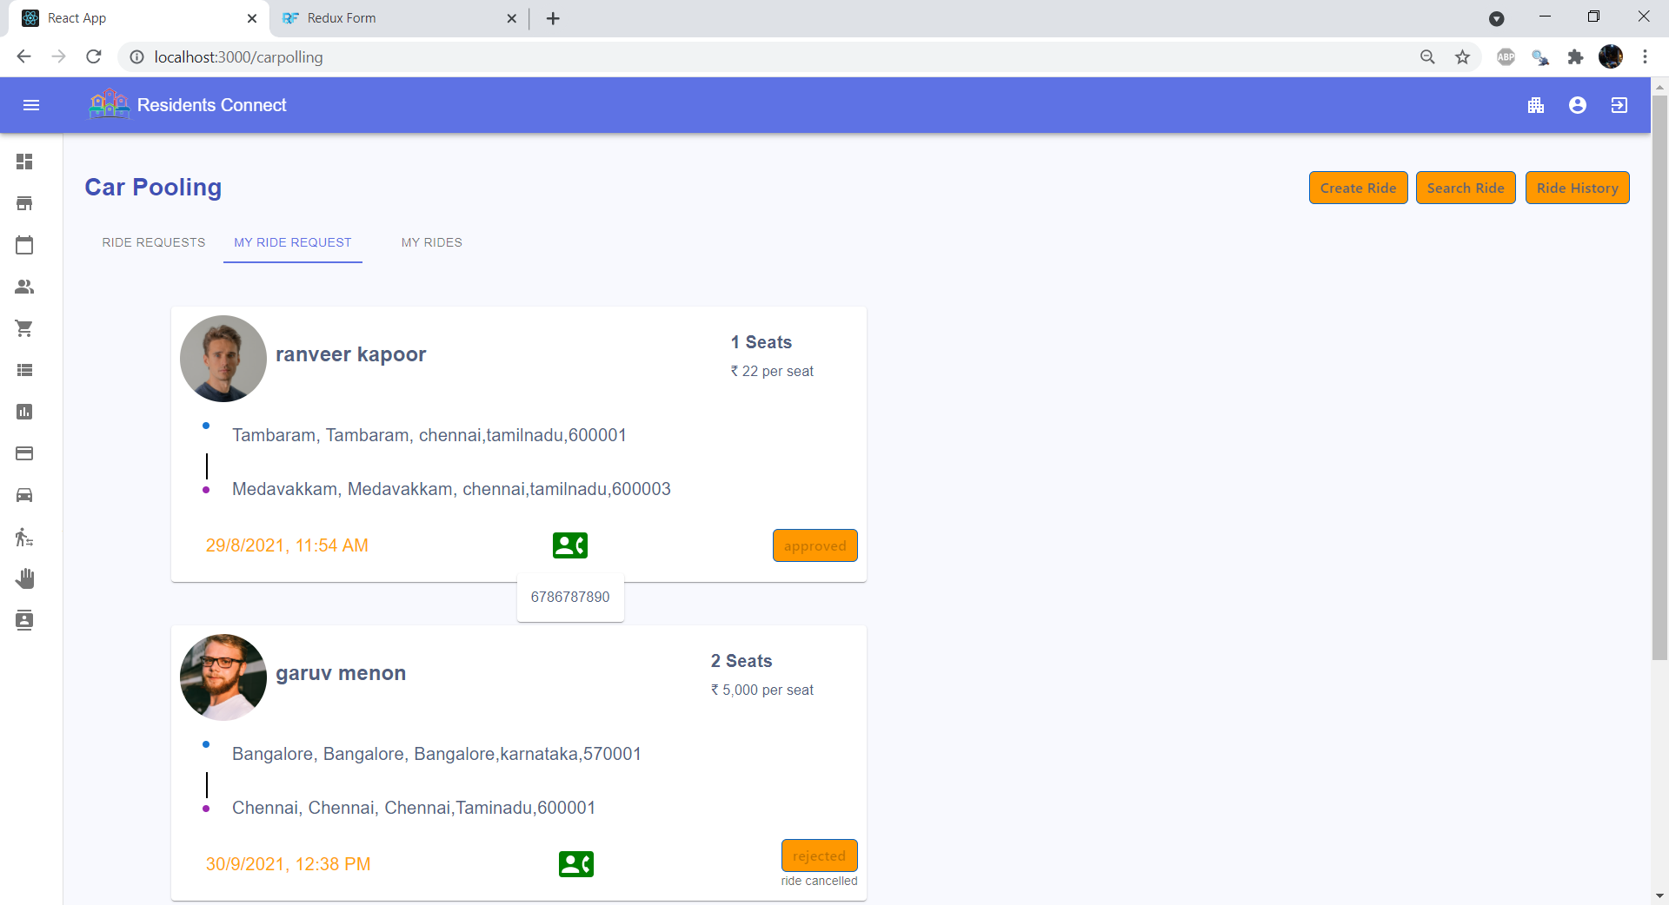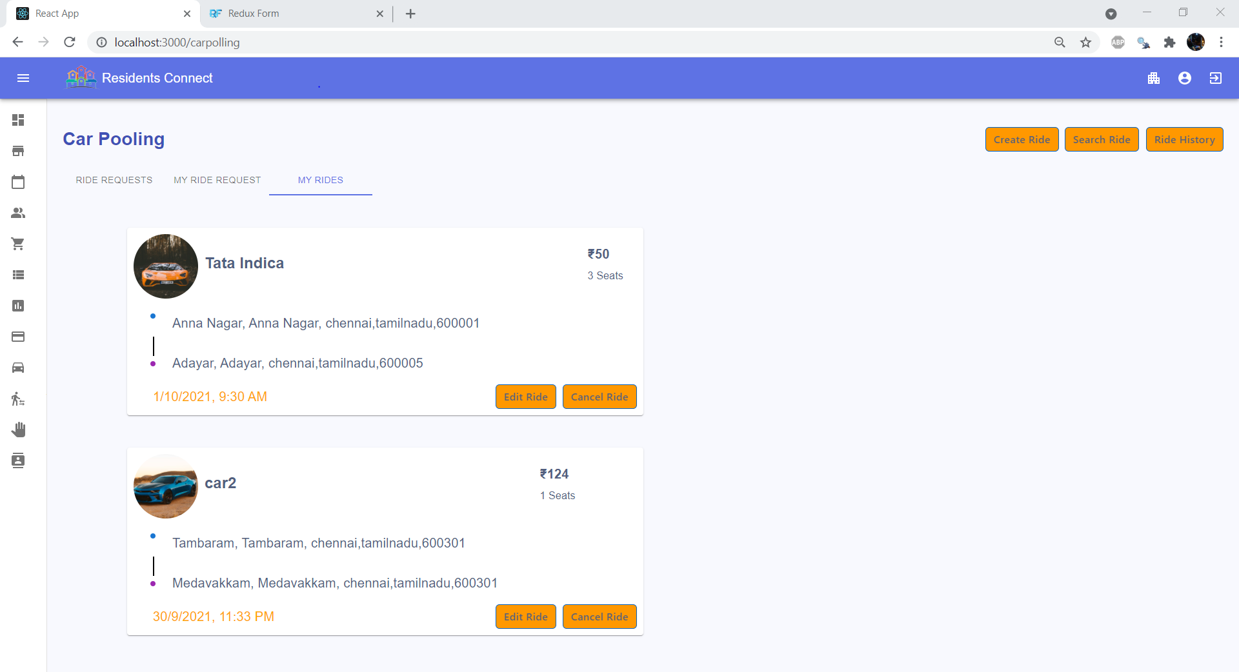

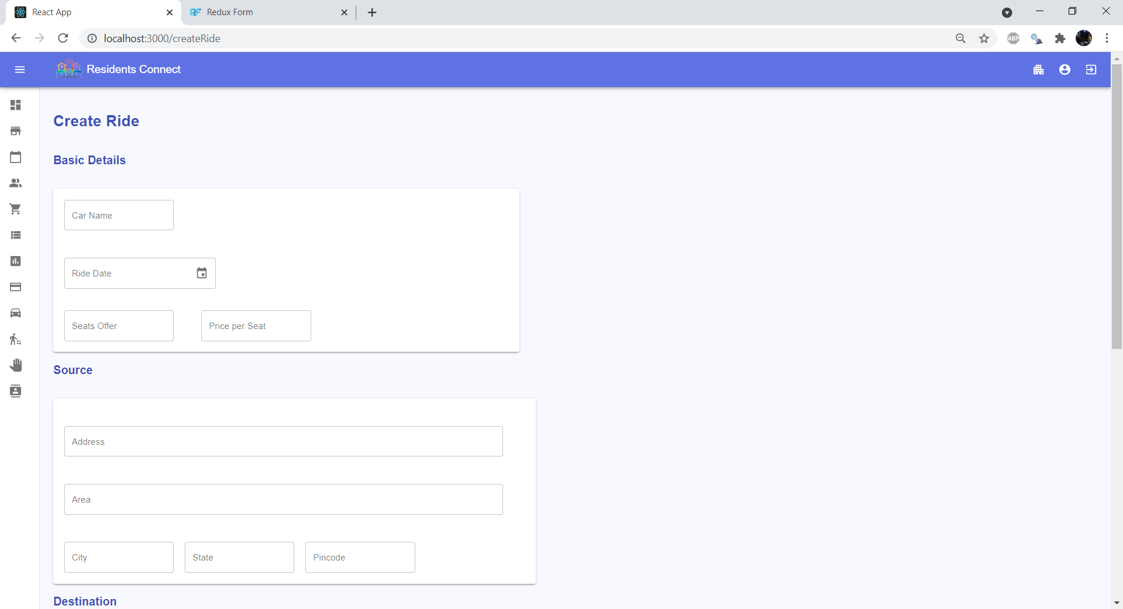

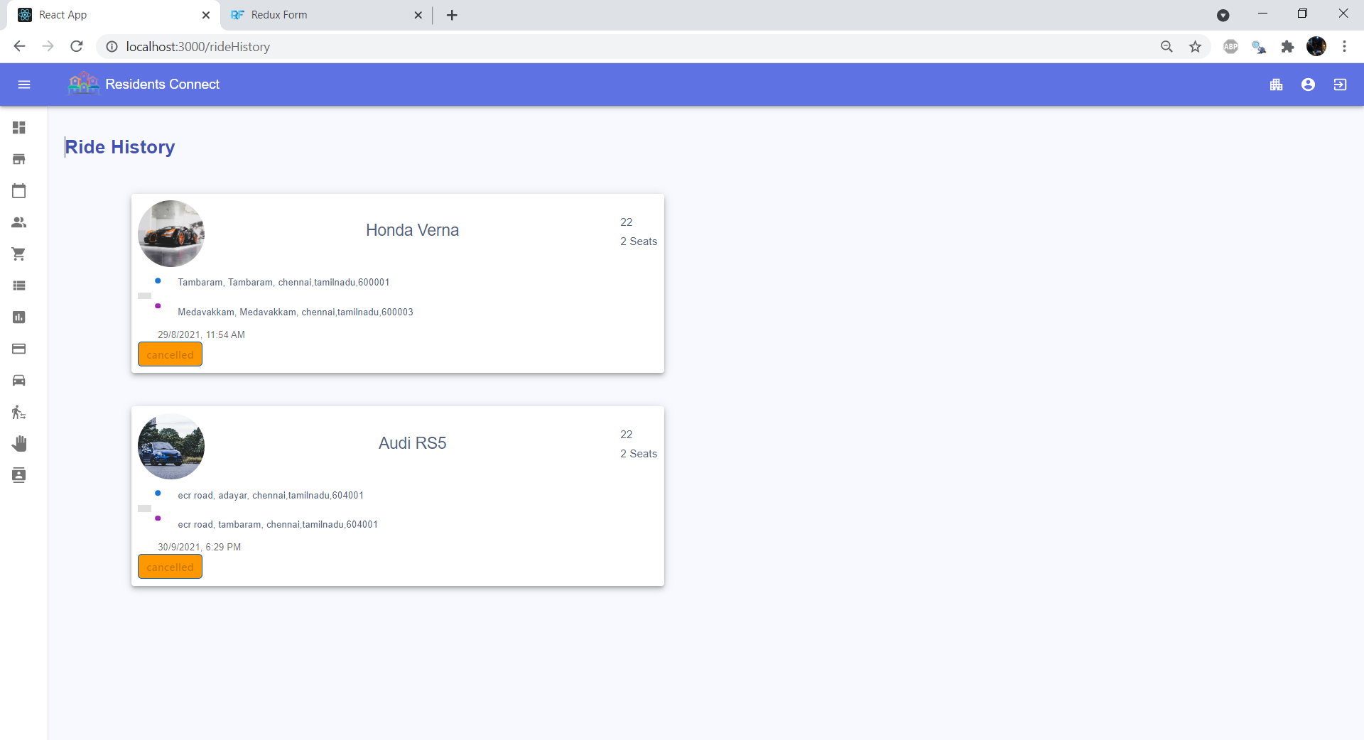

### **8.2.8 Polling**

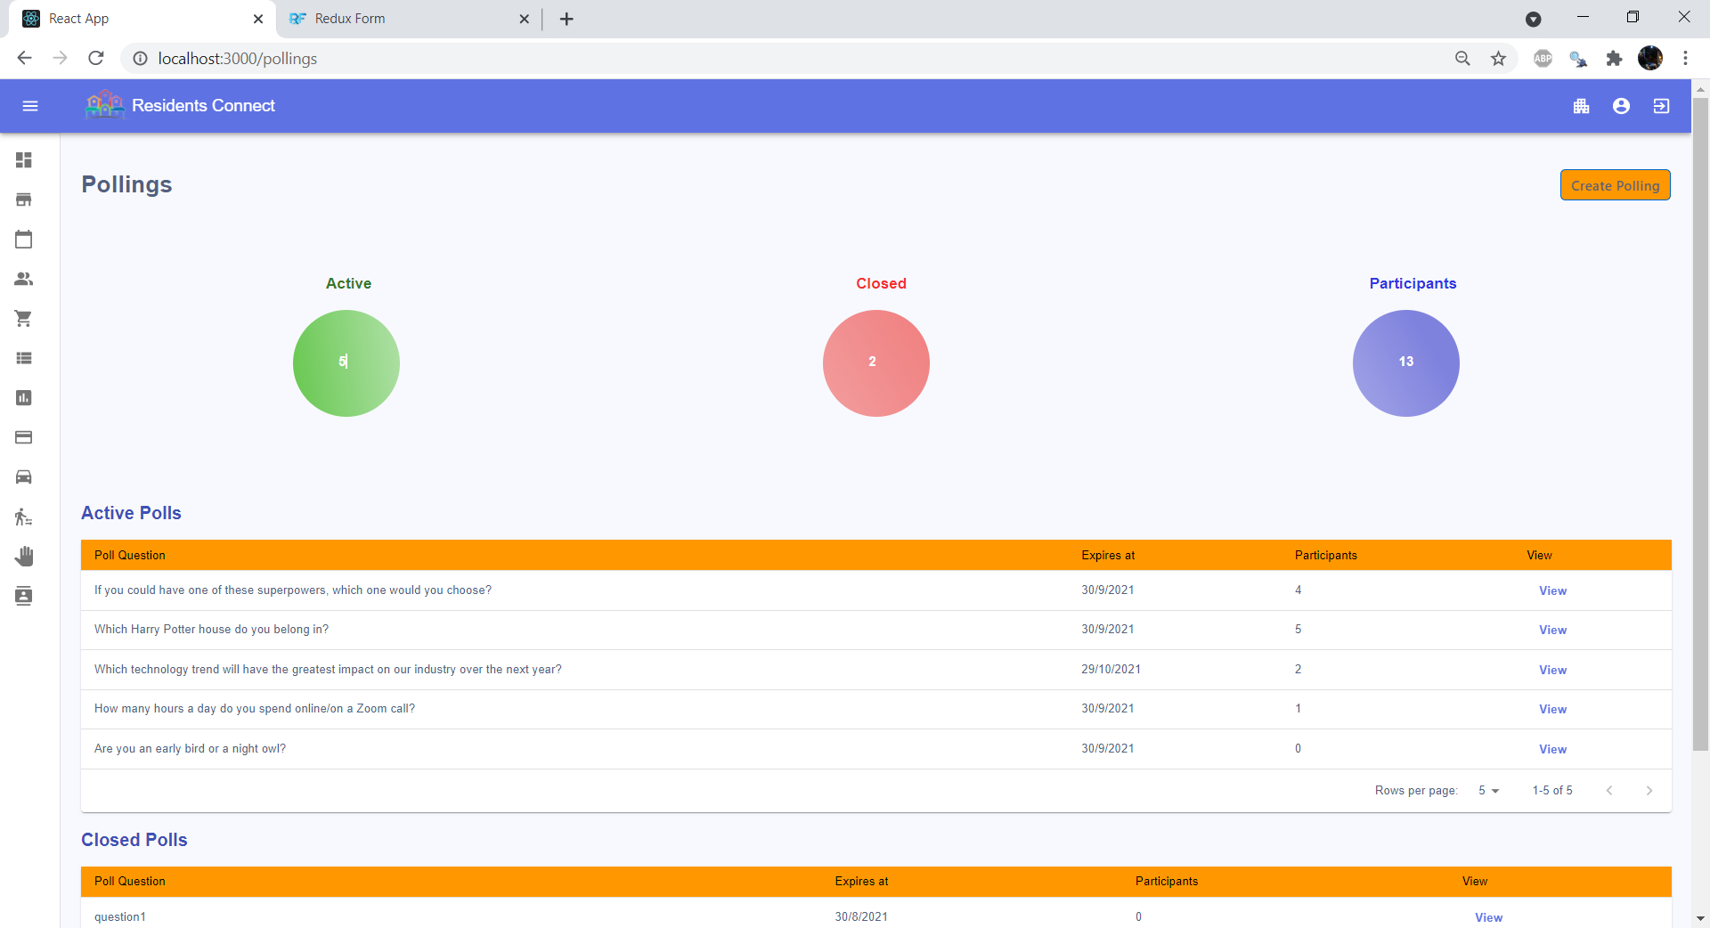

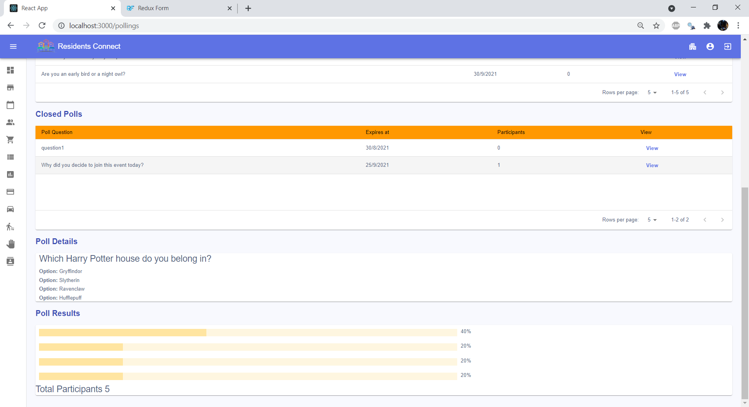

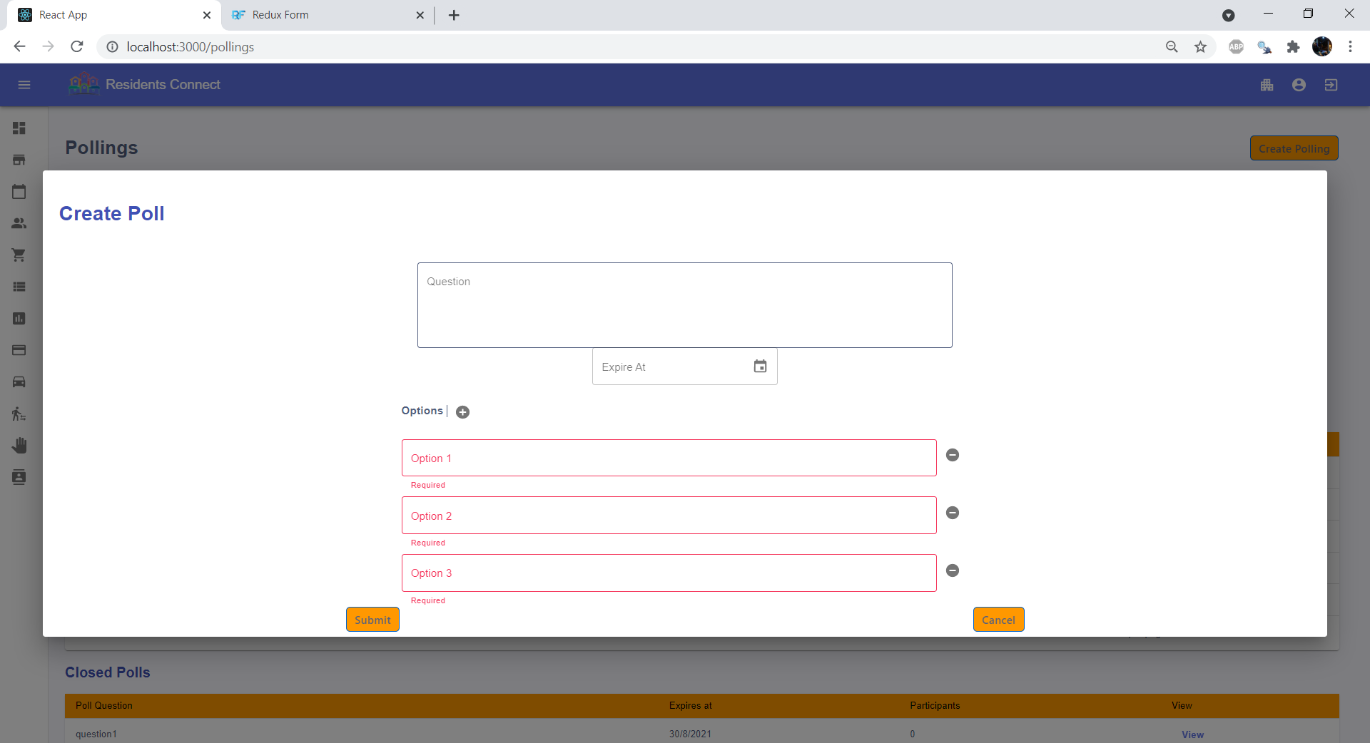

### **8.2.9 Events Management**

